Military Order of the World Wars

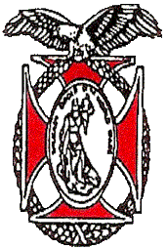 | Chapter 151  Region XIII  June 2026 Newsletter | 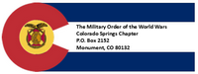
COMMANDER’S REMARKS (June 2026)

Greetings Companions!!
We had a wonderful Membership meeting on Saturday 28th of May. The speaker was Mayor “Yemi” Mobolade who presented the State of the City update and support for our military community, both active and retired. Thanks to Companion Randy Helms who arranged for and escorted Mayor Mobolade. In addition, Randy signed up a new Chapter member, Dave Saffold, Col (USAF, ret). Thank you Randy for your work in support of our Chapter. We also inducted our newest member, Joel Witzel. I also had the privilege to present the MOWW National Lufbery Award at the US Air Force Academy. More information is in an article in this newsletter.
Finally, elections were completed and our Chapter officers for OY 2026-2027 will be:
- Commander-Steve Shambach
- Senior Vice Commander-Mark Ellis
- Junior Vice Commander-Ulysses Swift
- Adjutant- Kirk Brown
- Treasurer- Mike Berendt

Thanks to those who volunteered to serve and for those of you who participated in the chapter elections.

Having said that, all of the officers have been serving on the staff for several years and we need you to volunteer to serve on our staff when their term expires in June 2027. To start this process, we are requesting companions to help serve on one of our committees:
- ROTC/JROTC
- Boy and Girl Scouts
- National and Homeland Security
- Police and Fire and First Responders
- Patriotic Education
You can find the contact information for current Committee Chairs in this newsletter. Help live our motto “It is nobler to serve than to be served.”
A number of companions are preparing to serve at the Rocky Mountain Youth Leadership Conference (RMYLC), 15-19 June at CSU, Pueblo. You should have received an invitation to visit this conference to observe the wonderful Patriotic Education Program and the great students attending the conference! More information is available at: www.rmylf.org Let me know when you plan to attend!

We will not be having a membership meeting in June because of the effort required to put on the RMYLC. Our next meeting with be on Thursday, 30th of July, 1700-1915 at the Patty Jewett Golf Course. Our guest speaker will be Companion Bill Hybl presenting how the El Pomar Foundation supports our military.
Also upcoming is the 4th of July parade in Monument, which our Chapter supports every year. We will again be able to partner with Nathan Watanabe and his historical military vehicle group. You can ride on one of these vehicles or walk in the parade. lease contact Kerm Neal if you are able and willing to participate in the parade. You can also attend to observe along the parade route.
Another reminder is that we are always looking for new members! If each one of you can recruit one new member this year, that would help our Chapter immensely!
Finally, we are looking for ways our Chapter can better serve you, our members. Please let us know your ideas for how to improve our service for you and our community.
Thank you again for the honor and privilege of being your commander and thank you all for your service!
Steve
sashambach@gmail.com
(719)447-5505
It is nobler to serve than to be served.

ROTC AND JROTC
Thanks to everyone who presented MOWW Awards of Merit at the ROTC and JROTC Awards Ceremonies at our local schools. These recognition events are special to the students and the culmination of their experiences throughout the school year. We have received photos from many of the events and you can see some of them in a MOWW Review submission on our CoS-MOWW.org website. After 6 six years of service managing this program, Ulysses and I are looking for a volunteer to take over leadership of this annual event. Please contact either of us if you are willing to take over the reins of this important COS MOWW program.

TREASURER’S REPORT INFORMATION
The following table depicts the Chapter’s financial status as of 2 May 2026.10 August
Account | Balances
CDs: | $ 13,785.21
Savings: | $105.16
Checking: | $5,617.27
Reserved: | $1,696.59
Total: | $ 21,206.51

AMERICA 250

We have a slot in the Monument Hill Kiwanis 4th of July Parade, in coordination with the Colorado Military History Group CMHG)! What a great way to celebrate our freedoms and the founding of our great Nation!! The CMHG will have two vintage vehicles this year; the 3/4 ton Dodge WC-21 WWII truck, and Nate Watanabe's venerable WWII Jeep. If you haven't ever been in the parade it is a memorable experience, and this year will be even more special!

The parade will begin at 10:00 AM, and the theme this year is “250 Years of Freedom; 150 Years of Colorado Statehood.” Contact Kerm Neal at knealsfour@yahoo.com or text to 719-205-1106 if you want to participate in the parade. Deadline for volunteering to participate in the parade is June 30th. We can accommodate eight Companions and family members for riding, any overage will walk. We don't know our spot yet, but we've asked to be close to the start line due to the aging veterans amongst us. The route is approximately 1.5 to 2.0 miles long, depending on where are starting spot is.

Hope to see you there!!
Mayor Yemi Mobolade Thanks COS MOWW for Support to the City

The Colorado Springs (COS), Colorado Chapter of MOWW was honored to welcome Mayor Yemi Mobolade as our guest speaker at our monthly Companions Dinner on Thursday, 28 May 2026. Mayor Mobolade thanked and praised the COS MOWW Chapter for its incredible support to the City of Colorado Springs through Companion support to Scouting, Girl Scouts, ROTC and JROTC awards programs at our local high schools, Financial Sponsorship of Police and Fire Awards Recognition programs, and support to local Veterans Organizations. He also recognized the success of the Rocky Mountain Youth Leadership Conference (RMYLC) in promoting patriotism, citizenship, and knowledge of the free enterprise system. Mayor Mobolade was born in Nigeria, was naturalized as a US Citizen, is an ordained minister, and has led a number of small businesses and charities in Colorado Springs. He stated his firm belief and support of the MOWW Preamble and the goals of our organization nationally and locally. He also recognized his appreciation for the enduring partnership with the Colorado Springs City Council President, our own Colonel Randy Helms, who invited Mayor Mobolade to visit our Chapter. Finally, Mayor Mobolade ended his remarks by noting that his leadership is based on the motto of MOWW – It is Nobler to Serve than to Be Served. We are honored to be recognized, and joined in Service, with Mayor Yemi Mobolade of Colorado Springs, CO.
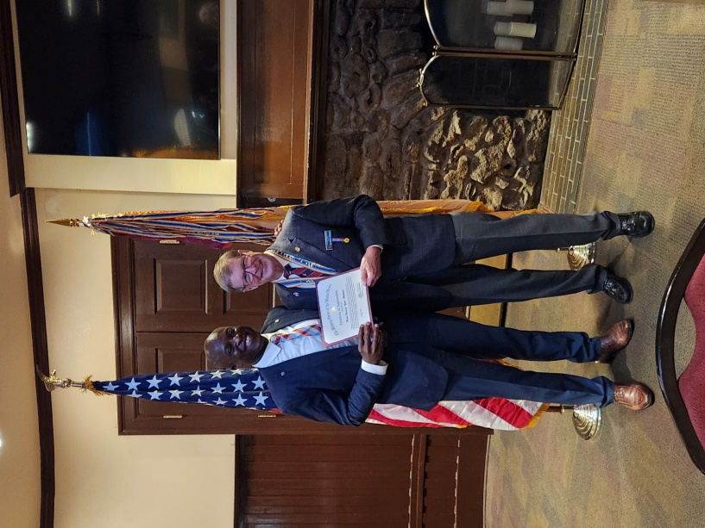COL Steve Shambach provides a MOWW Certificate to Mayor Yemi Mobolade of Colorado Springs, CO.

Colorado Springs MOWW Chapter Supports Memorial Day

The Colorado Springs (COS), Colorado Chapter of MOWW was honored to recognize our fallen comrades at the Monument Cemetery, Monument, Colorado on 25 May 2026. Past COS Chapter Commander, BG Anthony Trifiletti, joined Rocky Mountain Division Commander Colonel Kerm Neal, current COS Commander Colonel Steve Shambach, and Lt Colonels Jon Wisham and Paul Willey to pay tribute to our deceased military veterans.

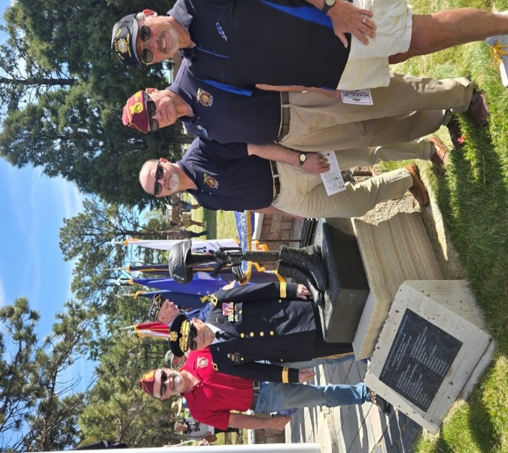

CHAPTER ACTION PLAN (CAP)

Strategic Goal (SG) Current | Initiative
SG1 Outreach – Consistent impactful outreach programs and activities. | Contact any Staff member if you have any suggestions on meeting SG-1.
SG2 Strategic Partnerships - | Engage with other veteran organizations to establish strategic partnerships. Contact Steve Shambach with any suggestions on meeting SG-2. In Progress.
SG3 Maximize Visibility | Chapter committed to participate in Monument Hill Kiwanis 4th of July Parade. Contact Staff if you have any suggestions for how Chapter can meet this objective.
SG4 Annually grow engaged and sustainable MOWW membership. | Chapter recruiting goal for OY25-26 is six Companions. Please contact Mark Ellis if you have any prospective candidates.
SG5 Obtain financial resources to fulfill Order’s mission. | Regular solicitation of donations from Chapter Companions. Contact Mike Berendt if you have any questions concerning donations or other opportunities for Chapter fundraiser.
SG6 Increase number of chapters and strengthen existing chapters. | Contact anyone on Staff if you would like to volunteer your skills or suggestions for meeting this SG (i.e., strengthen recruiting, Chapter social media presence, Chapter branding, etc.
JUNE MEMBERSHIP MEETING CANCELLED
We will not be having a membership meeting in June because of the effort required to put on the RMYLC. Our next meeting with be on Thursday, 30th of July, 1700-1915 at the Patty Jewett Golf Course. Our guest speaker will be Companion Bill Hybl presenting how the El Pomar Foundation supports our military.
Reservations required. RSVP to LTC Berendt, berendt478@aol.com, (410) 908-6777 NLT 27 July 2026.

JUNE COMPANION BIRTHDAYSs
Lt Col Kirk Brown, Lt Col Jo Carroll, LTC Chad Henderson, LTC James Liedle, CPT Daniel Monroe, Lt Kaleb Neal, Lt Col Richard Peters, MAJ Dean Rizzo, Mr. Walter Roy, Lt Col Ulysses Swift

JULY COMPANION BIRTHDAYS
Lt Col Douglas Brower, CWO4 John Cashman, LTC Iona Connolly, Ms. Eunice Hill, MAJ William Hybl, Jr., Maj Donald Johnson, CAPT John McGrath, Mrs. Sandra Russell, Ph. D., Col Frank Seaman, Col Robert Sommers, Lt Col Edward Tomlinson, COL Barrie Town, Lt Col Jon Wisham, Sr.,

PREAMBLE
To cherish the memories and associations of the World Wars waged for humanity;
To inculcate and stimulate love of our Country and the Flag;
To promote and further patriotic education in our Nation;
Ever to maintain law and order, and to defend the honor, integrity, and supremacy of our National Government and the Constitution of the United States;
To foster fraternal relations among all branches of the Armed Forces;
To promote the cultivation of Military, Naval and Air Science and the adoption of a consistent and suitable policy of National Security for the United States of America;
To acquire and preserve records of individual services;
To encourage and assist in the holding of commemorations and the establishment of Memorials of the World Wars;
And to transmit all these ideals to posterity, under God and for our Country, we unite to establish The Military Order of the World Wars.

Link to MOWW Preamble
Chapter Website: www.cos_moww.org
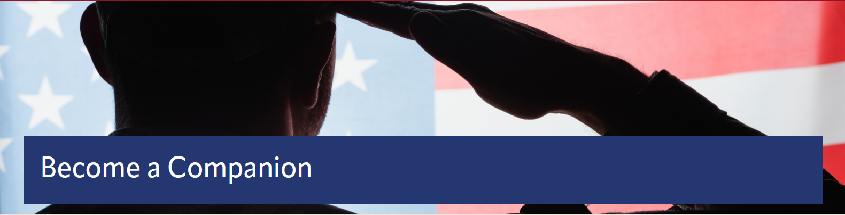
MOWW Membership Application
Please use this link to submit an electronic application: https://moww.org/become-a-companion/. Please see Staff for paper membership application or this link to print your own application: https://moww.org/wp-content/uploads/2022/10/MembershipApplication-MOWW-1.pdf

POINTS OF CONTACT

MOWW Chapter 151
Colorado Springs, CO
Commander
Stephen A. Shambach (COL, USA, Ret)
15270 Churchill Place
Colorado Springs, CO 80921
(719) 447-5505
shambachsm@msn.com

Senior Vice Commander
Mark A. Ellis (COL, USAR, RET)
5555 Chukar Trail
Colorado Springs, CO 80918
(402) 709-3373
Mae77@icloud.com

Junior Vice Commander
Ulysses Swift (Lt Col, USAF, Ret)
2585 Deliverance Drive
Colorado Springs, CO 80921
(719) 548-0865
swift888@comcast.net

Adjutant
Kirk Brown (Lt Col, USAF, Ret)
2539 Craycroft Drive
Colorado Springs, CO 80920-1423
(719) 500-9168
ltckirkbrown@juno.com

Treasurer
Mike Berendt (LTC, USA, Ret)
1230 Bowstring Rd.
Monument, CO 80132
(401) 908-6777
berendt478@aol.com

Patriotic Education Committee Chair
Stephen A. Shambach (COL, USA, Ret)
15270 Churchill Place
Colorado Springs, CO 80921
(719) 447-5505
shambachsm@msn.com

Homeland Security Committee Chair
(Vacant)

Public Safety and Law & Order Committee Chair
(Vacant)

ROTC and JROTC Committee Co-Chairs

Mike Berendt (LTC, USA, Ret)
Ulysses Swift (Lt Col, USAF, Ret)

Scouting Committee Chair
Kerm Neal (Col, USAF, Ret)
13303 Honey Run Way
Colorado Springs, CO 80921
(719) 205-1106
knealsfour@yahoo.com

National Security Committee Chair
(Vacant)

Veterans Affairs Committee Chair
(Vacant)

Surgeon General
Tisha K. Ellis (MAJ, USAR)
5555 Chukar Trail
Colorado Springs, CO 80918
(402) 541-2230
Kim40@icloud.com
Judge Advocate General
Mark A. Ellis (COL, USAR, Ret)
5555 Chukar Trail
Colorado Springs, CO 80918
(402) 709-3373
mae77@icloud.com

Rocky Mountains Department Commander
(Vacant)

Region XIII Commander
(Vacant )

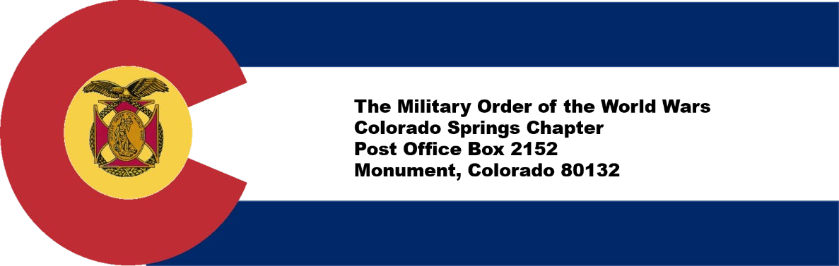

​
CONTRIBUTION OR PLEDGE
Yes, I am making a tax-deductible contribution or pledge to the Colorado Springs Chapter of the Military Order of the World Wars.
I wish to contribute or pledge $__________to the Patriotic Education Fund.
I wish to contribute or pledge $__________to the ROTC Fund.
I wish to contribute or pledge $__________to the Boy and Girl Scout Fund.
I wish to contribute or pledge $__________to the Law & Order Fund.
I wish to contribute or pledge $__________to the Operations Fund (postage, bulletin, directory, recognition programs – plaques, medals, etc.)
_______________________________________
Name
Please make checks payable to Colorado Springs Chapter, MOWW. Send to:
LTC Mike Berendt (USA, Ret), 1230 Bowstring Road, Monument, CO 80132

