**COMMANDER’S REMARKS (9 MARCH 2023)**

We will have a regular face-to-face General Membership Meeting on Saturday, 22 April 2023, starting at 11:30 A.M. The meeting will be held at Las Brisas Restaurant, 6787 S. Clinton Street, Greenwood Village, CO. We will be meeting in a different room this time so that the speaker can use a computer and projector. We will be using the large separate room outside the main dining area.

To get there (Las Brisas Restaurant), if you are coming from east of I25, drive west on Arapahoe Road to South Clinton Street (about a block before you get to I25) and take a left turn. Do not turn on Clinton Court as the next street is South Clinton Street. The restaurant is located on the east side of the Target Store parking lot. If you are coming from west of I25, drive east on Arapahoe Road until you pass under I25. The first street on the right is South Clinton Street. Turn right and you will see the restaurant on the east side of the Target Store parking lot. If you get lost, you can call me at 303-981-5519 (cell) and I will try to get you un-lost.

Coy D. Ritchie, D.M.

LCDR, USN (Ret)

Denver Chapter Commander

It is nobler to serve than to be served



**STAFF MEETING (9 MARCH 2023)**

This meeting was conducted at Frances Long’s home and was called to order by Commander Coy Ritchie at 1103 hours. Also attending were LT Evan Totten, HPM Pat Ritchie, HPM Francis Long, and HPM Stephanie Ritchie. The invocation was offered by LT Totten followed by the Pledge of Allegiance led by LCDR Ritchie.

Minutes The minutes of the meeting on 9 February 2023 were approved on a motion by LT Totten and seconded by HPM Stephanie Ritchie.

Treasurer’s Report The Treasurer’s Report as of 28 February was submitted by LCDR Ritchie. The month ended with a U.S. Bank fund balance of $6.772.47 and ENT Credit Union fund balance of $8,880.38. The Treasurer’s Report was approved on a motion by Evan Totten and seconded by HPM Stephanie Ritchie.

Scouts LT Totten reported that supplies have been ordered and names for recognition are coming in.

ROTC/JROTC LT Totten reported that ROTC and JROTC updates are coming in and medals, presentation folders, and certificates have been ordered.

Patriotic Education The YLC will be held in Pueblo on the CSU campus on 12-16 June 2023. All the high schools in the greater Denver area have been contacted for applications to the YLC. LCDR Ritchie will send a check for $750.00 as our chapter’s support for the YLC this year.

Public Safety and Law and Order Nothing new to report.

Region XIII and Department of the Rocky Mountains On 14 April there will be a Region XIII Conference in Tucson conducted by Zoom. A second Conference is scheduled for 15-17 June in Phoenix and will also be conducted utilizing Zoom.

Membership LCDR Ritchie reported that a possible new member has indicated he will attend our next general membership luncheon.

Hospitality Our next general membership luncheon will be held on 22 April 2023 at Las Brisas Restaurant with the social period at 11:30 and lunch at 12:00.

Program/Speaker LT Totten will be our speaker on 22 April. He will be speaking about his military experiences during the Viet Nam War.

New Business LT Totten has been selected as a member of the Committee for Renaming MOWW. Their first meeting has already occurred. This will be a year-long study before they make any recommendations.

Next Staff Meeting Thursday, 6 April 2023 starting at 1100 hours at the home of HPM Frances Long.

Benediction Offered by LT Totten.

Adjournment LCDR Ritchie adjourned the meeting at 1211 hours.



**COMING EVENTS (April & Later)**

* **STAFF MEETING (6 April 2023)**
  + (Thursday), 11:00 A.M.
  + Location: Frances Long’s Home
* **MOWW NATIONAL CONVENTION**

**(1-6 August 2023)**

* + Location: Annapolis, MD
* **MEMBERSHIP LUNCHEON**

**(22 April 2023)**

* + (Saturday), time 11:30 A.M.
  + Location: Las Brisas Restaurant, 6787 S. Clinton Street, Greenwood Village, CO.
  + Menu: Order from the menu.
  + Program: LT Evan Totten with a presentation on his experiences during the Viet Nam War.



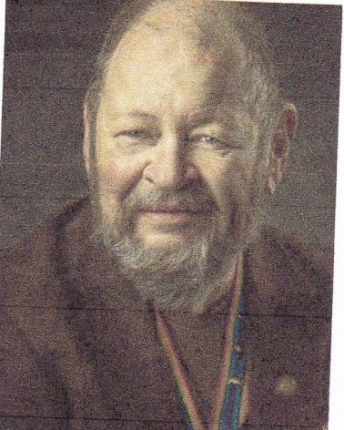

**Bob**

THE CAPTAIN HAS TURNED OFF THE SEATBELT LIGHT. YOU ARE FREE TO MOVE ABOUT THE CABIN.

CPT Robert E. Mallin, MD, USA (Fmr)

Surgeon General, MOWW

Pulmonary Embolism (PE) once seemed an exotic disease. As my personal experiences demonstrated, twice, it can be all too common. Healthy people can get PE. The condition results from blood clots moving to a main or branch artery in the lungs, thus stopping its functions. Clots often originate in a leg’s deep veins, and more than one embolus at a time is typical. If the vessels blocked are in critical places, one can die; otherwise, it is treatable. Large blockages can be untreatable and fatal. Symptoms include sudden shortness of breath, chest pain that gets worse but does not get better when one rests, and coughing, perhaps with blood in the sputum. Other symptoms may be wheezing, legs swelling (usually in the one with the deep vein disease), clammy or bluish coloring, rapid or irregular heartbeat and possibly fainting. Rapid treatment with anticoagulants, in the hospital, can be lifesaving. Symptoms vary with the amount of lung blood vessels involved, or with a history of lung and/or heart disease. Regardless, immediately see a doctor. I, foolishly, drove from the Albuquerque airport to my Santa Fe doctor, the first time. I should have immediately gone to the University Hospital in Albuquerque. Emergency Department treatment includes chest x-rays, lung scans, CAT scans, ultrasound to one’s leg veins to find clots, etc. Risk factors include prolonged immobility, e.g., long-term bed rest, long journeys with legs cramped, old age, medical problems, heart disease, cancer, pregnancy and dehydration. Family history can also play a part. Having surgery—especially hip or knee joint replacement—may allow embolic tissue to enter the bloodstream. Surgical risk increases with the length

of anesthesia. Smoking also increases risk, as does being overweight and taking some female replacement medications. So stop! What should I do? Immediately seek help. Minutes count! Once in the hospital, you will receive an injectable anticoagulant until an oral medication is used (the later often for six months or more). Fortunately, once blood thinner prevents clots from expanding, the clots generally resolve by themselves. Physically removing clots, e.g., inserting vein filters and surgery are generally reserved for use in extremely serious conditions and have complications of their own. In the hospital, pressure stockings, physical motion devices or just individual moving around helps. The IV pole pushers in the halls with their bottoms hanging out are saving their lives after surgery. In short, walk every day for exercise. While traveling via airlines, walk as much as you can (even on an aircraft). When driving, stop and walk every hour. Keep hydrated (without coffee and alcohol) while traveling. Wear support stockings (previously called “orthopedic stockings”) to help the legs move the blood. Lose weight. Be proactive!

*MOWW OFFICER REVIEW APRIL 2013 p21*

*The Military Order of the World Wars*

*CPT (Dr.) Robert E. Mallin, USA (Former) is a graduate of Adelphi University and New York Medical College. He is certified with the American Board of Plastic and Reconstructive Surgery and is a Fellow of the American College of Surgeons. In private practice from 1975-94, he was the Alaskan State Physician of the Year. While in the U.S. Army (1966-1968) he earned a Bronze Star, Purple Heart and Air Medal, and a Combat Medical Badge, among other decorations.*



**PREVIOUS MEMBERSHIP MEETING**

**(18 FEB 2023)**

LCDR Ritchie shared with the Chapter Companions his experiences in 1957 supporting the Formosan military forces in retaking the islands of Quemoy and Matsu from mainland China and later in patrolling in the China Sea berween Formosa and mainland China to prevent further hostilities. He also related his experience when entering the harbor in Guam at night and explained the facts behind the nautical rule “*Red right returning*.”

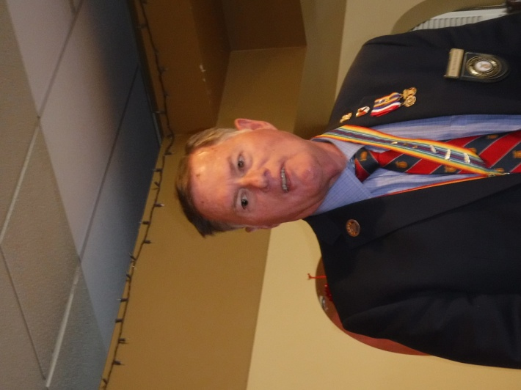

**Region XIII Commander, LTC Patrick Stolze, USA (Ret), visited the Denver Chapter during their General Membership Luncheon on 18 February 2023 and briefed them on current and future planned activities in Region XIII.**





**THE PREAMBLE**

To cherish the memories and associations of the World Wars waged for humanity;

To inculcate and stimulate love of our country and flag;

To promote and further patriotic education in our nation;

Ever to maintain law and order, and defend the honor, integrity, and supremacy of our national government and the Constitution of the United States;

To foster fraternal relations among all branches of the armed forces;

To promote the cultivation of military, naval, and air science and the adoption of a consistent and suitable policy of national security for the United States of America;

To acquire and preserve records of individual services;

To encourage and assist in the holding of commemorations and the establishment of memorials of the World Wars; and

To transmit all these ideals to posterity; under God and for our country, we unite to establish**…**

**The Military Order of the World Wars**



**THE CINC SOLICITATION**

The Commander in Chief is appealing to you to donate generously to the CINC Solicitation by making a *donation* in support of our Order’s patriotic and educational activities. He also asks that you encourage other Companions in your chapter to do so too. Our CINC Solicitation goal helps pay for activities such as:

* Supporting chapters via essential services (e.g., YLC insurance) and merchandise (i.e., products of all types)
* Existing awards, e.g., ROTC/JROTC Awards of merit, GSUSA Gold Award, and BSA Eagle Scout Certificates
* New awards, e.g., Outreach Service Medal and BSA Sea Scout, Quartermaster and Venture Scout Certificates
* Service Academy awards and military college awards
* Medals & certificates to ROTC/JROTC cadets & BSA & GSA scouts not supported by chapters
* Promotional material and program brochures for existing and start-up chapters
* The *Officer Review* magazine, which is MOWW’s only way to communicate with all Companions
* YLC Support via additional YLC issues of the *Officer Review* that YLC Directors use for advertising & recruiting
* The MOWW website at [www.moww.org](http://www.moww.org), which the Order’s Companions use in support of every activity area
* MOWW Convention Support, including the Distinguished Service and National Commander Award programs

It is very easy to contribute, just open up the Order’s web page and at the very top next to the logo is the DONATE tab. You can also mail in your contribution when you receive the solicitation in the mail from MOWW HQ.

Your donation supports patriotic activities only MOWW provides. *Please donate today!*



**MEMBERSHIP APPLICATIONS**

Applications may be obtained by contacting the Chair of the Membership Committee at 303-981-5519 or [coyritchie@aol.com](mailto:coyritchie@aol.com).

It is nobler to serve than to be served

**POINTS OF CONTACT**

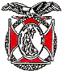

**MOWW Denver Chapter (093), CO**

c/o Coy D. Ritchie

4198 S. Kirk Court

Aurora, CO 80013-6022

[www.mowwscv.com/publications](http://www.mowwscv.com/publications)

**Commander and Treasurer**

LCDR Coy Ritchie, USN (Ret)

4198 South Kirk Court

Aurora, CO 80013-6022

303-690-5118 (Res), 303-981-5519 (Cell)

[coyritchie@aol.com](mailto:coyritchie@aol.com)

**Adjutant**

HPM Frances Long

6278 S. Kearney Street

Centennial, CO 80111-4237

303-694-1079 (Res)

[grannyfrancene@netzero.net](mailto:grannyfrancene@netzero.net)

**Commander, Rocky Mountains Department**

COL Steven A. Shambach, USA (Ret)

[shambachsm@msn.com](mailto:shambachsm@msn.com)

**Commander, Region XIII**

LTC Patrick C. Stolze, USA (Ret)

[pstolze40@gmail.com](mailto:pstolze40@gmail.com)

**DENVER CHAPTER STAFF**

Denver Chapter Executive Board-Elected Officers

Commander: LCDR Coy Ritchie, USN (Ret) 303-981-5519

1st Vice Cdr: CPT Robert Mallin, USA (Fmr) 303-794-4790

2nd Vice Cdr: HPM Stephanie Ritchie 312-599-4708

Adjutant: HPM Frances Long 303-694-1079

Chaplain: LT Evan Totten, USNR (Fmr) 303-819-5729

Treasurer: LCDR Coy Ritchie, USN (Ret) 303-981-5519

Denver Chapter Staff: Committee Chairs

Membership: LCDR Coy Ritchie, USN (Ret) 303-981-5519

Newsletter Editor “ “

Public Relations: “ “

Finance & Budget: “ “

Rocky Mountain YLC: “ “

Patriotism: “ “

ROTC & JROTC: LT Evan Totten, USNR (Fmr) 303-819-5729

Scouting: “ “

Programs: CPT Robert Mallin, USA (Fmr) 303-794-4790

Law & Order: Col Ron Rakowsky, USAF (Ret) 303-770-7121

Hospitality: HPM J. Pat Ritchie 303-690-5118

Marshall: HPM Stephanie Ritchie 720-667-3783