**COMMANDER’S REMARKS (9 FEBRUARY 2023)**

We will have a regular face-to-face General Membership Meeting on Friday, 18 February 2023, starting at 11:30 A.M. The meeting will be held at Las Brisas Restaurant, 6787 S. Clinton Street, Greenwood Village, CO.

To get there (Las Brisas Restaurant), if you are coming from east of I25, drive west on Arapahoe Road to South Clinton Street (about a block before you get to I25) and take a left turn. Do not turn on Clinton Court as the next street is South Clinton Street. The restaurant is located on the east side of the Target Store parking lot. If you are coming from west of I25, drive east on Arapahoe Road until you pass under I25. The first street on the right is South Clinton Street. Turn right and you will see the restaurant on the east side of the Target Store parking lot. If you get lost, you can call me at 303-981-5519 (cell) and I will try to get you un-lost.

Our Region XIII Commander, LTC Patrick Stolze, USA (Ret), is scheduled to meet us at the luncheon on 18 February. I am asking every companion that is able to attend to be there and give him the appropriate greeting. I will see you all there.

Coy D. Ritchie, D.M.

LCDR, USN (Ret)

Denver Chapter Commander

It is nobler to serve than to be served



**CSTAFF MEETING (9 FEBRUARY 2023)**

This meeting was conducted at Frances Long’s home and was called to order by Commander Coy Ritchie at 1130 hours. Also attending were LT Evan Totten, HPM Pat Ritchie, HPM Francis Long, and HPM Stephanie Ritchie. The invocation was offered by LT Totten followed by the Pledge of Allegiance led by LCDR Ritchie.

Minutes The minutes of the meeting on 8 December 2022 were approved on a motion by LT Totten and seconded by HPM Stephanie Ritchie. There was no staff meeting in January 2023.

Treasurer’s Report No activity in the U.S. Bank account. As of 31 January 2023 the balance remains at $6,812.47. The ENT Credit Union Business Savings Acct. earned $.03 in interest and the Certificate of Deposit earned $7.72 in interest for a total balance of $8,880.38. The Treasurer’s Report was approved on a motion by Evan Totten and seconded by HPM Pat Ritchie.

Scouts LT Totten reported that the Boy Scouts will have an awards banquet this year in late March. The Girl Scouts will have two presentations this year, one in April and one in May.

ROTC/JROTC LT Totten reported that information has been sent to all schools with only 5 responding so far. Presentations will be in late April or May.

Patriotic Education The YLC will be held in Pueblo on the CSU campus on 12-16 June 2023.

Public Safety and Law and Order Nothing new to report.

Region XIII and Department of the Rocky Mountains Region XIII Commander, LTC Pat Stolze is scheduled to attend our luncheon on 18 February. On 14 April there will be a Region XIII Conference in Tucson and by Zoom. A second Conference is scheduled for 15-17 June in Phoenix.

Membership LCDR Ritchie reported we have recruited one new member this year. However we lost one member to death and one member did not renew so we still need to recruit two new members to meet our goal.

Hospitality HPM Ritchie reported we will have a general membership luncheon on 18 February.

Program/Speaker LCDR Coy Ritchie will be our speaker at the luncheon on 2/18/23. His topic will be “Red, Right, Returning”

New Business LT Totten now has Zoom set up for our regular staff meetings.

Next Staff Meeting Thursday, 10 March 2023 starting at 1100 hours at Frances Long’s home

Benediction Offered by LT Totten.

Adjournment LCDR Ritchie adjourned the meeting at 1225 hours.



**COMING EVENTS (February & Later)**

* **STAFF MEETING (9 March 2023)**
  + (Thursday), 11:00 A.M.
  + Location: Frances Long’s Home
* **MOWW NATIONAL CONVENTION**

**(1-6 August 2023)**

* + Location: Annapolis, MD
* **MEMBERSHIP LUNCHEON**

**(18 February 2023)**

* + (Saturday), time 11:30 A.M.
  + Location: Las Brisas Restaurant, 6787 S. Clinton Street, Greenwood Village, CO.
  + Menu: Order from the menu.
  + Program: LCDR Coy Ritchie with the presentation “Red, Right, Returning.”
  + Visit: District XIII Commander, LTC Pat Stolze is scheduled to visit us.



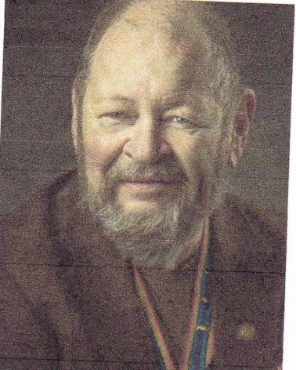

**Bob**

FACING REALITY: The End Game

CPT Robert E. Mallin, MD, USA (Fmr)

Surgeon General, MOWW

How to face reality and help your loved ones: You can, in advance plan for a spot in a national cemetery. Check the rules. Get your “permit” well in advance. Have several copies of your DD-214m draw up a will, and have a living will to express your wishes—before circumstances dictate them. Another wise move is deciding who will make decisions for you when you are unable to do so yourself. A medical directive or a more general power of attorney to a trusted person and provide guidance on likely decisions.

I remember in practice some family members saying, “Do all you can.” This may have salved their conscience but it did not take into consideration the patient’s feelings. Many burn patients opted to being “comfortable” while nature took its course, thus avoiding many painful and fruitless procedures. An earlier trip to the Emergency Room revealed they offered Living Will forms. Once you lose the old-fashioned idea that talking of such things brings them on, take advantage of advance planning. Make three copies of your will, etc. Keep one for your use. Give one copy to your doctor, and provide one to the “person who will make decisions.” In addition, a reduced copy of a living will can fit in your wallet. A good idea is also to do a review of your insurance policies.

Life insurance can be costly, especially, when your kids are grown and doing well. You may not still need such a financial burden. I find I can use the expensive premiums to enjoy myself. By the way, I ensure the kids have my will, which I review yearly. They do not need an insurance policy too! However, an Old Age Care Policy is a good option. The younger you are, the cheaper the premium. This policy can cover home care, hospice care, etc. I got mine at age 54. It gives a certain comfort to me and will to my family when the time comes. As hard as it is to discuss your thoughts with the family, you should think about it.

Perhaps you might make a video for that “last visit.” If you are facing the inevitable, keep control of things. You deciding about your burial wishes, music, pallbearers, etc., keeps you in control and is a real gift to the family. Many people opt for giving their treasured items to those in their will now, not later, so they can see them being enjoyed. I took a Kubler-Ross seminar once. She asked the question, “What things would you do if you had two hours to live?” After fielding the answers she said, “Why not do them now?” Why not, indeed? Never going to bed angry, telling people your feelings, etc., may be concepts I have picked up living in Santa Fe, but they are something you might consider. My father used to say, “Take advantage of time. The only thing you know for sure is the only thing for which you are never fully prepared.” Be well / Bob

*MOWW OFFICER REVIEW SEPTEMBER 2014 p22*

*The Military Order of the World Wars*

*CPT (Dr.) Robert E. Mallin, USA (Former) is a graduate of Adelphi University and New York Medical College. He is certified with the American Board of Plastic and Reconstructive Surgery and is a Fellow of the American College of Surgeons. In private practice from 1975-94, he was the Alaskan State Physician of the Year. While in the U.S. Army (1966-1968) he earned a Bronze Star, Purple Heart and Air Medal, and a Combat Medical Badge, among other decorations.*



**PREVIOUS MEMBERSHIP MEETING**

**(16 DEC 2022)**

Rabbi Rick Brody presented the Holiday Program which was a presentation on the origin and the meaning of Hanukkah or The Festival of Lights. Not being Jewish, I knew nothing about Hanukkah or its origin. Now we have a good knowledge of its origin and meaning because Rabbi Brody answered all our questions. Thank you Rabbi Brody.

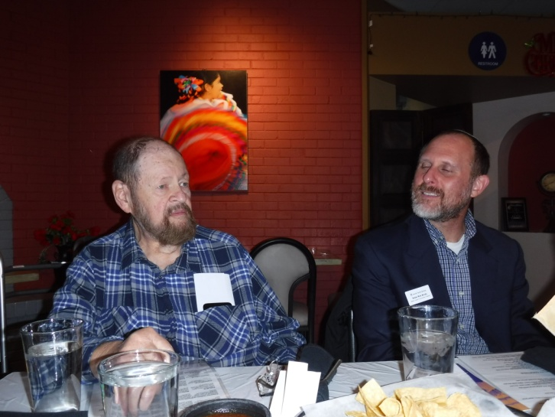

**In the photo above, CPT Bob Mallin, MD, USA (Fmr), on the left, introduces our Guest Speaker, Rabbi Rick Brody, on the right, at the luncheon on 16 Dec 2022.**



**THE PREAMBLE**

To cherish the memories and associations of the World Wars waged for humanity;

To inculcate and stimulate love of our country and flag;

To promote and further patriotic education in our nation;

Ever to maintain law and order, and defend the honor, integrity, and supremacy of our national government and the Constitution of the United States;

To foster fraternal relations among all branches of the armed forces;

To promote the cultivation of military, naval, and air science and the adoption of a consistent and suitable policy of national security for the United States of America;

To acquire and preserve records of individual services;

To encourage and assist in the holding of commemorations and the establishment of memorials of the World Wars; and

To transmit all these ideals to posterity; under God and for our country, we unite to establish**…**

**The Military Order of the World Wars**



**THE CINC SOLICITATION**

The Commander in Chief is appealing to you to donate generously to the CINC Solicitation by making a *donation* in support of our Order’s patriotic and educational activities. He also asks that you encourage other Companions in your chapter to do so too. Our CINC Solicitation goal helps pay for activities such as:

* Supporting chapters via essential services (e.g., YLC insurance) and merchandise (i.e., products of all types)
* Existing awards, e.g., ROTC/JROTC Awards of merit, GSUSA Gold Award, and BSA Eagle Scout Certificates
* New awards, e.g., Outreach Service Medal and BSA Sea Scout, Quartermaster and Venture Scout Certificates
* Service Academy awards and military college awards
* Medals & certificates to ROTC/JROTC cadets & BSA & GSA scouts not supported by chapters
* Promotional material and program brochures for existing and start-up chapters
* The *Officer Review* magazine, which is MOWW’s only way to communicate with all Companions
* YLC Support via additional YLC issues of the *Officer Review* that YLC Directors use for advertising & recruiting
* The MOWW website at [www.moww.org](http://www.moww.org), which the Order’s Companions use in support of every activity area
* MOWW Convention Support, including the Distinguished Service and National Commander Award programs

It is very easy to contribute, just open up the Order’s web page and at the very top next to the logo is the DONATE tab. You can also mail in your contribution when you receive the solicitation in the mail from MOWW HQ.

Your donation supports patriotic activities only MOWW provides. *Please donate today!*



**MEMBERSHIP APPLICATIONS**

Applications may be obtained by contacting the Chair of the Membership Committee at 303-981-5519 or [coyritchie@aol.com](mailto:coyritchie@aol.com).

It is nobler to serve than to be served

**POINTS OF CONTACT**



**MOWW Denver Chapter (093), CO**

C/o Coy D. Ritchie

4198 S. Kirk Court

Aurora, CO 80013-6022

[www.mowwscv.com/publications](http://www.mowwscv.com/publications)

**Commander and Treasurer**

LCDR Coy Ritchie, USN (Ret)

4198 South Kirk Court

Aurora, CO 80013-6022

303-690-5118 (Res), 303-981-5519 (Cell)

[coyritchie@aol.com](mailto:coyritchie@aol.com)

**Adjutant**

HPM Frances Long

6278 S. Kearney Street

Centennial, CO 80111-4237

303-694-1079 (Res)

[grannyfrancene@netzero.net](mailto:grannyfrancene@netzero.net)

**Commander, Rocky Mountains Department**

COL Steven A. Shambach, USA (Ret)

[shambachsm@msn.com](mailto:shambachsm@msn.com)

**Commander, Region XIII**

LTC Patrick C. Stolze, USA (Ret)

[pstolze40@gmail.com](mailto:pstolze40@gmail.com)

**DENVER CHAPTER STAFF**

Denver Chapter Executive Board-Elected Officers

Commander: LCDR Coy Ritchie, USN (Ret) 303-981-5519

1st Vice Cdr: CPT Robert Mallin, USA (Fmr) 303-794-4790

2nd Vice Cdr: HPM Stephanie Ritchie 312-599-4708

Adjutant: HPM Frances Long 303-694-1079

Chaplain: LT Evan Totten, USNR (Fmr) 303-819-5729

Treasurer: LCDR Coy Ritchie, USN (Ret) 303-981-5519

Denver Chapter Staff: Committee Chairs

Membership: LCDR Coy Ritchie, USN (Ret) 303-981-5519

Newsletter Editor “ “

Public Relations: “ “

Finance & Budget: “ “

Rocky Mountain YLC: “ “

Patriotism: “ “

ROTC & JROTC: LT Evan Totten, USNR (Fmr) 303-819-5729

Scouting: “ “

Programs: CPT Robert Mallin, USA (Fmr) 303-794-4790

Law & Order: Col Ron Rakowsky, USAF (Ret) 303-770-7121

Hospitality: HPM J. Pat Ritchie 303-690-5118

Marshall: HPM **Stephanie** Ritchie 312-599-4708