**COMMANDER’S REMARKS (11 MAY 2023)**

We will have a regular face-to-face General Membership Meeting on Saturday, 24 June 2023, starting at 11:30 A.M. The meeting will be held at Las Brisas Restaurant, 6787 S. Clinton Street, Greenwood Village, CO.

To get there (Las Brisas Restaurant), if you are coming from east of I25, drive west on Arapahoe Road to South Clinton Street (about a block before you get to I25) and take a left turn. Do not turn on Clinton Court as the next street is South Clinton Street. The restaurant is located on the east side of the Target Store parking lot. If you are coming from west of I25, drive east on Arapahoe Road until you pass under I25. The first street on the right is South Clinton Street. Turn right and you will see the restaurant on the east side of the Target Store parking lot. If you get lost, you can call me at 303-981-5519 (cell) and I will try to get you un-lost.

Our 2022 Operating Year ends officially on 30 June 2023. At that time, we may install new Chapter officers. We will have an election at our meeting on 24 June for new officers. The positions available are Commander, 1st Vice Commander, 2nd Vice Commander, Adjutant and Treasurer. The Nominating Committee has selected a list of Companions that have agreed to serve in these positions. They are Commander-LCDR Coy Ritchie, 1st Vice Commander-CPT Bob Mallin, 2nd Vice Commander-HPM Stephanie Ritchie, Adjutant-HPM Frances Long, and Treasurer-LCDR Coy Ritchie. Additional nominations will be accepted from the floor prior to the election. The elected officers will be installed after the election.

Coy D. Ritchie, D.M.

LCDR, USN (Ret)

Denver Chapter Commander

It is nobler to serve than to be served



**STAFF MEETING (11 MAY 2023)**

This meeting was conducted at Frances Long’s home and was called to order by Commander Coy Ritchie at 1108 hours. Also attending were LT Evan Totten, HPM Pat Ritchie and HPM Francis Long. Attending by Zoom were CPT Bob Mallin, MD and HPM Stephanie Ritchie. The invocation was offered by LT Totten followed by the Pledge of Allegiance led by LCDR Ritchie.

Minutes The minutes of the meeting on 6 April 2023 were approved on a motion by LT Totten and seconded by HPM Long.

Treasurer’s Report The Treasurer’s Report as of 30 April 2023 was submitted by LCDR Ritchie. The month ended with a U.S. Bank fund balance of $4,473.18 and ENT Credit Union fund balance of $8,887.96. The Treasurer’s Report was approved on a motion by HPM Frances Long and seconded by LT Totten.

Scouts LT Totten reported that presentation of 160 Eagle Awards was made by the Districts. There were 40 Gold Awards made to Girl Scouts by their leadership.

ROTC/JROTC LT Totten reported that 18 presentations were made (including 5 Universities) and are now done. Space Force Awards were made for the first time.

Patriotic Education LCDR Ritchie reported that the Rocky Mountain Youth Leadership Conference will be conducted during 12-16 June at CSU Pueblo.

Public Safety and Law and Order A person from Homeland Security will be the speaker at the luncheon on 24 June 2023.

Region XIII and Department of the Rocky Mountains On 13 June there will be a Region XIII Conference in Phoenix conducted by Zoom.

Membership Nothing new to report.

Hospitality Our next general membership luncheon will be held on 24 June 2023 at Las Brisas Restaurant with the social period at 11:30 and lunch at 12:00.

Program/Speaker A representative from the Department of Homeland Security will be our speaker on 24 June 2023.

Old Business LT Totten reminded us to submit reports to National prior to 1 June 2023. There will be an election and installation of officers at the General Membership Luncheon on 24 June. The present Officers have agreed to serve another term.

New Business There will be another Naming Committee meeting in June.

Next Staff Meeting Thursday, 8 June 2023, starting at 1100 hours at the home of HPM Frances Long.

Benediction Offered by LT Totten.

Adjournment LCDR Ritchie adjourned the meeting at 1204 hours.



**COMING EVENTS (April & Later)**

* **STAFF MEETING (8 June 2023)**
  + (Thursday), 11:00 A.M.
  + Location: Frances Long’s Home
* **MOWW NATIONAL CONVENTION**

**(1-6 August 2023)**

* + Location: Annapolis, MD
* **MEMBERSHIP LUNCHEON**

**(24 June 2023)**

* + (Saturday), time 11:30 A.M.
  + Location: Las Brisas Restaurant, 6787 S. Clinton Street, Greenwood Village, CO.
  + Menu: Order from the menu.
  + Program: A representative from the Department of Homeland Security.



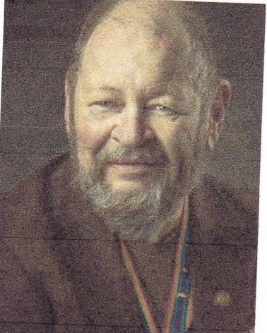

**Bob**

TAKE MY BLOOD PRESSURE, PLEASE!

CPT Robert E. Mallin, MD, USA (Fmr)

Surgeon General, MOWW

After having one of my frequent and periodic, specialty Doctor’s visits, it occurred to me that many never take my blood pressure. Instead, they just asked my weight and height. I have, it seems, many doctors: kidney, back, knees, feet, rehab, a dentist, a hematologist, and oncologist, lab experts, a cardiologist and even a “hospitalist.” …I’ve also seen an ER doctor, a radiologist, a vein doctor and anesthetist, as well as pharmacists, nurses and technicians. Since my 2016 move to Colorado, I have also met numerous receptionists, paperwork specialists and my “Primary Care Physician.” Some routinely take my blood pressure, some take my oxygen level and temperature, but none have examined me!!

When I was in medical school, I was taught to take a 20-page history of everything and do clothes off, head-to-toe examination. As a student, it took a long time. Shortening the procedure to my specialty eliminated such things as hearing, teeth and knee reflexes. In getting the “complete patient picture”, should one take short cuts? No. Admittedly, much of a patient’s history is in a database. Unfortunately, since insurance companies usually allow only about 15 minutes per visit, we have to do the best we can with various levels of assistants. All offices have extensive paperwork, many only related to getting their bills paid. The detailed history relating to past conditions may be filled out, but I can seldom remember them or their electronic versions being referred to in the doctor’s “warm-up chat.” They should be. To be my own best patient care advocate, I make up a sheet with my medications and conditions listed, as well as special weekly Bp numbers, any stents, artificial joints and more. I make sure the technician assistant—not always a nurse—puts them on the clipboard…or the mouse that she hands to the doctor. Once the doctor arrives, I mention pertinent things such as,”I am being anti-coagulated” or “I am not diabetic,” etc., so the doctor better understands my general and specific conditions, and the resulting interrelationships. In that regard, I have asked various practitioners, “Who is in charge of my overall care?” In response, I sometimes get blank stares; everyone assumes it is the primary care physician. However, she is often the least likely to keep up on the numerous specialists a person sees in the pursuit of treatment. I question if he/she ever consults with the other guys to ask questions or get detailed explanations of things relating to my care.

My primary care doctor is OK, and she refills my prescriptions from other doctors—many still from New Mexico from where I have moved. She never questions them or wonders if they are still the latest and best way to handle problems, unless I do. Because I am a doctor, I usually know what question to ask—and I politely insist on answers. I know smart people who take another person with them to get things very clear—especially if the person being seen is older. However, some say people prepare better for a vacation or retirement than a doctor’s visit involving their life and death. All of this reminds me that my father was a wise man. He always said, “If you don’t take care of yourself and your loved ones, no one else will.” Take ownership of your health and well-being. That means being informed on your own situations—to include being informed on whatever affects you. Getting answers from medical people and asking, “Aren’t you even going to examine me,” puts you in charge—and that’s the way it should be. Be well.

*MOWW OFFICER REVIEW*

*The Military Order of the World Wars*

*CPT (Dr.) Robert E. Mallin, USA (Former) is a graduate of Adelphi University and New York Medical College. He is certified with the American Board of Plastic and Reconstructive Surgery and is a Fellow of the American College of Surgeons. In private practice from 1975-94, he was the Alaskan State Physician of the Year. While in the U.S. Army (1966-1968) he earned a Bronze Star, Purple Heart and Air Medal, and a Combat Medical Badge, among other decorations.*



**PREVIOUS MEMBERSHIP MEETING**

**(18 FEB 2023)**

LCDR Ritchie shared with the Chapter Companions his experiences in 1957 supporting the Formosan military forces in retaking the islands of Quemoy and Matsu from mainland China and later in patrolling in the China Sea berween Formosa and mainland China to prevent further hostilities. He also related his experience when entering the harbor in Guam at night and explained the facts behind the nautical rule “*Red right returning*.”





**THE PREAMBLE**

To cherish the memories and associations of the World Wars waged for humanity;

To inculcate and stimulate love of our country and flag;

To promote and further patriotic education in our nation;

Ever to maintain law and order, and defend the honor, integrity, and supremacy of our national government and the Constitution of the United States;

To foster fraternal relations among all branches of the armed forces;

To promote the cultivation of military, naval, and air science and the adoption of a consistent and suitable policy of national security for the United States of America;

To acquire and preserve records of individual services;

To encourage and assist in the holding of commemorations and the establishment of memorials of the World Wars; and

To transmit all these ideals to posterity; under God and for our country, we unite to establish**…**

**The Military Order of the World Wars**



**THE CINC SOLICITATION**

The Commander in Chief is appealing to you to donate generously to the CINC Solicitation by making a *donation* in support of our Order’s patriotic and educational activities. He also asks that you encourage other Companions in your chapter to do so too. Our CINC Solicitation goal helps pay for activities such as:

* Supporting chapters via essential services (e.g., YLC insurance) and merchandise (i.e., products of all types)
* Existing awards, e.g., ROTC/JROTC Awards of merit, GSUSA Gold Award, and BSA Eagle Scout Certificates
* New awards, e.g., Outreach Service Medal and BSA Sea Scout, Quartermaster and Venture Scout Certificates
* Service Academy awards and military college awards
* Medals & certificates to ROTC/JROTC cadets & BSA & GSA scouts not supported by chapters
* Promotional material and program brochures for existing and start-up chapters
* The *Officer Review* magazine, which is MOWW’s only way to communicate with all Companions
* YLC Support via additional YLC issues of the *Officer Review* that YLC Directors use for advertising & recruiting
* The MOWW website at [www.moww.org](http://www.moww.org), which the Order’s Companions use in support of every activity area
* MOWW Convention Support, including the Distinguished Service and National Commander Award programs

It is very easy to contribute, just open up the Order’s web page and at the very top next to the logo is the DONATE tab. You can also mail in your contribution when you receive the solicitation in the mail from MOWW HQ.

Your donation supports patriotic activities only MOWW provides. *Please donate today!*



**MEMBERSHIP APPLICATIONS**

Applications may be obtained by contacting the Chair of the Membership Committee at 303-981-5519 or [coyritchie@aol.com](mailto:coyritchie@aol.com).

It is nobler to serve than to be served

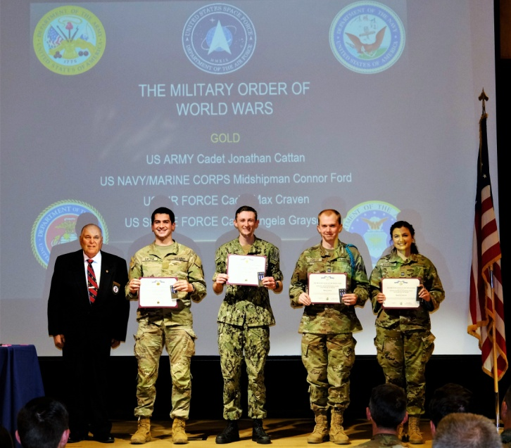

**LT Evan Totten, USNR (Fmr) presents MOWW Gold ROTC Medals to four seniors at the University of Colorado Boulder at their honors ceremony on 24 April 2023. (L to R) LT Evan Totten, Jonathan Cattan, Connor Ford, Max Craven, Angela Grayson.**



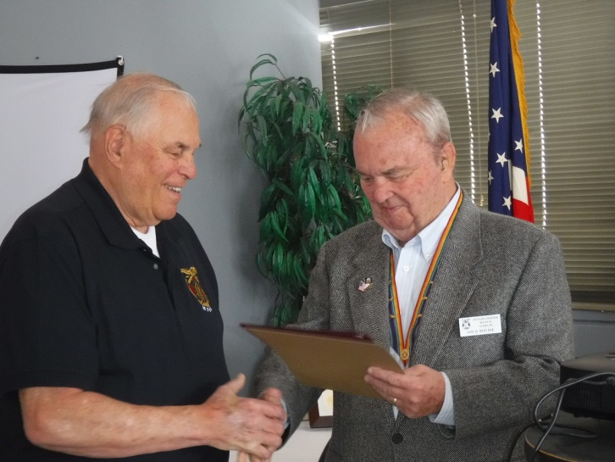

**LT Evan Totten, USNR (Fmr) on the left is presented a National Citation for his outstanding performance as Chair of the ROTC Committee for the Denver Chapter. The award was presented by Denver Chapter Commander, LCDR Coy Ritchie, USN (Ret).**



**POINTS OF CONTACT**



**MOWW Denver Chapter (093), CO**

C/o Coy D. Ritchie

4198 S. Kirk Court

Aurora, CO 80013-6022

[www.mowwscv.com/publications](http://www.mowwscv.com/publications)

**Commander and Treasurer**

LCDR Coy Ritchie, USN (Ret)

4198 South Kirk Court

Aurora, CO 80013-6022

303-690-5118 (Res), 303-981-5519 (Cell)

[coyritchie@aol.com](mailto:coyritchie@aol.com)

**Adjutant**

HPM Frances Long

6278 S. Kearney Street

Centennial, CO 80111-4237

303-694-1079 (Res)

[grannyfrancene@netzero.net](mailto:grannyfrancene@netzero.net)

**Commander, Rocky Mountains Department**

COL Steven A. Shambach, USA (Ret)

[shambachsm@msn.com](mailto:shambachsm@msn.com)

**Commander, Region XIII**

LTC Patrick C. Stolze, USA (Ret)

[pstolze40@gmail.com](mailto:pstolze40@gmail.com)



**DENVER CHAPTER STAFF**

Denver Chapter Executive Board-Elected Officers

Commander: LCDR Coy Ritchie, USN (Ret) 303-981-5519

1st Vice Cdr: CPT Robert Mallin, USA (Fmr) 303-794-4790

2nd Vice Cdr: HPM Stephanie Ritchie 720-657-3783

Adjutant: HPM Frances Long 303-694-1079

Chaplain: LT Evan Totten, USNR (Fmr) 303-819-5729

Treasurer: LCDR Coy Ritchie, USN (Ret) 303-981-5519

Denver Chapter Staff: Committee Chairs

Membership: LCDR Coy Ritchie, USN (Ret) 303-981-5519

Newsletter Editor “ “

Public Relations: “ “

Finance & Budget: “ “

Rocky Mountain YLC: “ “

Patriotism: “ “

ROTC & JROTC: LT Evan Totten, USNR (Fmr) 303-819-5729

Scouting: “ “

Programs: CPT Robert Mallin, USA (Fmr) 303-794-4790

Law & Order: Col Ron Rakowsky, USAF (Ret) 303-770-7121

Hospitality: HPM J. Pat Ritchie 303-690-5118

Marshall: HPM Stephanie Ritchie 720-657-3783