**COMMANDER’S REMARKS (6 February 2025)**

We will have our next General Membership Meeting on Saturday, 15 February 2025, starting at 11:30 A.M. Our usual meeting place, Las Brisas Restaurant is going out of business on 8 February 2025. Therefore, we had to find a new venue. The meeting on 15 February will be held at The Black-eyed Pea Restaurant, 5180 S. Broadway, Englewood, CO 80113. It is located near the corner of Broadway and Belview next to Starbucks. This is the same location where MHMOA held their luncheon meetings. The featured speaker will be Pastor John Altland, Major, USA (Ret) who served as an Intelligence Officer during his Army service. His topic will be “Intelligence is the Foundation for Law Enforcement.”

To get there (The Black-Eyed Pea Restaurant), if you are coming from I25, drive west on Belview to Broadway take a left turn on Broadway, then turn left at the first break in the center divider and you will be there. If you are coming from west of Broadway, drive east on Belview until you come to Broadway, take a right turn, then turn left at the first break in the center divider and you will be there. If you get lost, you can call me at 303-981-5519 (cell) and I will try to get you un-lost.

I am looking forward to seeing all of you at our luncheon on Saturday, 15 February 2025.

Coy D. Ritchie, D.M.

LCDR, USN (Ret)

It is nobler to serve than to be served

______________________________________________________________________________________________________________________

**STAFF MEETING (6 February 2025)**

This meeting was conducted at Frances Long’s home and was called to order by Chapter Commander Coy Ritchie at 1102 hours. Also attending were HPM Stephanie Ritchie, HPM Pat Ritchie, and HPM Francis Long. Capt Dennis Orr attended by telephone. The invocation was offered by HPM Frances Long followed by the Pledge of Allegiance.

Minutes: The minutes of the staff meeting on 9 January 2025 were approved on a motion by Capt Dennis Orr and seconded by HPM Pat Ritchie.

Treasurer’s Report: Treasurer’s Report as of 31 January 2025 was submitted by LCDR Ritchie. The U.S. Bank checking account remained at $2,673.62. The Business Savings Account at the ENT Credit Union account earned 3 cents interest for a balance of $132.84. The 16-Month Certificate earned $98.38 in interest for a new balance of $9,249.27. The Treasurer’s Report was approved on a motion by Capt Dennis Orr and seconded by HPM Stephanie Ritchie.

Then in a separate report, LCDR Ritchie reported that as previously approved, on 2/5/2025, he transferred $1,286.55 from the 16-Month Certificate at the ENT Credit Union and deposited it in the checking account at the U.S. Bank. This changed the total in the checking account to $3,960.17. The remaining $8,000 in the ENT Certificate account was used to purchase a 5-Month Certificate of Deposit at a much better earning rate than the 16-Month Certificate.

The Board then approved reimbursing LCDR Ritchie $1,519.95 for the expense of ordering medals and awards for Scouts and ROTC/JROTC,

leaving $2,440.22 in the U.S. Bank checking account. Motion to approve this action by Capt Dennis Orr with a second by HPM Stephanie Ritchie.

Scouts: The Gold Award and Eagle Award Certificate have been ordered and received.

ROTC/JROTC: Responses from the high schools and universities are coming in. Medals and Certificates have been ordered and received.

Patriotic Education: RMYLC is scheduled for 16-20 June 2025. Some nominations of students in the Denver Metro area have already been received.

Public Safety and Law and Order: Capt Dennis Orr has arranged for Major John Atland, USA (Ret) to be our speaker on 15 February 2025.

Region XIII and Dept. of the Rocky Mountains: On 19 February 2025, there will be a Region XIII meeting conducted by Zoom to elect a new Region XIII Commander. Coy Ritchie will attend.

Membership: Several non-members have been invited to attend the General Membership Meeting on 15 February 2025.

Program/Speaker: Capt Dennis Orr has arranged a speaker on Homeland Security for the membership meeting on 15 February 2025.

Hospitality: The next luncheon is on Saturday, February 15, 2025 at the Black-eyed Pea Restaurant starting at 1130 hours. We will order from the menu.

Old Business: Nothing to report.

New Business: Capt Dennis Orr has been appointed and accepted the position of 1st Vice Commander. He will serve until 30 June 2025.

Next Staff Meeting: Thursday, 6 March 2025, starting at 1100 hours at the home of HPM Frances Long.

Benediction: Given by HPM Frances Long.

Adjournment LCDR Ritchie adjourned the meeting at 1135 hours.

Submitted by Adjutant HPM Frances Long



**COMING EVENTS (February & Later)**

* **STAFF MEETING (6 March 2025)**
  + (Thursday), 11:00 A.M.
  + Location: Frances Long’s Home
* **MOWW NATIONAL CONVENTION**

**(August, 2025)**

* + Location: Tucson, Arizona
* **MEMBERSHIP LUNCHEON**

**(15 February 2025)**

* + (Saturday), time 11:30 A.M.
  + Location: The Black-eyed Pea Restaurant, 5180 S. Broadway, Englewood, CO 80113.
  + Menu: Order from the menu.
  + Program: A speaker on Homeland Security has been arranged.



**PREVIOUS MEMBERSHIP MEETING SPEAKER**

**(21 DEC 2024)**

SMSgt Steven Seiler, USAF Aerospace Science Instructor in the JROTC Program at Aurora Central High School gave an outstanding presentation about the USAF JROTC Program and the program at Aurora Central High School.



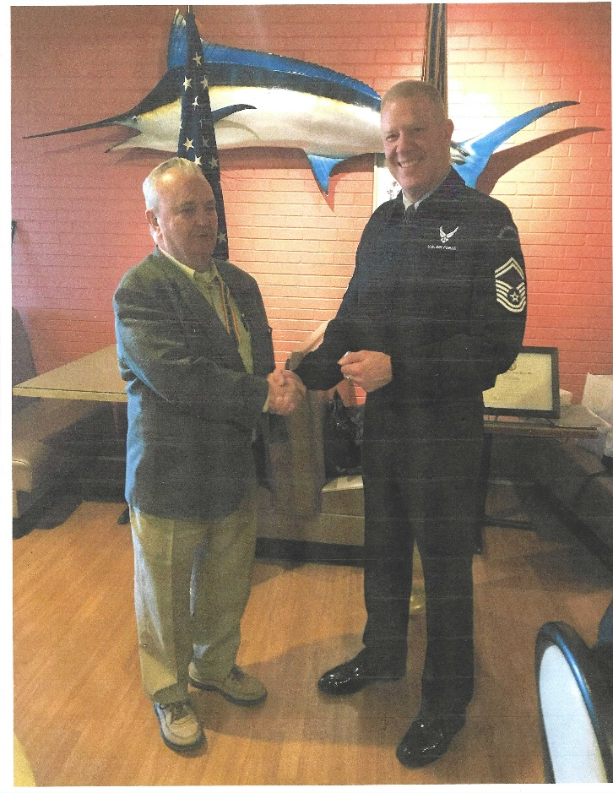

LCDR Coy Ritchie (L) presents SMSgt Steven Seiler (R) with the MOWW Coin of Excellence and congratulates him on his excellent presentation on the USAF JROTC Program at Aurora Central High School.





**THE PREAMBLE**

To cherish the memories and associations of the World Wars waged for humanity;

To inculcate and stimulate love of our country and flag;

To promote and further patriotic education in our nation;

Ever to maintain law and order, and defend the honor, integrity, and supremacy of our national government and the Constitution of the United States;

To foster fraternal relations among all branches of the armed forces;

To promote the cultivation of military, naval, and air science and the adoption of a consistent and suitable policy of national security for the United States of America;

To acquire and preserve records of individual services;

To encourage and assist in the holding of commemorations and the establishment of memorials of the World Wars; and

To transmit all these ideals to posterity; under God and for our country, we unite to establish**…**

**The Military Order of the World Wars**



**TODAY IN NAVAL HISTORY**

26 **JANUARY 1943**

**“DOWN THE THROAT”**

*USS WAHOO (SS238)* is one of the best remembered submarines of WWII, and her third war patrol from 14 January to 7 February 1943, under CDR Dudley W. “Mush” Morton, is perhaps the most noteworthy of her career. Assigned to reconnoiter the Japanese anchorage at Wewak, New Guinea; Morton’s transit from Brisbane was preceded by three days of anti-submarine exercises with the destroyer *PATTERSON (DD-392)*. On the afternoon of the last exercise day, *PATTERSON* spotted *WAHOO’s* periscope wake and charged. Morton took advantage of the circumstances to drill his crew in the chancy maneuver of a bow-on attack.

On this day, *WAHOO* made New Guinea but was chased from Victoria Bay on Kairiru Island by two *Chidori*-class destroyers. Morton moved nearby to a narrow strait between Kairiru and Mushu Islands, known to be a foul-weather anchorage for the Japanese. Unable to see into this anchorage or maneuver to the other side of the island, Morton realized the only way to scout the refuge was to penetrate its shallow waters. He sneaked nine miles up the narrow strait undetected, with only the tip of the periscope visible. Here he lined up on a tender and fired three torpedoes. They missed, and now a destroyer closing from 10 degrees to port turned to charge headforemost down the torpedo wakes. Prudence dictated that Morton crash dive and shoot from sonar bearings. Confined by the shallow water however, and fresh from his encounter with PATTERSON, Morton chose a more daring option. He instantly recognized that if he fired at a range greater than 1200 yards the destroyer would have time to turn away. Yet if he fired at less than 700 yards the torpedoes wouldn’t run long enough to arm. And, the 30-knot destroyer would traverse the 500 yards of vulnerability in only 30 seconds!

Morton used the tick marks in the periscope’s crosshairs from the destroyer’s masthead and the waterline to gauge distance and estimated his shots. At 1400 yards the first torpedo leapt free. An interminable few seconds later the enemy reached 850 yards and the second “fish” gushed forth. *WAHOO* dove, passing 80 feet by the time the first torpedo should have hit. But the only sound was the now deafening screw noise of the onrushing destroyer! His men braced for the inevitable depth charges; the first “crash” jarred the sub seconds later. But this blast was quickly followed by the crackling sound of steam hitting cold water. Everyone in the control room exclaimed almost in unison, ***“We hit the son of a bitch!”*** *WAHOO* surfaced to see the destroyer cut in two just forward of her stack. But now in great danger of discovery, *WAHOO* turned and slipped back to the open sea.

Watch for more “Today in Naval History”

CAPT James Bloom, Ret

ADDITIONAL NOTES: This brazenly daring maneuver did not end the heroics of this cruise, for the following day *WAHOO* located a small convoy at sea. She dodged escort attacks to sink three and damage a fourth ship, earning “Mush” Morton the Navy Cross and the Distinguished Service Medal, and the crew the Presidential Unit Citation, for this cruise.

The episode above was in part the inspiration for Edward Beach’s novel and the 1958 Hollywood classic “Run Silent, Run Deep” starring Clark Gable and Burt Lancaster. In that film Gable plays the skipper of a fictitious submarine “USS Nerka,” who drills and drills his crew, then successfully executes a bow-on shot at the climax of the film. The exterior shots for this movie were filmed at the Sub Base in San Diego, using *USS REDFISH (SS-395)*. The film debuted on 1 April 1958 with a special showing to an audience of U.S. sailors aboard *USS PERCH (SS-313)*.



**MEMBERSHIP APPLICATIONS**

Applications may be obtained by contacting the Chair of the Membership Committee at 303-981-5519 or [coyritchie@aol.com](mailto:coyritchie@aol.com).

It is nobler to serve than to be served



**THE CINC SOLICITATION**

The Commander in Chief is appealing to you to donate generously to the CINC Solicitation by donating in support of our Order’s patriotic and educational activities. He also asks that you encourage other Companions in your chapter to do so too. Our CINC Solicitation goal helps pay for activities such as:

* Supporting chapters via essential services (e.g., YLC insurance) and merchandise (i.e., products of all types)
* Existing awards, e.g., ROTC/JROTC Awards of merit, GSUSA Gold Award, and BSA Eagle Scout Certificates
* New awards, e.g., Outreach Service Medal and BSA Sea Scout, Quartermaster and Venture Scout Certificates
* Service Academy awards and military college awards
* Medals & certificates to ROTC/JROTC cadets & BSA & GSA scouts not supported by chapters
* Promotional material and program brochures for existing and start-up chapters



* The *Officer Review* magazine, which is MOWW’s only way to communicate with all Companions
* YLC Support via additional YLC issues of the O*fficer Review* that YLC Directors use for advertising & recruiting
* The MOWW website at [www.moww.org](http://www.moww.org), which the Order’s Companions use in support of every activity area
* MOWW Convention Support, including the Distinguished Service and National Commander Award programs

It is very easy to contribute, just open up the Order’s web page and at the very top next to the logo is the DONATE tab. You can also mail in your contribution when you receive the solicitation in the mail from MOWW HQ.

Your donation supports patriotic activities only MOWW provides. *Please donate today!*



**CHAPTER ACTION PLAN**

Each year our chapter is asked to prepare and submit a Chapter Action Plan to the Commander Region XIII. The Action Plan shows the actions to be taken by the chapter to support the MOWW Strategic Goals. Our Action Plan is shown below.

Reviewing the Action Plan may explain why we do certain things.

**2024-2025 DENVER CHAPTER ACTION PLAN**

*Strategic Goal 1 (SG 1) Consistently develop and deliver attractive and high-impact community outreach programs and activities.*

#Improve planning for speakers at our meetings.

#A new member is chair of Law & Order Comm.

#Continue to Support the Colorado Springs YLC.

#Support Buckley SFB Retiree Appreciation Day.

*SG 2 Expand our impact through alliances and strategic partnerships with organizations that align with our mission.*

#Become a member of the United Veterans Coalition. Their membership includes practically all Veterans Service Organizations in Colorado. This will improve our visibility and communications with like-minded organizations.

*SG3 Increase visibility of the Order at the national and community levels through focused communications, marketing strategies, and local community engagement.*

#We have a social media presence through the Region XIII Hub and Spoke project.

*SG4 Annually grow engaged and sustainable MOWW membership.*

#Hold a general membership meeting every other month.

#Meet or exceed the small chapter recruiting goal of two new members.

#Recruit only military veterans to support the IRS 75% requirement.

#Encourage members to regularly attend general membership meetings.

*SG5 Increase adequate financial resources to fulfill Order’s mission.*

#Obtain at least one donation from a community civic organization or Chapter supporting organization.

#Solicit donations from Chapter members to support selected expensive programs such as ROTC/JROTC, Scouting and recognition awards for deserving Companions.

*SG6 Increase the number of chapters and strengthen existing chapters.*

#Continue to support our succession plan & prepare Companions to assume leadership roles.

#Continue to identify, recognize, and nominate for awards our highly productive chapter Companions.





**POINTS OF CONTACT**

**Denver Chapter (093), CO**

c/o Coy D. Ritchie

4198 S. Kirk Court

Aurora, CO 80013-6022

[www.mowwscv.com/publications](http://www.mowwscv.com/publications)

**Commander and Treasurer**

LCDR Coy Ritchie, USN (Ret)

4198 South Kirk Court

Aurora, CO 80013-6022

303-690-5118 (Res), 303-981-5519 (Cell)

[coyritchie@aol.com](mailto:coyritchie@aol.com)

**Adjutant**

HPM Frances Long

278 S. Kearney Street

Centennial, CO 80111-4237

303-694-1079 (Res)

[grannyfrancene@netzero.net](mailto:grannyfrancene@netzero.net)

**Commander, Rocky Mountains Department**

COL Steven A. Shambach, USA (Ret)

[shambachsm@msn.com](mailto:shambachsm@msn.com)

**Commander, Region XIII**

Currently vacant

**DENVER CHAPTER STAFF**

Denver Chapter Executive Board-Elected Officers

Commander: LCDR Coy Ritchie, USN (Ret) 303-981-5519

1st Vice Cdr: Capt Dennis Orr, USAF (Former) 303-526-2156

2nd Vice Cdr: HPM Stephanie Ritchie 720-910-3647

Adjutant: HPM Frances Long 303-694-1079

Chaplain: HPM Frances Long 303-694-1079

Treasurer: LCDR Coy Ritchie, USN (Ret) 303-981-5519

Denver Chapter Staff: Committee Chairs

Membership: LCDR Coy Ritchie, USN (Ret) 303-981-5519

Newsletter Editor “ “

Public Relations: “ “

Finance & Budget: “ “

RMYLC Board : “ “

ROTC & JROTC: HPM Stephanie Ritchie 720-910-3647

Scouting: “ “

Programs: Capt Dennis Orr, USAF (Fmr) 303-526-2156

Law & Order: Capt Dennis Orr, USAF (Fmr) 303-526-2156

Hospitality: HPM J. Pat Ritchie 303-690-5118

Marshall HPM Stephanie Ritchie 720-910-3647