Military Order of the World Wars

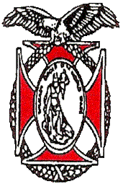 | Chapter 151  Region XIII  APRIL 2026 Newsletter | 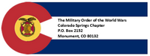
COMMANDER’S REMARKS (APRIL 2026)

Greetings Companions!!
We had a superb Membership meeting Saturday 21st of March. This was our annual Scouting Program. The speaker was Col (AF, ret) Kerm Neal, our past Commander and current Department of the Rocky Mountain Commander. He is the membership chair of the Pathway to the Rockies Scouting Chapter. Kerm provided an update on the Scouting program in the area, noting that membership numbers are increasing. He also addressed the relationship of Scouting with the Department of Defense which has been in the papers recently.
Our next meeting with be on Saturday, April 18th. Our speaker will be LTC (Army, ret) Nathan Watanabe. He is currently working as a planner at NORAD/NORTHCOM and will be speaking about plans and operations and any information he can provide regarding current operations in Iran. Plan to attend and bring others to hear this presentation.
April is also the month for elections for Chapter Commander and Staff. We are looking for volunteers to serve on the Chapter staff to bring new ideas to the team as well as to allow current staff who have served for a few years to step down. See the article OY2027 Staff Elections in this newsletter. Help liver our motto “It is nobler to serve than to be served.”
Applications are now open for this year’s Rocky Mountain Youth Leadership Conference, our flagship program. The Conference will be held from 15-19 June at CSU Pueblo. The focus is on rising High School Seniors (this year’s juniors), and exceptional rising Juniors. More information is available at: The Conference - Rocky Mountain Youth Leadership Foundation Inc, The deadline for applications has been extended until 10 April and we still have capacity for students to apply and attend.
Another reminder is that we are always looking for new members! Our goal this year from National is six new members, of which we have only enrolled two. Remember also that membership is now open to all ranks! Please consider who you can invite to attend meetings and join our worthwhile organization! Here is the link to the membership application on our website: moww-membership.pdf
Finally, we are looking for ways our Chapter can better serve you, our members. Please let us know your ideas for how to improve our service for you and our community.
Thank you again for the honor and privilege of being your commander and thank you all for your service!
Steve
sashambach@gmail.com
(719)447-5505
It is nobler to serve than to be served.

OY2027 STAFF ELECTION.
It is time for our annual MOWW Staff elections. The vitality of our Chapter depends on volunteers willing to take on leadership roles to bring fresh energy and new ideas to our organization. In accordance with our Bylaws, the following are the elected positions for our Chapter:
Elected | Elected/Appointed*
• Chapter Commander | - Historian
• Senior Vice Commander | - Marshall
• Junior Vice Commander | - Chaplain
• Adjutant | - Surgeon General
• Treasurer | - Public Relations Officer
 | - Judge Advocate
*If no volunteers for these positions, then Commander can appoint Companion to position
See this link for position descriptions and duties in Chapter Article V Bylaws.
Election Procedures
• Submit to Chapter Adjutant, Lt Col Kirk Brown, ltckirkbrown@juno.com, no later than noon Tuesday, 14 Apr nominations for yourself or other Chapter Members.
• Adjutant will send ballots electronically to Chapter members no later than Thursday, 16 Apr.
• Chapter members submit absentee ballots (i.e., not attending monthly meeting, etc.) to the Chapter Adjutant, Lt Col Brown no later than noon Friday, 17 April.
• Saturday, 19 April General Membership Floor nominations for vacant position(s) (i.e., positions with no nominations, etc.) accepted prior to in person voting.

STAFF MEETING (9 APRIL 2026)
TREASURER’S REPORT INFORMATION
The following tables depict the Chapter’s financial status as of 1 April 2026.10 August
Account | Balances
CDs: | $ 13,785.21
Savings: | $105.16
Checking: | $5,619.55
Reserved: | $1,696.59
Total: | $ 21,206.51

CHAPTER ACTION PLAN (CAP)

Strategic Goal (SG) Current | Initiative
SG1 Outreach – Consistent impactful outreach programs and activities. | Contact any Staff member if you have any suggestions on meeting SG-1.
SG2 Strategic Partnerships - | Engage with other veteran organizations to establish strategic partnerships. Contact Steve Shambach with any suggestions on meeting SG-2. In Progress.
SG3 Maximize Visibility | Chapter committed to participate in Colorado Springs Veterans Day Parade. Contact Staff if you have any suggestions for how Chapter can meet this objective.
SG4 Annually grow engaged and sustainable MOWW membership. | Chapter recruiting goal for OY25-26 is six Companions. Please contact Mark Ellis if you have any prospective candidates.
SG5 Obtain financial resources to fulfill Order’s mission. | Regular solicitation of donations from Chapter Companions. Contact Mike Berendt if you have any questions concerning donations or other opportunities for Chapter fundraiser.
SG6 Increase number of chapters and strengthen existing chapters. | Contact anyone on Staff if you would like to volunteer your skills or suggestions for meeting this SG (i.e., strengthen recruiting, Chapter social media presence, Chapter branding, etc.
APRIL MEMBERSHIP MEETING
The next MOWW lunch meeting is on Saturday, 18 April 2026. LTC Nathan Watanabe, USA (Ret) will be our guest speaker, providing an update on NORAD/NORTHCOM Strategic Planning. Reservations required. RSVP to LTC Berendt, berendt478@aol.com, (410) 908-6777 NLT 15 Apr 2026.

MAY MEMBERSHIP MEETING
The May MOWW Dinner meeting is on Saturday, 28 May 2026. Mayor Blessing Adeyemi Mobolade will be our guest speaker, providing an update on the city of Colorado Springs. Reservations required. RSVP to LTC Berendt, berendt478@aol.com, (410) 908-6777 NLT 25 May 2026.

MOWW Highlights our Commitment to Scouting at our March monthly Companions Luncheon

MOWW was honored to welcome the Rocky Mountain Division Commander and our Scouting Coordinator, Colonel Kerm Neal, at our monthly Companions Luncheon on Saturday, 21 March 2026. Kerm provided a report on the Chapter’s preparation of MOWW Eagle Scout Awards to be presented at the upcoming Pathway to the Rockies Council Recognition Ceremony on 21 April. Additionally, he updated Companions on changes to the Memorandum of Agreement between Scouting America and the Department of War. Specifically,
- Scouting America National office is waiving registration fees for children of active-duty, Guard and Reserve families effective June 1, 2026.
- Scouting America is introducing a new “Military Service” merit badge.
- The DEI committee at the national level will be dissolved into the “People and Culture” committee. This committee will deal with all things related to outreach.
- Citizenship in Society Merit Badge has been discontinued.
Colonel Neal emphasized that the relationship between Scouting America and the Department of War is important to both parties and the military families they serve. Tens of thousands of Scouts participate in scouting units that meet on or near military installations throughout the world and this partnership provides the opportunity to continue serving the military families who depend on Scouting America to mentor and nurture their children. We thank Colonel Kerm Neal for his continued leadership as our MOWW Scouting Chair as well as his leadership in the Pathways to the Rockies Scouting Council.

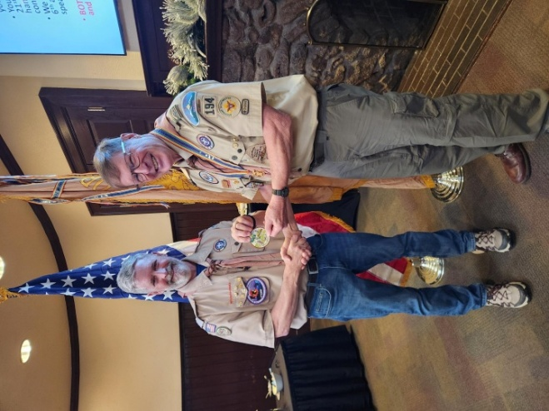
COL Steve Shambach, COS MOWW Commander, provides a MOWW Certificate to Col Kerm Neal, Past COS Commander

Volunteer Opportunities
Companions consider volunteering for the following Chapter vacancies for OY25-26

- Historian
- Marshall
- Chaplain
- Public Relations Officer
- National Security Chair
- Veterans Affairs Chair


ROTC/JROTC
Thanks to all of you that have volunteered to present our MOWW Awards of Merit at ROTC and JROTC Awards ceremonies! We still have some openings for presentations in Pueblo. Please consider helping out by attending a ceremony and presenting a medal and certificate at one of our local high schools. I will provide a complete package for you to take to the presentation and most ceremonies last about an hour. You have no speaking part; simply present the award to the deserving student, take a picture with him/her and enjoy spending time with our upcoming citizen leaders. Please call me at 410-908-6777 or email me at berendt478@aol.com for more information and to sign up. Thanks, in advance, for volunteering!

APRIL COMPANION BIRTHDAYS
Lt Col Adam D. Ackerman, USAF; LTC William G. Chadick, USA (Ret); LTC Donald H. Holt, USA (Ret); 2nd Lt Kristy M. Katein -Taylor, USAF; LTC William D. Linn II, USA (Ret); Col Richard P. Macleod, USAF (Ret); Maj Leroy H. Pedone, USAF (Ret); Maj David K. Ritterling, USAF (Fmr) ; 1LT William T. Shambach, USAR;

MAY COMPANION BIRTHDAYS
LTC Michael David Berendt, USA (Ret); Lt Col James B. Borders, Ph.D., USAF (Ret); Col Lowell B. Fisher, USAF (Ret); CDR Brian Q. Gauck, USN (Ret); Col Albert Joseph Gerathy Jr., USAF ANG; LTC Phillip L. Mallory II, M.D., USA (Ret); Col Robert F. Smith, USAF (Ret); Lt Col John W. Snider, USAF (Ret); Col James W. Taylor, USAF (Ret); 1LT Valerie J. Warner, USA (Fmr); Lt Col Paul D. Willey, USAF (Ret);

Pathway To The Rockies Council Recognition Dinner!
Tuesday, April 21, 2026 from 5:30pm to 7:30pmPenrose House Garden Pavilion
Join the Pathway to the Rockies Council on April 21 at 5:30 PM for an evening of celebration and recognition. This event honors the contributions and achievements within our Scouting community. We will celebrate our dedicated volunteers, present the prestigious Silver Beaver Award, and applaud the 2025 class of Eagle Scouts.
MOWW recognizes new Eagle Scouts at this event with certificates and patches, all are welcome! If interested, the cost is $45. Link to register is at: Event Registration

PREAMBLE
To cherish the memories and associations of the World Wars waged for humanity;
To inculcate and stimulate love of our Country and the Flag;
To promote and further patriotic education in our Nation;
Ever to maintain law and order, and to defend the honor, integrity, and supremacy of our National Government and the Constitution of the United States;
To foster fraternal relations among all branches of the Armed Forces;
To promote the cultivation of Military, Naval and Air Science and the adoption of a consistent and suitable policy of National Security for the United States of America;
To acquire and preserve records of individual services;
To encourage and assist in the holding of commemorations and the establishment of Memorials of the World Wars;
And to transmit all these ideals to posterity, under God and for our Country, we unite to establish The Military Order of the World Wars.

Link to MOWW Preamble
Chapter Website: www.cos_moww.org
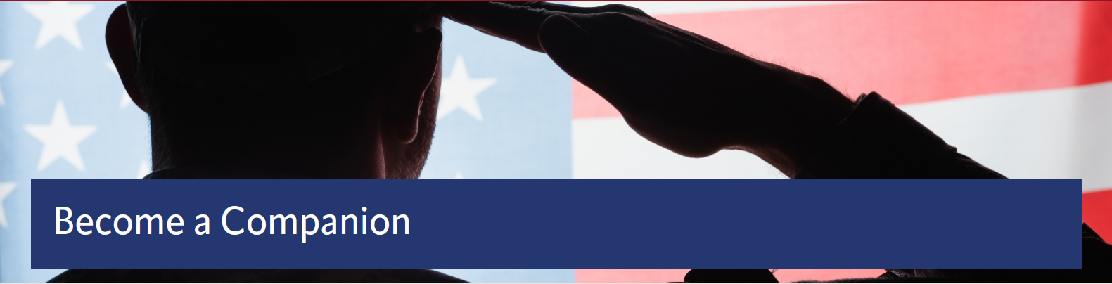
MOWW Membership Application
Please use this link to submit an electronic application: https://moww.org/become-a-companion/. Please see Staff for paper membership application or this link to print your own application: https://moww.org/wp-content/uploads/2022/10/MembershipApplication-MOWW-1.pdf

POINTS OF CONTACT

MOWW Chapter 151
Colorado Springs, CO
Commander
Stephen A. Shambach (COL, USA, Ret)
15270 Churchill Place
Colorado Springs, CO 80921
(719) 447-5505
shambachsm@msn.com

Senior Vice Commander
Mark A. Ellis (COL, USAR, RET)
5555 Chukar Trail
Colorado Springs, CO 80918
(402) 709-3373
Mae77@icloud.com

Junior Vice Commander
Ulysses Swift (Lt Col, USAF, Ret)
2585 Deliverance Drive
Colorado Springs, CO 80921
(719) 548-0865
swift888@comcast.net

Adjutant
Kirk Brown (Lt Col, USAF, Ret)
2539 Craycroft Drive
Colorado Springs, CO 80920-1423
(719) 500-9168
ltckirkbrown@juno.com

Treasurer
Mike Berendt (LTC, USA, Ret)
1230 Bowstring Rd.
Monument, CO 80132
(401) 908-6777
berendt478@aol.com
Patriotic Education Committee Chair
Stephen A. Shambach (COL, USA, Ret)
15270 Churchill Place
Colorado Springs, CO 80921
(719) 447-5505
shambachsm@msn.com

Homeland Security Committee Chair
(Vacant)

Public Safety and Law & Order Committee Chair
(Vacant)

ROTC and JROTC Committee Co-Chairs

Mike Berendt (LTC, USA, Ret)
Ulysses Swift (Lt Col, USAF, Ret)

Scouting Committee Chair
Kerm Neal (Col, USAF, Ret)
13303 Honey Run Way
Colorado Springs, CO 80921
(719) 205-1106
knealsfour@yahoo.com

National Security Committee Chair
(Vacant)
Veterans Affairs Committee Chair
(Vacant)

Surgeon General
Tisha K. Ellis (MAJ, USAR)
5555 Chukar Trail
Colorado Springs, CO 80918
402 541-2230
kim40@icloud.com

Judge Advocate General
Mark A. Ellis (COL, USAR, Ret)
5555 Chukar Trail
Colorado Springs, CO 80918
402 709-3373
mae77@icloud.com

Rocky Mountains Department Commander
Kerm Neal (Col, USAF, Ret)
13303 Honey Run Way
Colorado Springs, CO 80921
(719) 205-1106
knealsfour@yahoo.com

Region XIII Commander
Vacant

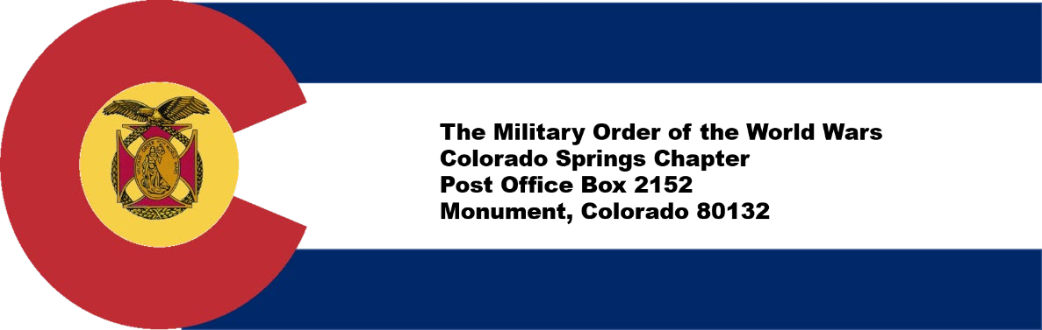

​
CONTRIBUTION OR PLEDGE
Yes, I am making a tax-deductible contribution or pledge to the Colorado Springs Chapter of the Military Order of the World Wars.
I wish to contribute or pledge $__________to the Patriotic Education Fund.
I wish to contribute or pledge $__________to the ROTC Fund.
I wish to contribute or pledge $__________to the Boy and Girl Scout Fund.
I wish to contribute or pledge $__________to the Law & Order Fund.
I wish to contribute or pledge $__________to the Operations Fund (postage, bulletin, directory, recognition programs – plaques, medals, etc.)
_______________________________________
Name
Please make checks payable to Colorado Springs Chapter, MOWW Send to: LTC Mike Berendt (USA, Ret) 1230 Bowstring Road Monument, CO 80132

