COMMANDER’S LOG

The activities of the Chapter are based upon the MOWW Preamble, the Annual Goals of the CINC and the Strategic Plan of the Order. Strategic Goal 1 is Recruit, Convene & Involve Companions. Specific chapter goals are to increase chapter end strength by at least 4%. For the chapter, that means recruiting at least two new companions over losses. Other specific goals including holding monthly chapter meetings and including companion participation in chapter meetings and events.

This chapter suffered a great loss at the beginning of this operational year. In July, HPM Vernon Haywood who was chapter adjutant and senior vice commander died from a heart attack. One new companion has been recruited since then. We still need to recruit two new companions.

A related problem is the lost patrols (a term from past Chief of Staff Art Morrill) in this chapter. When the Santa Fe and Albuquerque chapters were closed, its members were moved to this chapter. Because those chapters were inactive for years, the contact information for some of those members is incomplete. Efforts are under way to update this information.

We are holding the chapter’s monthly meetings In hybrid format, that both in person and on Zoom. You are encouraged to participate in one of those ways.

The final part of that strategic goal is more companion involvement in the chapter. As mentioned above, the chapter still needs an adjutant and senior vice commander. These are two separate positions and can be two different people.

Another event that the three chapters used to do is the Sunbelt Patriotic Youth Leadership Conferences. These were held in northern and southern parts of the state. However, the venues used became unavailable, and the leadership either moved away or passed. In order to restart these probably with one day events in several parts of the state will take the involvement of several people. This is one thing the chapter can do.

THIS MONTH’S EVENTS

Spy Ships – Cold War to Present.
In the late 1960s Bob Hull was an ELINT operations/analyst for the US Air Force Security Service in the Middle East, and at two different intel sites in Florida. At one of these sites, the USAF Special Communications Center (AFSCC), Detachment 5, Eglin AFB, FL, his unit on Okaloosa Island ran missions against Soviet trawler spy ships just outside of the 3 nautical mile territorial waters. The incident a few weeks ago with a Russian spy ship off the coast of Hawaii and the current Chinese Balloon incident reminds us all that Cold War type spying is not a thing of the past. Bob Hull is going to give us a a brief overview of US, Soviet/Russian, and Chinese spy ships – Cold War to Present. He will talk about spy ship technologies and notable incidents.

MEETING DETAILS

This month’s meeting will be on Tuesday February 21st. We will meet in the Los Alamos Research Park 2nd floor conference room 203A. The Los Alamos Research Park building is located west of the South Mesa Fire Station. Parking is available east of the fire station [accessible from southbound lane of the Los Alamos Canyon Bridge] or east of the Research Park building [access is through the LANL control stations to West Jemez Road.] Entrance to the Research Park main conference room is from the ground level by use of the ground level elevator on the east side of the building to the 2nd level.

The meeting will begin with a social period at 6:00 PM followed by a brief business meeting and dinner at 6:25 PM. The presentation is scheduled to begin at about 7:15 PM. The Military Order of the World Wars meetings are open to interested citizens for the dinner and program with RSVP, or the program only at no cost. The cost for dinner is $25. Please call Robert Hull 1-505-328-1502 for reservations. A reservation is a commitment to pay.

Because of the ongoing COVID situation, the meeting will be a hybrid session including Zoom. Zoom will start at about 6:25 pm. Zoom details will be in the reminder email on the Sunday before the meeting.

LAST MONTH: SPEAKER

The Cuban Missile Crisis +60: An Intelligence Perspective

Companion Robert Hull was a high school freshman in Florida when the Cuban Missile Crisis upset our daily lives in 1962. Little did he know that just a few years later he would be part of the “after-action operations” as an intelligence analyst with the USAF 6947th Security Squadron, Det-1, in Cudjoe Key, Fl, the unit that collected much of the SIGINT used during the crisis. Previously he was in Europe monitoring Soviet activities.

This started with a presentation by Adlai Stevenson to the UN Security Council. The Cuban back story begins on January 1, 1959 when Fidel Castro took power in Cuba and the previous ruler Batista fled to Spain. On August 5, 1960, the Cuban government passed a law to nationalize all businesses. This was followed on October 12th with the government nationalizing 382 big businesses including many manufacturers and banks. In 1960 and into 1961, the Cuban Expeditionary Force which was composed of about 1500 Cuban exiles and was supported by the CIA trained in Guatemala. On April 17th 1961, they started the Bay of Pigs invasion. Of that group, 1180 Brigade members were captured and 118 died. Later, James Donovan who was an OSS leader in WW II and help start the CIA went to Cuba to get them released.

On April 29, 1961, President Kennedy, Secretary of Defense Robert McNamara and Admiral Burke reviewed a contingency plan which called fore an invasion force of 60,000 men. It estimated it would take about eight days to completely control the island, but a guerilla force would continue to operate. Later, on November 4th, a major new covert plan was developed to overthrow the Cuban government. It was named Operation Mongoose. President Kennedy signed the memorandum establishing the program on November 30th.

Meanwhile, Castro knows the U.S. is trying to get rid of him. Over 600 plots to kill him were developed. These included contaminated cigars, contaminated diving suits, and an aerosol attack on a radio station when he was doing a broadcast.

Castro asked the Soviet Union for help. He needed to be better armed in case of another attack. In July 1962, Castro and Khrushchev completed a secret agreement to put nuclear missiles in Cuba. It included about 60,000 personnel to support the deployment. In July 1962, the Soviets secretly sent SS-4 MRBMs, SS-5 IRBMs, launchers, SA-2 antiaircraft batteries, MiG-21 interceptors, and Il-25 bombers. These missiles could send nuclear warheads over the eastern part of the U.S.

On September 15th, the signal of the Spoon radar used by the SA-2 batteries was detected. By October 14th, 42 missile complexes with a striking range of 1200 miles were in position. Hull then showed pictures of the radars used by the SA-2 batteries. These radars are modified U.S. radars that were sent to Russia as lend-lease gifts during ww II. The U.S. had jamming capabilities for these radars.

Hull now switched to the spy plane back story. The U-2 is a single-seat high-altitude jet aircraft for intelligence gathering. It was used by the CIA and the USAF to monitor electronic emissions, sample the upper atmosphere for evidence of nuclear weapons tests, and photograph sites within the territory of Cold War enemies. The first U-2 flight over Russia took place on July 4, 1956. Through April 1960, 23 successful flights took place over the Soviet Union. Then on May 1, 1960 Francis Gary Powers was flying at 70,000 feet over the Soviet Union and was knocked out of the sky by the shock wave from an antiaircraft missile that exploded near his aircraft. President Eisenhower cancelled further U-2 flights over the Soviet Union.

Meanwhile, U-2 pilots flying at 460 mph at 72,500 feet took pictures over Cuba. They had 5000 feet of film producing pictures 18 inches square. Each mission took about 4000 pictures, and after October 16th, they flew as many as 6 missions per day.

In August 1962, routine twice a month CIA U-2 surveillance flights discovered SA-2 SAM sites, MiG-21 fighters and IL-28 bombers. On August 10th, CIA Director John McCone tells President Kennedy that they Soviets are about to deploy missiles in Cuba. On September 4th, President Kennedy used TV to issue a public warning to the Soviets against introducing offensive weapons into Cuba. There were then no CIA U-2 flights from Sept. 5th to Oct. 14th.

On October 14, 1962, USAF U-2s began regular flights taking pictures of sites now showing MRBM and later IRBM sites, but no missiles have arrived. On Oct. 16th, the CIA and NPIC brief the president on the missile crisis.

The U.S. now started using RF-101s nd RF-8As for photo missions over Cuba. These aircraft had both forward facing and side facing cameras. They flew many missions flying low to avoid fire from surface-to air-missiles flying 200 feet above the water then climbing to 500 feet to take the pictures.

On October 17th, a U-2 flight finds a SS-5 IRBM site, but no missiles. On October 22nd, President Kennedy declares on TV a naval “quarantine” of Cuba. A blockage is illegal. On October 25th, Adlai Stevenson presents aerial photos at an emergency meeting of the UN Security Council. Two days later, a USAF U-2 is shot down over Banes, Cuba. The same day another U-2 took off heading to the North Pole on a high-altitude sampling flight to collect particle debris from a Soviet nuclear test on the Arctic island of Novaya Zemlya. He had gone off course by human error. He was blinded by the aurora borealis and hampered by a compass malfunction near the Pole. The Soviets scrambled MiG-19 to intercept him over Siberia and shot him down.

On October 1, 1962 four diesel-electric nuclear armed “Foxtrot” submarines with independent authority to fire their nuclear-armed torpedoes left the Soviet Union to go the Mariel, Cuba. Each had 22 torpedoes including one with a 1,5 kt nuclear warhead. By November 1st, three were found by the U.S. Navy and were forced to surface when they needed to recharge their batteries. The fourth was never found.

On October 27th, President Kennedy dispatched his brother Robert to meet with the Soviet Ambassador to offer a top- secret deal to end the standoff. If the Soviets agreed to remove their missiles from Cuba, the U.S. would remove its IRBMs from Turkey and promise not to invade Cuba. The next day, Khrushchev announced on Radio Moscow that he was ordering the weapons we described as “offensive” to be returned to the Soviet Union.

On November 1st, photoreconnaissance confirmed the MRBM sites had been bulldozed. The next day, President Kennedy announced the missile bases were being destroyed. Air surveillance continues to trust but verify. By November 5th, ships began taking the missiles and other equipment back to the Soviet Union. By December 1st, all the missiles were gone.

Now Hull talked about the Soviet side of the story. Based on secret transcripts of the top-level diplomacy taken by Soviet number-two leader Anastas Mikoyan to settle the Cuban Missile Crisis, the book The Soviet Cuban Missile Crisis rewrites conventional history. The “missiles of October” and the “13 days” were only half the story. The nuclear crisis stretched well into November because the Soviets secretly planned to leave over 100 tactical nuclear weapons in Cuba. They reversed themselves because of the unruly behavior by Fidel Castro. Mikoyan led the highly-charged negotiations with the Cuban leadership who bitterly felt sold out by the Soviet concessions to the U.S.

Now looking at the NSA and the Cuban Missile Crisis. The events of this crisis demonstrated the maturity of the U.S> intelligence community especially its ability to collect and analyze information. The crucial roles of human intelligence and photographic intelligence in this crisis have been known from the beginning. Documents declassified and released in 1998 now reveal that signals intelligence also played an exceedingly important part in managing the crisis. It should be said that signals intelligence did not provide any direct information about the Soviet introduction of offensive ballistic missiles into Cuba, However, in the more than two years before that fact was known, signals analysts thoroughly studied the Cuban military buildup. Once the offensive missiles were discovered, signals intelligence provided direct support for day-to-day management of the crisis.

By some accounts, the Cuban Missile Crisis actually lasted 59 days, not the fabled “13 days” so familiar from books and Hollywood. Soviet nuclear warheads arrive in Cuba on October 4, 1962 and did not leave until December 1.

Companion Hull then displayed the cover of three books. The Cuban Missile Crisis, 1962 present the American side of the story, NSA and the Cuban Missile Crisis presents the NSA side of the story, and The Soviet Cuban Missile Crisis presents the Soviet side of the story. He ended with a slide talking about air power and the Cuban Missile Crisis.

LAHS NJROTC news

Welcome back to another edition of the latest NJROTC newsletter, you have missed some key events. We just completed our annual area manager inspection, this inspection is necessary because it showcases the skills and knowledge of the cadets. If ranked highly for the review the
unit will be awarded the unit achievement award and the distinguished unit award. From what unfolded during the inspection I would say it was one of the most remarkable displays of Topper Company’s pride and accuracy when it comes to being committed to the program and its values.
The unit’s next event will be an NJROTC food drive, this project was created to help promote cadets to give back to people within the community. We are also planning for the change of command ceremony and military ball.

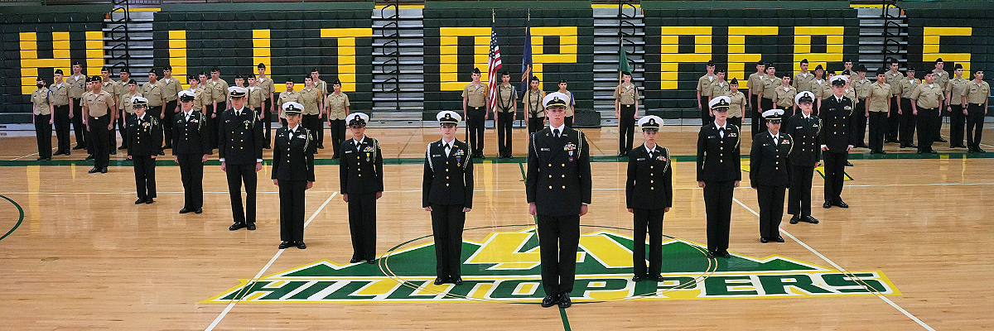

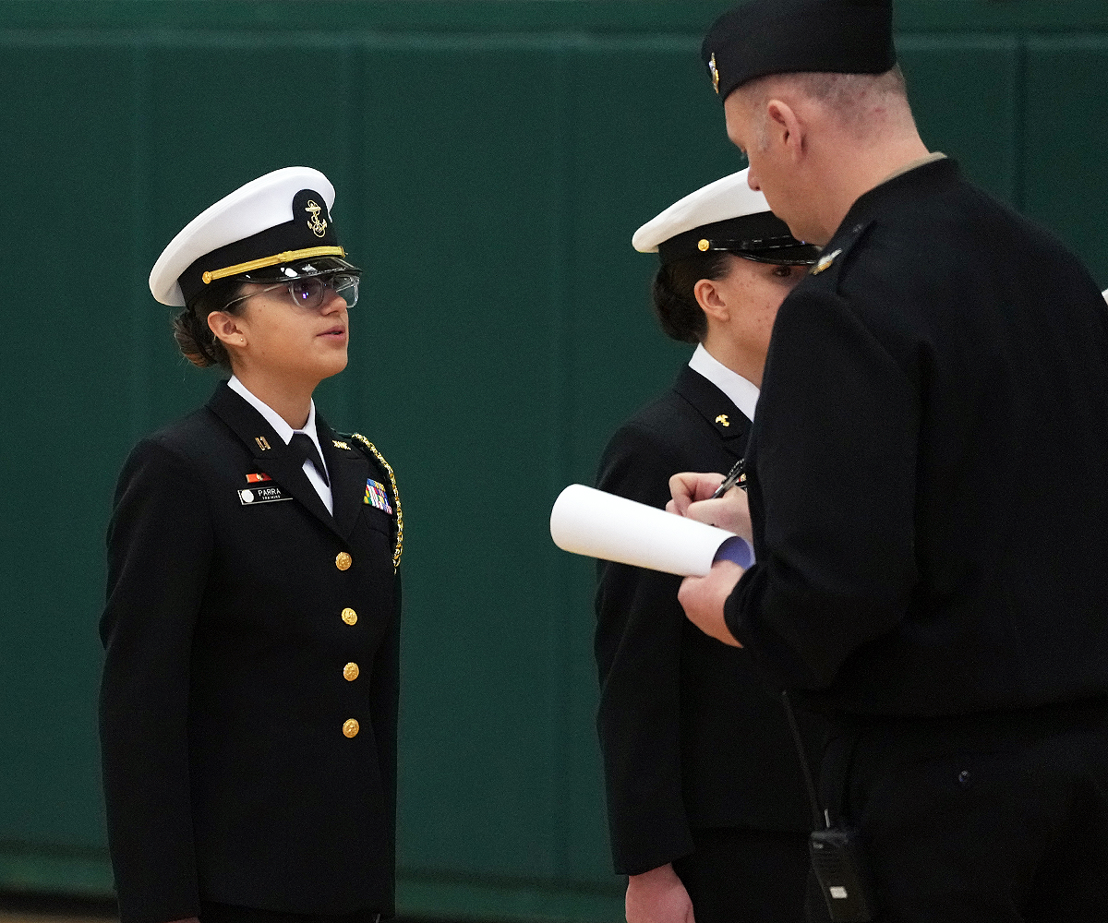

Pictures from Annual Area Managers Inspection

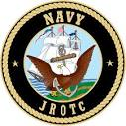
C/ENS Miranda Lopez

FOR THE GOOD OF THE CHAPTER
MOWW CINC Solicitation/Annual Fund-Raising Drive

Dear Companions,

Please donate to the CINC Solicitation/Annual Fund-Raising Drive for Operating Year 2022.

Our Order is undergoing changes that will enable it to thrive for the next hundred years and more. Our focus is service to others and our primary mission is to serve this nation and our local communities by encouraging leadership and patriotism in our youth, and by promoting a strong nation and national defense through the numerous outreach programs of which you are familiar.

I realize this past year has been financially challenging for many of you as it has been for the Order. Yet, the work of the Order has never been more important than it is today. The most visible initiative is the upgrade to the MOWW website, however, initiatives not readily apparent include the development of a national youth experience to be held in Washington, D.C., branding and marketing efforts, refocusing our Strategic Plan, among others.

It is imperative for the continued success and growth of the Order that Companions, like you, step forward to support the work the Order needs to accomplish to fulfill our collective vision. Please donate to this year’s CINC Solicitation/Annual Fund-Raising Drive which will help to continue the work of the Order and further our outreach to our youth and the nation.

Thank you in advance for your generous support of our Order.

Contributions or gifts to MOWW are NOT deductible as charitable contributions.

FOR THE GOOD OF THE ORDER

LTC MICHAEL A. OKIN, MD, USA (Retired)
Commander-in-Chief & Chief Executive Officer, MOWW, Inc.®

NATIONAL OFFICERS

- COMMANDER IN CHIEF
LTC Michael A. Okin M.D. USA (Ret)
maokin1953@gmail.com

- VICE COMMANDER IN CHIEF
Lt Col Marlon Ruiz, USAF (Ret)
ruizmarlon08@gmail.com

- REGION XIII COMMANDER
LTC Patrick C. Stolze, USA (Ret)
pstolze40@gmail.com

Region XIII website www.MOWWSCV.com

NATIONAL STAFF

- CHIEF OF STAFF & COO
Col Michael Farrell, USMC (Ret) | chiefofstaff@moww.org

- DIRECT OF FINANCE
finance@moww.org

- MANAGER, MEMBERSHIP PROGRAMS (including dues payments)
HPM Justin Hiller | membership@moww.org

- MANAGER, MOWW STORE
Mrs. Sunny Alley | merchandise@moww.org

Website www.moww.org

MG MILES CHAPTER OFFICERS

Commander
LTC Gregg Giesler USA (Ret)
Home: 505-662-5574
g.giesler@computer.org

Senior Vice Commander
MAJ Robert Hull USAF (Ret)
Home: 505-662-7950
rhull@lata.com

Adjutant
Vacant

Treasurer
MAJ Robert Hull USAF (Ret)
Home: 505-662-7950
rhull@lata.com

COMING EVENTS

February
13 Staff Meeting
21 Chapter Dinner – Robert Hull – Spy Ships – Cold War to Present

March
13 Staff Meeting
21 Chapter Dinner – Roberta Beal – Working on Mars with Rovers

April
10 Staff Meeting -
18 Chapter Dinner – Christine Chandler - Legislative Session Review
8 NJROTC Awards Ceremony, Smith Auditorium -

May
8 Staff Meeting
16 Chapter Dinner – Alan Carr
29 Memorial Day Ceremony – 11:00 am Gauje Pines Cemetery

