COMMANDER’S LOG

Come One! Come All!

The MG Franklin E. Miles Chapter is having its Summer get together in Santa Fe at 11:30 am on Saturday July 13^{th.} This is an opportunity for chapter companions in Santa Fe and Albuquerque to join together with those from Los Alamos. Since the Santa Fe and Albuquerque Chapters were closed in the spring of 2020 and their companions were transferred to the MG Miles Chapter in Los Alamos, there has been little opportunity to meet together. Because Santa Fe is fifty miles from Los Alamos and Albuquerque is one hundred miles away, it is difficult for those companions to attend meetings in Los Alamos which are held on Tuesday evenings.

The annual convention will be held in King of Prussia, PA on August 7-10, 2024. More information is in the Officer Review or on the MOWW.org website. This meeting is very important for the future of the Order. Perhaps the most important issue to be addressed is the membership of the Order. It is proposed to expand the membership to include enlisted ranks of E-7 and above or to expand it to all enlisted ranks. The concern is the shrinking membership as we all are ageing, and it is becoming more difficult to recruit only officers. Since 1969, the living membership has dropped by half. Other veterans service organizations have loosened their membership requirements including the ROA and MOAA admitting enlisted members. With the currently smaller military and only 7% of the veterans are officers, the candidate pool is shrinking. There is more information on this issue in the January-February issue of the Officer Review and on the MOWW website. Please let me know your opinion on this issue so that I can represent you at the national convention.

Another issue to be discussed is the name of the organization. The Military Order of the World Wars sounds like it is only for veterans of World Wars I and II. Almost all of them have passed. The concern is the need for a more modern name. This also was discussed in the January-February issue of the Officer Review. What do you think?

There are other proposed changes to the constitution and the bylaws. A list is in the May-June issue of the Officer Review with details on the MOWW website. Let me know if you have any concerns about them.
THIS MONTH’S EVENTS

This month’s speaker will be William Tobey.

The Challenges We Face to the International Nuclear Order

The war in Ukraine, the expansion of China’s nuclear forces, and the threat of nuclear proliferation from North Korea and Iran all shake the pillars of the decades-old international nuclear order, which consists of deterrence, arms control, nonproliferation, and nuclear security. The United States and its allies and partners face a radically different security environment and will need to respond accordingly.

William Tobey directs the Office of National Security and International Studies at the Los Alamos National Laboratory. He is also a Senior Fellow with the Avoiding Great Power Wars Project at Harvard Kennedy School's Belfer Center. Tobey served as Deputy Administrator for Defense Nuclear Nonproliferation at the National Nuclear Security Administration from 2006-2009. There, he managed the U.S. government's largest program to prevent nuclear proliferation and terrorism by detecting, securing, and disposing of dangerous nuclear material.

MEETING DETAILS

This month’s meeting will be on Saturday July 13th. We will meet in the Pecos Trail Café at 2239 Old Pecos Trail. In Santa Fe The meeting will begin with a social period at 11:30 AM followed by a brief business meeting and lunch at noon. There may be a presentation starting at about 12:45 PM. The Military Order of the World Wars meetings are open to interested citizens. You may order lunch from the café menu.

All companions are urged to attend this casual get together to be acquainted with the other members of this extended chapter We are companions so we should work together to support the Order and each other. It will be great to see many of you again. Please come to this meeting. We don’t want to forget you.

The meeting will be a hybrid session including Zoom. Zoom will start at about 11:30 AM. Zoom details will be in the reminder email several days before the meeting.

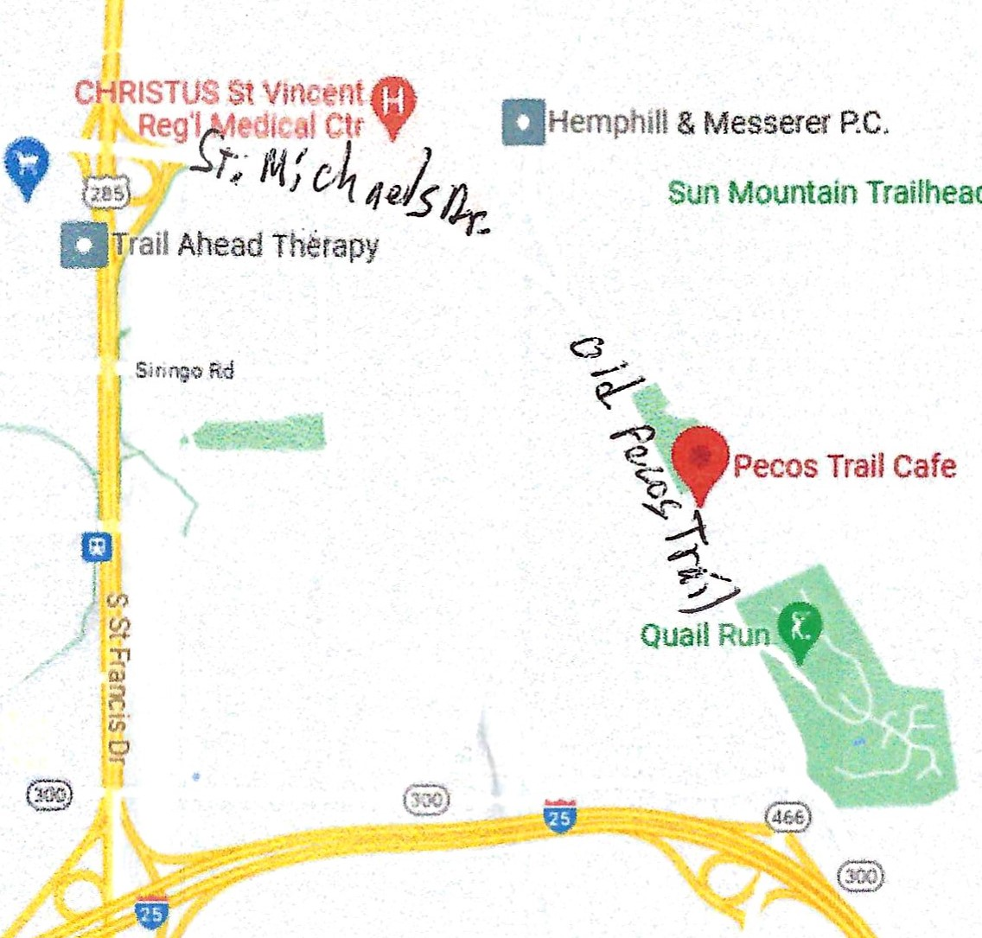

LAHS NJROTC news

For the summer, we have senior cadets attending Leadership Academy at McGregor Range on Ft. Bliss in El Paso this week. Next week, we will have junior cadets attending Basic Leadership Training, also at McGregor Range. These camps are for cadets already in leadership positions or are on track for future positions. They’re giving lessons on leadership and teamwork, while also learning marching drill and participating in physical training activities.

The cadets will not have anything going on during July.

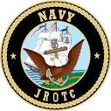
Chief Aron Ayers USN (Ret)
Naval Science Instructor

CHAPTER ELECTIONS

The annual election of chapter officers was held at the June 18th meeting. The nominees were LTC Gregg Giesler for chapter commander, Robert Malone for chapter adjutant, and Robert Hull as chapter treasurer. There were no other nominees. These individuals were elected by acclimation.

FOR THE GOOD OF THE CHAPTER

The Spring Region XIII meeting was held on Zoom on Friday June 21st. the meeting began with a presentation by VCINC Edward Gantt on the upcoming National Youth Civics Summit giving the details as they are known now. This was followed by reports from AZYLC and RMYLC. VCINC Ruiz emphasized that he will remain Region XIII Adjutant in addition to any other positions he may have. He reminded all to keep the information in the National Directory up to date using FORM 5 and FORM 6 as necessary. He stated that Annex A and Annex B for the Strategic Plan are now available for download. Each chapter does not have to include activities for every bullet in the annexes. You will identify those operations that are scalable to your operation. It is okay to leave blanks on the CAR if you are not doing things. The CAR is information only to indicate where chapters are putting their efforts. Remember, the number one goal in the new strategic plan is outreach and partnerships. Those are the primary importance to the Order. Recruitment is still in there but is not of primary importance. If you have outreach and partnerships already in your goals, expand on them and enrich them.

It is the time of year to do your IRS report. There are two items. One is to permit you to work in the operating year, and the other is to get a PM dividend if there is one in the operating year. As an alternative, consider fund raising, partnerships, grant writing, and donations. This year, national is going to develop a playbook covering region by region ways that chapter can develop partnerships and outreach that the chapter can do to stabilize chapter finances. They will be looking at places with IRS 501©3 organizations such as the RMYLC and AZYLC to connect them with grant awarding organizations with the ability to spread the funds to chapters especially supporting JROTC units.

All chapters need to keep the balance of 75 per cent veterans. Keep that in mind when recruiting new members especially when recruiting nonveterans to keep at least 75 per cent veterans.

AWARDS

On June 28,1994, the Los Alamos, New Mexico Chapter was chartered by the Military Order of the World Wars. In the June 18, 2024, the chapter commanders for the past thirty years were honored. From the start in 1994 through 2010, the chapter has had ten commanders with Lt Col Norman Wilson serving for a total of five terms. Five past commanders are still living. They are Lt Roy Bates, LtCol Roger Goldie, COL Anthony Trottier, COL Gerald Bolme, and MAJ Donald Davidson. Only COL Bolme was able to be present, and MAJ Davidson attended via Zoom. Certificates of Appreciation will be presented as they are available. The current commander LTC Gregg Giesler has served in that position since July, 2010.
MEMORIAL DAY
The Los Alamos County Joint Organizations Memorial Day ceremony was held in Guaje Pines Cemetery on Monday May 27th. This year, the participating organization were represented with only their organizational flag and no national colors, and some organizations also placed memorial wreaths. This chapter was represented with its organizational flag and a wreath.
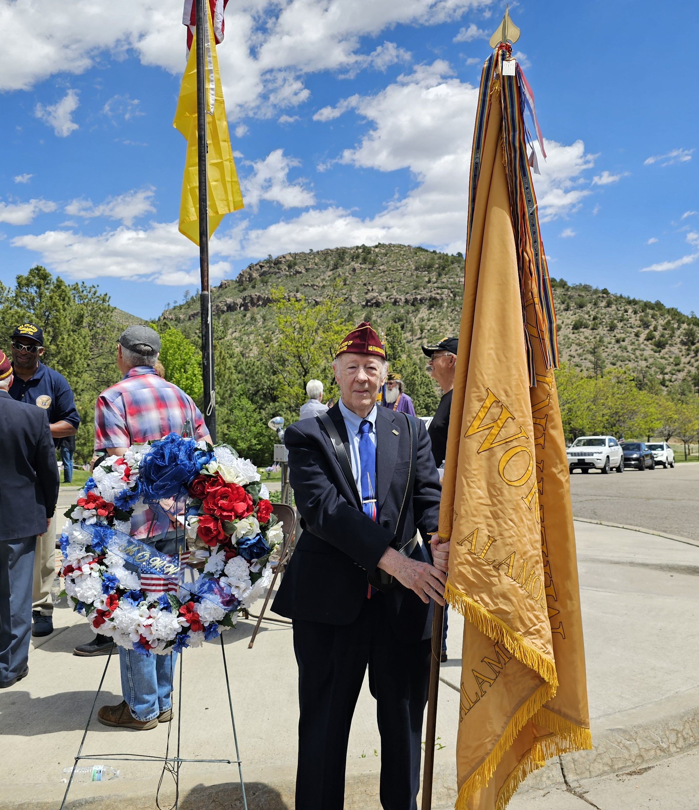
HPM Robert Malone with the chapter’s flag standing next to the chapter’s wreath.
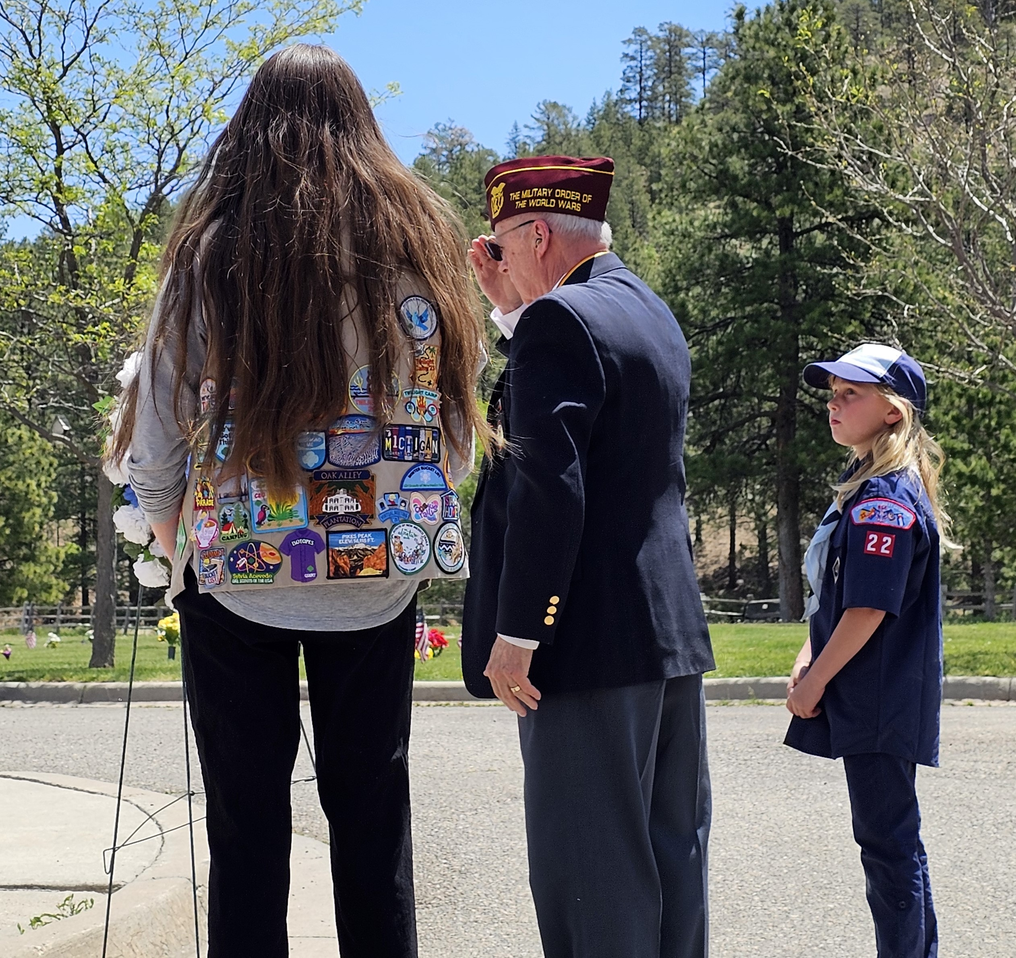
Lt Col Roger Goldie escorted with a local Cub Scout and Girl Scout after placing the chapter’s wreath
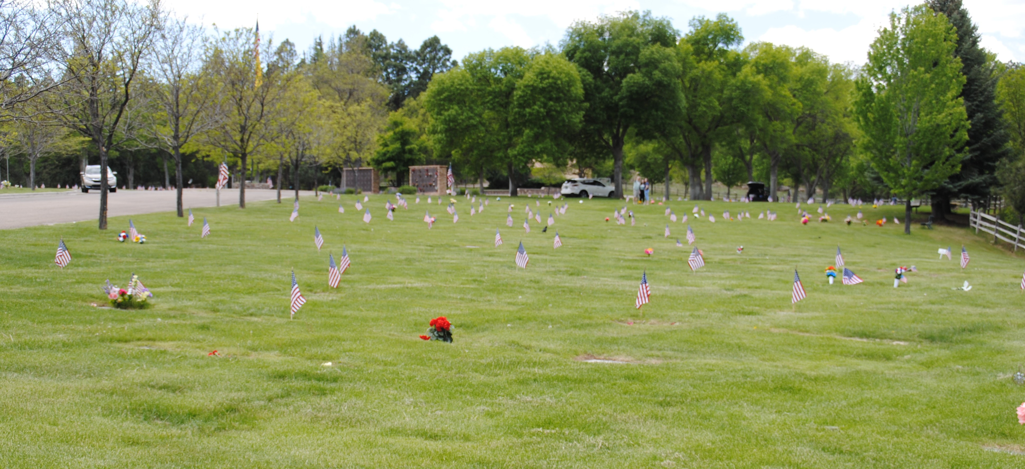
One section of Guaje Pines Cemetery showing the flags placed on the graves of veterans.
NATIONAL OFFICERS

- COMMANDER IN CHIEF
LTC Michael A. Okin M.D. USA (Ret)
maokin1953@gmail.com

- VICE COMMANDER IN CHIEF
Lt Col Marlon Ruiz, USAF (Ret)
ruizmarlon08@gmail.com

- REGION XIII COMMANDER
LTC Patrick C. Stolze, USA (Ret)
pstolze40@gmail.com

Region XIII website www.MOWWSCV.com

NATIONAL STAFF

- CHIEF OF STAFF & COO
Col Michael Farrell, USMC (Ret) | chiefofstaff@moww.org

- DIRECT OF FINANCE
finance@moww.org

- MANAGER, MEMBERSHIP PROGRAMS (including dues payments)
HPM Justin Hiller | membership@moww.org

- MANAGER, MOWW STORE
Mrs. Sunny Alley | merchandise@moww.org

Website www.moww.org

MG MILES CHAPTER OFFICERS

Commander
LTC Gregg Giesler USA (Ret)
Home: 505-662-5574
g.giesler@computer.org

Senior Vice Commander
MAJ Robert Hull USAF (Ret)
Home: 505-662-7950
rhull@lata.com

Adjutant
HPM Robert Malone
Home: 505-672-0248
Robert_malone2@aol.com

Treasurer
MAJ Robert Hull USAF (Ret)
Home: 505-662-7950
rhull@lata.com

COMING EVENTS

July
4 Independence Day
12 Staff Meeting –
15 Chapter Lunch at Pecos Trail Café in Santa Fe –
William Tobey - The Challenges We Face to the International Nuclear Order

August
2-5 National Meeting in Annapolis, MD
7 Staff Meeting –
15 Chapter Dinner –

September
11 Staff Meeting –
19 Chapter Dinner – Travis Pitts – Climate Shift and
National Security

October
Region XIII Zoom meeting
7 Staff Meeting
15 Chapter Dinner –

LAST MONTH: SPEAKER

The speaker at our June 18th meeting was Chapter Commander Gregg Giesler. He talked about

MG Franklin E. Miles Chapter: Past Present, and Future.

Going back to the beginning, MOWW was founded on January 27,1919 and was chartered by Congress in March, 1919, the same day as the American Legion. In a way, they celebrate the same birthday. The Order was started by General Pershing to keep his officers involved in national security. The organization was growing slowly until World War II came along which provided a great influx of officers for the organization. It grew rapidly after that with, I think, more than 200 chapters. Nationwide, the membership was well over ten thousand. Then in 1990, a member of the organization wrote a history of the organization. This is Volume 2 which covers the 1980s. They have not written a history since then. In this, I found the chapters that were in New Mexico, the Department of the Rio Grande which includes El Paso were the El Paso Chapter 070, the Albuquerque Chapter 094, Pecos Valley Chapter, which I never heard of, was 184, and the Santa Fe Chapter 209. This was June 1, 1990.

This chapter was chartered on June 28, 1994, and is one of several started by MG Franklin E. Miles. He had been the Adjutant General of the State of New Mexico. I had forgotten the White Sands Chapter 219. That was in June, 1990, and we are chapter 229. So that is ten chapters later in four years. There were about half a dozen chapters in New Mexico when this chapter was started.

Shortly after that, in 1994, the Department of the Rio Grande which all these chapters were in started the Sun Belt Patriotic Youth Conferences (SPYLC). They had one in the spring at Philmont Boy Scout Ranch. It was so successful that they had another one in the fall.

Delbert Lewis was one of the founding members of this chapter. I had a list of the founding members, but I can’t find it. From what I can tell from membership dates, Roger Goldie, Roy Bates, Paul Guthals, Del Lewis, Don Scheid, and of course Frank Miles. I had the document that was the request for a charter, but I can’t find it at the moment.

This is a binder with the Companion Profiles which every companion is supposed to fill out and then sent to national. They have not talked about it in years. I don’t see one for Don Scheid, but I see one for Don Stevens and one for Steve Stoddard, for example. I didn’t know he was a member, but he was probably a regular member. Because these are alphabetical, the first one I see is for Bolme, Gerald. Here, you can look through this for the early members of the chapter.

They started the SPYLC, and it was very successful. They even had a brochure. They were holding them in multiple places, but have not had them in years. The first one was in Fort Bliss, TX on three consecutive weekends. They were held in the Glorieta Conference Center northeast of Sant Fe in late June or Early July. One was held in Roswell at the New Mexico School for the Deaf in end of June or the beginning of July or at the National Guard Training Center at Eastern New Mexico University campus in Roswell. So they had a number of these conferences every year.

In 2004-2005 the national office published a National Directory. In New Mexico, there was the Bataan Memorial Chapter 231. Ours is 229. There were also the Albuquerque Chapter, the Mesilla Valley Chapter, the Pecos Valley Chapter, the Santa Fe Chapter, and the El Paso Chapter. So there were a lot of chapters. I joined in 2003, so I knew very little about chapters or the SPYLCs.

Back in the 1970s and 1980s, Doul Lier has a similar group that would meet monthly at the Los Alamos Inn for dinner and a speaker. The meeting announcement were sent out through lab mail, and the mailing list was a full two columns. So that is about 120 names. This was well before the lab’s veterans’ group. When Doug was at the lab, he was the coordinator between the lab and the service academies and also with the military personnel serving at the lab. He had what might be the predecessor to the lab’s current veterans’ group. It was before MOWW and is probably where the initial members came from.

Back when I joined in 2003, there were about twenty people at the meetings. I remember having dinner at the American Legion post with the Legion Auxiliary serving the dinner. From there, we went to Aspen Ridge where we had the dinner in the atrium and the meeting in the main room by the fireplace or in the chapel. We met there for a number of years, and I don’t have the exact date, but there was a change in management in Aspen Ridge, It did not work out well with them, especially the kitchen staff that was supporting us. So we went to Hill Top House. We met there for a number of years until Hill Top House closed. We met briefly in the upper-level meeting room at the American Legion. We met at Bethlehem Lutheran Church. We met once in the Shriner’s Building where Natural Grocers is now. Don Davidson got us in there, and someone arranged for Brad Burke to cater us there. Brad said we could save the catering fee if we met in Hot Rocks. That is why we are now meeting in the Research Park Building. We have been there for a long time.

I am looking for a list that I have for all the meetings beginning in the 2010-2011 year listing all the speakers over the years. I have been arranging speakers for the meetings long before I was commander. I would suggest to Norm Wilson to get this person or that person as speaker. Norm to me to go do it. So I was scheduling speakers before I was commander.

On the back of the dinner agenda is a list of the chapter commanders. Norm Wilson’s last stretch as commander was 2007-2010. He made me Junior Vice Commander, then Senior Vice Commander. Then in the fall of 2009, he had a heart attack so then I had to run the meetings for several months until he came back. Then when chapter elections came up in 2011, he said he was not running again, and I would be the designee for chapter commander. We used to have ten people at meetings, but that has slowly dwindled.

In 2019, I was elected as department commander. My principal duty was closing the Mesilla Valley Chapter. The chapter was down to basically one member, Elsa Baker. Walter had spent much of the previous years in the hospital in and out until he passed. Then it was just Elsa. The White Sands Chapter had closed because White Sands had changed from military to mostly civilian so there were very few officers there. She could get the members to contribute for their awards banquet, but she could not get the JROTC officers to join the chapter. She said that since they would not join the chapter, she would stop giving awards. They said fine. So in 2019, as department commander, I was given orders to close the chapter which I did, and the members were moved into the El Paso Chapter.

They following year, 2020, I was still the department commander, and I was given orders to close the Santa Fe and Albuquerque Chapters for inactivity. Going through the files from the chapters, I found a letter from Bert Terrazas has sent to MOWW ten years earlier requesting closing the chapter. The chapter had been inactive all those years so I had to go through the process of closing those two chapter, and the members of those two chapters are now in this chapter. Now this chapter is serving all of New Mexico from I-40 north. The Albuquerque Chapter had seven living members in state, six out of state, and thirty-two deceased perpetual members. The Santa Fe Chapter had twelve living members in the area, nine out of state, and fourteen deceased members. At that time, this chapter had about thirty-two living members and four deceased members.

The chapter is now about half and half, fifty-eight living members and fifty-eight deceased perpetual members. There are about sixteen living members in the Los Alamos-White Rock area, another twenty-three living in the Santa Fe and Albuquerque area, and eighteen living elsewhere in the United States. Riz Ali joined the chapter several years ago and is now living in Louisiana. Gerrick Jones who is in the Public Health Service is now in South Carolina. He was at the Indian Health Service down in Espanola. Gloria Guthals is now living in Florida as is Elinor Pinyan. Then there is this Jerry Bolme who lives in Knoxville, TN. [He was at the meeting]. Don Lott was the head ranger at Bandolier is now the head ranger at a national park in south central MO. Talking with him, the park is 20 to 30 miles long, and using its winding road takes half a day to get from the headquarters at the south end to get to a meeting at the north end of the park. So he spends a lot of time on the road. Roy Bates is in CO, but I have not been able to find him. As I mentioned, Don Scheid is in Las Vegas, NV Bill Phillips, who you may know, attended here a number of years gave a presentation on his days in the CIA. He lives in CA north of San Francisco. I talk with him on occasion. Those are the ones from this chapter.

As I said, the chapter has about 58 living members now. It is actually three small chapters. Because it has more than fifty members, it is a medium-sized chapter. One of the things I started after I became chapter commander and talked with Paula Mitchell at a national meeting about how the El Paso Chapter kept winning all these awards at national meetings and still does. She said all you have to do is apply. If you look in the September issue of the Officer Review after national meetings, you will probably see in the small chapter category, which we were in the past, there were not even three awards given. So the people that applied got an award. So you see in the newsletter all the awards I applied for. We are competing as a medium-sized chapter with Marlon’s chapter, the Santa Cruz Chapter in AZ for awards. He generally wins awards, but I have not been as successful. In the past, not only would the top three chapters get a certificate but would also get a ribbon. There is a pile of the certificates that the chapter received on the table. That is why there are all these ribbons on the chapter flag for all the awards received over the years. Now they only give ribbons for the winner, and second and third place only get certificates. That shows how successful the program here has been over the years that won that many awards nationally.

Individually, the growth of this chapter has been of the fifty-eight members of this chapter, I have personally recruited fourteen that are perpetual members. Unfortunately, they have declined to participate in the activities of this chapter. As I talked with the chapter commander of the General Meade chapter in Washington, DC several years ago, his chapter has over three hundred members but can barely get twenty to attend a meeting. It is difficult. Many of them pay their perpetual membership but are never seen again. Unfortunately, I have a number of those. Justin Green joined five years ago and is now just coming to meetings.

Here is a list of some of the honors earned by members of this chapter. There are fourteen members that Silver Patrick Henry Awards have been presented to. There may be one or two more that are not on this list. I will have to find them in the newsletters. This list is by chapter but the current list which is thirty-one pages long is listed alphabetically. The net result is that there may be one or two more on that list that I do not have.

This is a list of the attendees at a chapter meeting in 2010 showing the number of members in the chapter then.

There have been two members of the chapter that have received a Gold Patrick Henry Award. The one to Norm Wilson was in 2019 when CINC John Hollywood came out to award it. It was a very good meeting that day. It was at the American Legion and Alan Carr was talking about the Rover Program. The second Gold Patrick Henry Award was given to me by Paula Mitchell just before she ended her last term as VCINC.

I am trying to keep the chapter going. The chapter is very active in giving scouting awards and in giving ROTC awards We support the three ROTC chapters at UNM and the JROTC chapters in all the Albuquerque high schools and as far east as NMMI. We have supported this high school for years as well as Santa Fe, BJ takes care of that as well as the five high schools in the Farmington Area. We literally now have the northern half of New Mexico.

Ideally, I would like to get a chapter restarted in Albuquerque. If you read the obituaries every week in the Sunday Albuquerque Journal, almost always there is at least one if not more deceased officers in Albuquerque. So there is a large pool of officers available not including those serving in Kirkland Air Force Base which are only here for three years at most before they are off somewhere else. Unless they are retiring here, they are not interested in local things. I have tried recruiting the military officers serving here at the lab, but they join as a regular member, are here one year and gone, and are never heard from again.

The Santa Fe Chapter used to meet with MOAA and used to alternate hosting joint monthly meetings with them. Some of them are present or former lab employees. I tried to recruit one that lives on North Mesa but he was never interested. I still send him the newsletter, but I have not heard from him. I don’t think he is interested in joining. I think the MOAA chapter is still active but not very active.

Some of the things this chapter did with the Santa Fe Chapter when I joined was we would have joint Pearl Harbor Day dinners alternating between here and Santa Fe. They would be at the Santa Fe Country Club or a restaurant in Espanola or in a restaurant off of Second Street in Santa Fe. I was there once when as the department commander I called a meeting of the chapter there to try to keep the chapter going. They were not interested in doing that. I had about half a dozen members there. They had a member who would bring his guitar and they would sing God Bless America. I have a listing of the members of the Santa Fe Chapter, but he is not listed there.

As I said, we would have Pearl Harbor Day dinners alternating but that was stopped one year when the meeting was up here and we had about six inches of snow that day December 7th. I was working at TA-55 at the time and almost did not make it to the meeting. It took we half an hour to get from the parking lot at TA-55 to Pajarito Road, then another half hour to get to Pajarito and Diamond, and another half hour to get down Diamond to East Jemez Road. After that, it was smooth sailing. TA-55 is at the end of the line whichever way you go especially if you are trying to go through the lab. All the lab parking lots are before you. These are all one lane roads so you cannot pass cars to go around. We stopped meeting on December 7th and are now holding the December meeting on the Sunday closest to December 7th. In the last several years, the meeting was held up here because the Santa Fe Chapter was no longer meeting. That is why we hold the December meeting early.

We have only about a dozen people here in Los Alamos. , and most of them don’t participate. One of those listed in Los Alamos is Wes Schumaker who spends most of his time at the family homestead down in Silver City than he does up here. He does come up here occasionally to work with the JROTC unit. He was there at the last JROTC awards ceremony presenting the Wes Schumaker Award.

That is sort of the history of this chapter. Today, this will be starting my fifteenth year as chapter commander. I would like to get several things accomplished. One is restarting a chapter in Albuquerque. There are enough people, but getting them involved, getting them to understand what and how MOWW would be difficult.

The other thing is SPYLC. It met several times a year until about ten years ago. It sort of fell apart when the Glorieta Conference Center was sold. A conservative Christian organization took it over and did not allow outside organizations to use it. Efforts were made to try to find other facilities. One year, it was scheduled for the National Guard Headquarters south of Santa Fe but were then told the dorms were going to be used for National Guard training, and the students would have to sleep in tents. It was deemed unacceptable. There were other attempts. Mike Halpin tried to hold one in Albuquerque but only got two people to sign up. I was vice commander at the time when Norm took me up to the SPYLC banquet in Glorieta. I think CINC Rice was the speaker, and half of the thirty plus cadets there were from Farmington. They came down by bus. What I have been thinking, instead of having a four day conference, have several one day seminars which MOWW also does. I would have one in Farmington, one in Albuquerque, and perhaps one in this facility in Los Alamos or in Santa Fe. A one day seminar on a Saturday does not have to be during the summer. It can be anytime. That is one of my goals. I would need help to do it. I need more younger people to participate. The students that participated in the previous conferences found them very beneficial. Justin may be able to help. I need to talk to the ROTC commanders.

That is all I have.

