Military Order of the World Wars

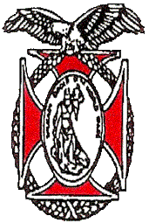 | Chapter 151  Region XIII  May 2026 Newsletter | 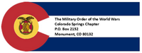
COMMANDER’S REMARKS (May 2026)

Greetings Companions!!
We had a wonderful Membership meeting on Saturday 18th of March. The speaker was LTC (Army, ret) Nathan Watanabe. He is currently working as a planner at NORAD/NORTHCOM and spoke about the plans and operations process at NORAD/NORTHCOM. He related the current challenges and threats, as well as provided updates on current operations. Our chapter has also presented MOWW medals and certificates to outstanding ROTC and JROTC students. Thanks to the 9 members who assisted Mike Berendt in this effort. In addition, I will be presenting the MOWW National Luftbury Award for the outstanding USAFA cadet in foreign languages on May 26th.
Our next meeting with be on Thursday, 28th of May. We will be resuming our Thursday evening dinner events now that the winter weather is over. The program starts at 1700 hours at the Patty Jewett Golf Course. Our speaker will be Mayor Yemi Mobalade, the Colorado Springs Mayor. He will be speaking about the city support for veterans as well as updates on plans and programs for the city. Plan to attend and bring others to hear this presentation.
May is also the month for elections for Chapter Commander and Staff. Voting will be done in person for those attending the May membership meeting. For those unable to attend, you may submit a ballot by email. See instructions in this newsletter. NOTE: There is space on the ballot for you to write in your name if you would like to be considered for one of our command and staff positions. Help live our motto “It is nobler to serve than to be served.”
Applications have closed for our Rocky Mountain Youth Leadership Conference. We welcome volunteers who would like to assist with this year’s Conference, 15-19 June at CSU Pueblo. More information is available at: The Conference - Rocky Mountain Youth Leadership Foundation Inc
A reminder that we will not be having a membership meeting in June because of our focus on the RMYLC. Our next Chapter event after the RMYLC will be participating in the Monument 4th of July Parade. There will also be other events to mark America 250 in the coming few months. I encourage you to attend and participate in these opportunities to demonstrate our patriotism!
Another reminder is that we are always looking for new members! Our goal this year from National is six new members, of which we have only enrolled four. Remember also that membership is now open to all ranks! Please consider who you can invite to attend meetings and join our worthwhile organization! Here is the link to the membership application on our website: moww-membership.pdf
Finally, we are looking for ways our Chapter can better serve you, our members. Please let us know your ideas for how to improve our service for you and our community.
Thank you again for the honor and privilege of being your commander and thank you all for your service!
Steve
sashambach@gmail.com
(719)447-5505
It is nobler to serve than to be served

ROTC AND JROTC
Our Colorado Springs Chapter of MOWW was honored to provide MOWW ROTC/JROTC Award of Merit Medals, Ribbons, and Certificates to 21 outstanding cadets throughout the Pikes Peak region and 1 student in Amherst, Ohio. Nine Companions recognized 3 outstanding UCCS (University of Colorado, Colorado Springs) ROTC Cadets and 18 JROTC high school students at 17 Awards Ceremonies in Colorado Springs, Fountain, Pueblo, Widefield, and Canon City. Thanks to our presenters for their support: Brigadier General Tony Trifiletti; Colonels Kerm Neal, Mark Ellis, and Steve Shambach; Lt Colonels Mike Berendt, Ulysses Swift, Kirk Brown, and Paul Willey; and Captain John Hannan.

The incredible value of our ROTC/JROTC programs in training, mentoring, teaching
citizenship, and molding the next generation of leaders for our nation cannot be overstated! As MOWW members, we provide the support and encouragement to dedicated active duty and retired Officers and Senior Non-Commissioned Officers from our Armed Services that have
stepped up and volunteered to continue to mentor and teach our nation’s high school and college students to be better leaders, citizens, and hopefully, take our place in military service to the nation. Our COS MOWW presenters were impressed with the quality and standards of the cadets we saw at these events and are proud to report that our nation will be in good hands for
years to come.

TREASURER’S REPORT INFORMATION
The following table depicts the Chapter’s financial status as of 2 May 2026.10 August
Account | Balances
CDs: | $ 13,785.21
Savings: | $105.16
Checking: | $5,617.27
Reserved: | $1,696.59
Total: | $ 21,206.51

AMERICA 250

We have a slot in the Monument Hill Kiwanis 4th of July Parade, in coordination with the Colorado Military History Group CMHG)! What a great way to celebrate our freedoms and the founding of our great Nation!! The CMHG will have two vintage vehicles this year; the 3/4 ton Dodge WC-21 WWII truck, and Nate Watanabe's venerable WWII Jeep. If you haven't ever been in the parade it is a memorable experience, and this year will be even more special!

The parade will begin at 10:00 AM, and the theme this year is “250 Years of Freedom; 150 Years of Colorado Statehood.” Contact Kerm Neal at knealsfour@yahoo.com or text to 719-205-1106 if you want to participate in the parade. Deadline for volunteering to participate in the parade is June 30th. We can accommodate eight Companions and family members for riding, any overage will walk. We don't know our spot yet, but we've asked to be close to the start line due to the aging veterans amongst us. The route is approximately 1.5 to 2.0 miles long, depending on where are starting spot is.

Hope to see you there!!

MAY MEMBERSHIP MEETING
MEMBERSHIP DINNER: Thursday, 28 May, 1700-1915
- Guest Speaker: Colorado Springs Mayor
- Location: Patty Jewett Golf Course.
- RSVP Required: No later than Noon, Monday, May 25th to Mike Berendt,berendt478@aol.com, (410) 908‐6777
- Menu: Buffet.
- Notify Mike Berendt if you have special menu requirements when submitting RSVP.
- Cost: $30 (cash or check only)

Mayor Mobalade Bio:

Blessing ‘Yemi’ Mobolade was sworn in as the 42nd Mayor of Colorado Springs on June 6, 2023. This is his first four-year term as mayor. He is the first Black man and immigrant to be elected mayor of Colorado Springs and one of the youngest. Mayor Mobolade moved from Indiana to Colorado Springs in 2010, where he started a church as part of the Christian and Missionary Alliance. After identifying a need in downtown Colorado Springs for cultural gathering places, he became one of the first entrepreneurs to invest in downtown after the Great Recession when he co-founded The Wild Goose Meeting House in 2013. Seeing a greater need for collaboration within the faith community, He began working as director of outreach and engagement at First Presbyterian Church, where he would go on to co-found COSILoveYou, a nonprofit that unites more than 100 area churches under the common mission of serving the Colorado Springs community. In 2017, Mayor Mobolade co-founded Good Neighbors Meeting House in the Patty Jewett neighborhood to provide an additional gathering place in the downtown area. He also began to leverage his success as an entrepreneur and business owner and began working as the vice president of business retention and expansion at the Colorado Springs Chamber & Economic Development Corporation. There he was instrumental in caring for local employers and attracting new companies during a period of record job growth for Colorado Springs. In 2019, Mayor Mobolade served the City of Colorado Springs as a small business development administrator. In this role, he established tools to assist entrepreneurs with starting a business, COSOpenForBiz.com and Permit Partner, and led many collaborative efforts across the community’s public and private sectors. He stepped down from this position in March 2022 to officially launch his mayoral campaign.

Mayor Mobolade was born in Nigeria to two bi-vocational pastors. His father was in finance and his mother was a secondary education teacher. At age 17, he immigrated to the United States, following in the footsteps of his brother to pursue the American Dream through education. Mayor Mobolade has bachelor’s degrees in business administration and computer information systems from Bethel University (Mishawaka, Ind.) and master’s degrees in management and leadership from Indiana Wesleyan University (Marion, Ind.) and theology-intellectual leadership from the A.W. Tozer Theological Seminary, part of Simpson University (Redding, Calif.).
He lives in Colorado Springs with his wife, Abbey, a nurse and nursing educator, and their three young children.

OY2027 STAFF ELECTION.
It is time for our annual MOWW Staff elections. The vitality of our Chapter depends on volunteers willing to take on leadership roles to bring fresh energy and new ideas to our organization. In accordance with our Bylaws, the following are the elected positions for our Chapter:
Elected | Elected/Appointed*
• Chapter Commander | - Historian
• Senior Vice Commander | - Marshall
• Junior Vice Commander | - Chaplain
• Adjutant | - Surgeon General
• Treasurer | - Public Relations Officer
 | - Judge Advocate
*If no volunteers for these positions, Commander can appoint Companion to position

CHAPTER ACTION PLAN (CAP)

Strategic Goal (SG) Current | Initiative
SG1 Outreach – Consistent impactful outreach programs and activities. | Contact any Staff member if you have any suggestions on meeting SG-1.
SG2 Strategic Partnerships - | Engage with other veteran organizations to establish strategic partnerships. Contact Steve Shambach with any suggestions on meeting SG-2. In Progress.
SG3 Maximize Visibility | Chapter committed to participate in Monument Hill Kiwanis 4th of July Parade. Contact Staff if you have any suggestions for how Chapter can meet this objective.
SG4 Annually grow engaged and sustainable MOWW membership. | Chapter recruiting goal for OY25-26 is six Companions. Please contact Mark Ellis if you have any prospective candidates.
SG5 Obtain financial resources to fulfill Order’s mission. | Regular solicitation of donations from Chapter Companions. Contact Mike Berendt if you have any questions concerning donations or other opportunities for Chapter fundraiser.
SG6 Increase number of chapters and strengthen existing chapters. | Contact anyone on Staff if you would like to volunteer your skills or suggestions for meeting this SG (i.e., strengthen recruiting, Chapter social media presence, Chapter branding, etc.
Colorado Springs MOWW Chapter welcomes LTC Nathan Watanabe April Speaker

LTC Nathan Watanabe, USA (Ret) is currently a Strategic Campaign Planner and Deputy Branch Chief, North American Aerospace Defense Command and US Northern Command, Peterson Space Force Base, Colorado. He provided a very informative briefing on the Unified Command Plan (UCP) and the role of USNORTHCOM as a US geographic Combatant Command. LTC Watanabe also discussed the role of NORAD, a Combined US/Canada Military Command charged with protecting North America from ground, sea, air, and space attacks by threat actors. Nathan presented the roles and responsibilities of the two commands, the organizational structures, and current missions and threats they face. He ended with a brief discussion of the current wars in Iraq and Ukraine and the newly acquired mission for USNORTHCOM of managing relations with Greenland.

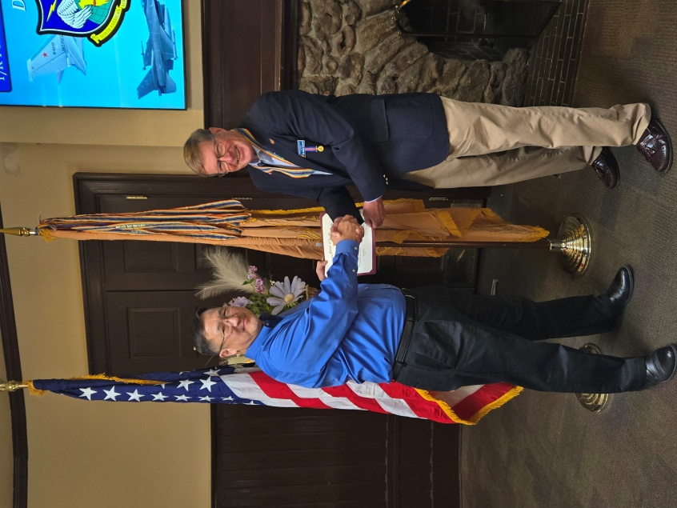
COL Shambach provides MOWW Certificate to LTC Nathan Watanabe, USA (Ret)

MAY MEMBERSHIP MEETING
The May MOWW Dinner meeting is on Thursday, 28 May 2026. Mayor Blessing Adeyemi Mobolade will be our guest speaker, providing an update on the city of Colorado Springs. Reservations required. RSVP to LTC Berendt, berendt478@aol.com, (410) 908-6777 NLT 25 May 2026.

MAY COMPANION BIRTHDAYSs
LTC Michael David Berendt, USA (Ret); Lt Col James B. Borders, Ph.D.,
USAF (Ret); Col Lowell B. Fisher, USAF (Ret); CDR Brian Q. Gauck, USN (Ret); Col Albert Joseph Gerathy Jr., USAF ANG; LTC Phillip L. Mallory II, M.D., USA (Ret); Col Robert F. Smith, USAF (Ret); Lt Col John W. Snider, USAF (Ret); Col James W. Taylor, USAF (Ret); 1LT Valerie J. Warner, USA (Fmr); Lt Col Paul D. Willey, USAF (Ret);

JUNE COMPANION BIRTHDAYS
Lt Col Kirk Brown, Lt Col Jo Carroll, LTC Chad Henderson, LTC James Liedle, CPT Daniel Monroe, Lt Kaleb Neal, Lt Col Richard Peters, MAJ Dean Rizzo, Mr. Walter Roy, Lt Col Ulysses Swift

PREAMBLE
To cherish the memories and associations of the World Wars waged for humanity;
To inculcate and stimulate love of our Country and the Flag;
To promote and further patriotic education in our Nation;
Ever to maintain law and order, and to defend the honor, integrity, and supremacy of our National Government and the Constitution of the United States;
To foster fraternal relations among all branches of the Armed Forces;
To promote the cultivation of Military, Naval and Air Science and the adoption of a consistent and suitable policy of National Security for the United States of America;
To acquire and preserve records of individual services;
To encourage and assist in the holding of commemorations and the establishment of Memorials of the World Wars;
And to transmit all these ideals to posterity, under God and for our Country, we unite to establish The Military Order of the World Wars.

Link to MOWW Preamble
Chapter Website: www.cos_moww.org
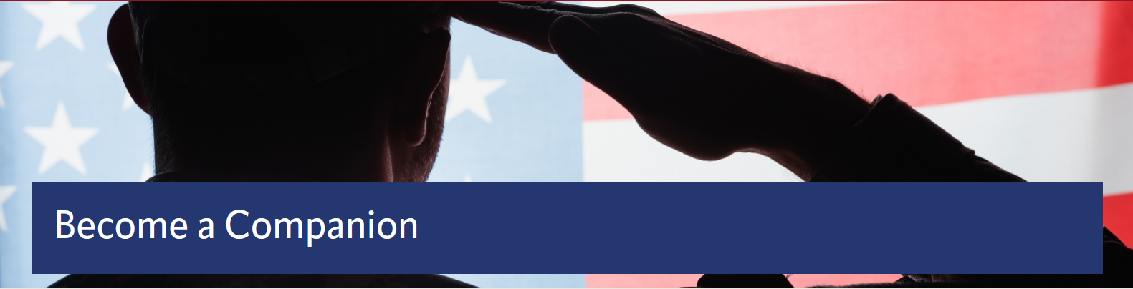
MOWW Membership Application
Please use this link to submit an electronic application: https://moww.org/become-a-companion/. Please see Staff for paper membership application or this link to print your own application: https://moww.org/wp-content/uploads/2022/10/MembershipApplication-MOWW-1.pdf

POINTS OF CONTACT

MOWW Chapter 151
Colorado Springs, CO
Commander
Stephen A. Shambach (COL, USA, Ret)
15270 Churchill Place
Colorado Springs, CO 80921
(719) 447-5505
shambachsm@msn.com

Senior Vice Commander
Mark A. Ellis (COL, USAR, RET)
5555 Chukar Trail
Colorado Springs, CO 80918
(402) 709-3373
Mae77@icloud.com

Junior Vice Commander
Ulysses Swift (Lt Col, USAF, Ret)
2585 Deliverance Drive
Colorado Springs, CO 80921
(719) 548-0865
swift888@comcast.net

Adjutant
Kirk Brown (Lt Col, USAF, Ret)
2539 Craycroft Drive
Colorado Springs, CO 80920-1423
(719) 500-9168
ltckirkbrown@juno.com

Treasurer
Mike Berendt (LTC, USA, Ret)
1230 Bowstring Rd.
Monument, CO 80132
(401) 908-6777
berendt478@aol.com
Patriotic Education Committee Chair
Stephen A. Shambach (COL, USA, Ret)
15270 Churchill Place
Colorado Springs, CO 80921
(719) 447-5505
shambachsm@msn.com

Homeland Security Committee Chair
(Vacant)

Public Safety and Law & Order Committee Chair
(Vacant)

ROTC and JROTC Committee Co-Chairs

Mike Berendt (LTC, USA, Ret)
Ulysses Swift (Lt Col, USAF, Ret)

Scouting Committee Chair
Kerm Neal (Col, USAF, Ret)
13303 Honey Run Way
Colorado Springs, CO 80921
(719) 205-1106
knealsfour@yahoo.com

National Security Committee Chair
(Vacant)
Veterans Affairs Committee Chair
(Vacant)

Surgeon General
Tisha K. Ellis (MAJ, USAR)
5555 Chukar Trail
Colorado Springs, CO 80918
402 541-2230
kim40@icloud.com

Judge Advocate General
Mark A. Ellis (COL, USAR, Ret)
5555 Chukar Trail
Colorado Springs, CO 80918
402 709-3373
mae77@icloud.com

Rocky Mountains Department Commander
Kerm Neal (Col, USAF, Ret)
13303 Honey Run Way
Colorado Springs, CO 80921
(719) 205-1106
knealsfour@yahoo.com

Region XIII Commander
Vacant

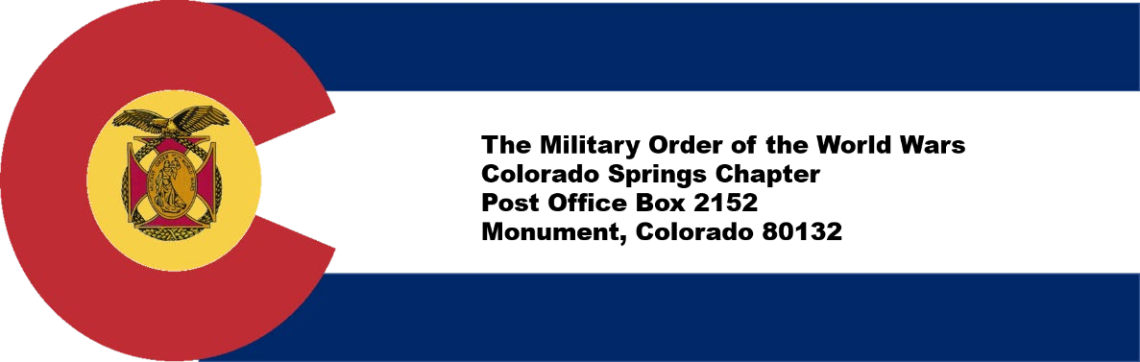

​
CONTRIBUTION OR PLEDGE
Yes, I am making a tax-deductible contribution or pledge to the Colorado Springs Chapter of the Military Order of the World Wars.
I wish to contribute or pledge $__________to the Patriotic Education Fund.
I wish to contribute or pledge $__________to the ROTC Fund.
I wish to contribute or pledge $__________to the Boy and Girl Scout Fund.
I wish to contribute or pledge $__________to the Law & Order Fund.
I wish to contribute or pledge $__________to the Operations Fund (postage, bulletin, directory, recognition programs – plaques, medals, etc.)
_______________________________________
Name
Please make checks payable to Colorado Springs Chapter, MOWW Send to:
LTC Mike Berendt (USA, Ret), 1230 Bowstring Road, Monument, CO 80132

