COMMANDER’S LOG

ACHTUNG! ATTENTION! CUIDADO!

This month the chapter is to in person dinner meetings. With that, there is a change in meeting location. The meeting room that the chapter has in the Los Alamos Research Park is being used from May 15th through August 31st for housing LANL summer students. Therefore, it is no available for the chapter to use during this time period. The meeting will be held in the 2nd floor meeting room in the American Legion Post building at 1325 Trinity Drive. Meeting details below. This may change due to the Cerro Pelado fire activities.

In some parts of this country, COVID-19 Omicron variant B.A.2 is making a fifth COVID infection wave. This variant is more infectious, but produces a less serious illness. Although the infection rate is up, hospitalizations and deaths are still low. My of us are vaccinated, boosted, and even double boosted. Therefore, wherever we go, the threat of catching COVID is still there, but is currently considered not a serious problem as it previously was.

On a separate note, Memorial Day is on the 30th. A two- person color guard is needed as well as someone to place the wreath. I will be out of town that weekend so volunteers are needed. I will provide the necessary items before hand.

THIS MONTH’S EVENTS



This month’s speaker will be Alan Carr, LANL Senior Historian.

Clouds Over Kokura: The Atomic Strike Against Nagasaki and the End of World War II

On August 6, 1945, an atomic bomb was detonated over the Japanese city of Hiroshima. Three days later, a second bomb was detonated over Nagasaki. On August 14, Imperial Japan surrendered and World War II can to an abrupt and victorious conclusion. But is there more to the story? Why wasn’t a demonstration of the atomic bomb performed before the combat strikes? Were the Japanese warned? Why was a second bomb used? Why was Nagasaki selected as the target? Did the mission go smoothly? What role did the use of atomic bombs play, if any, in ending the war?

MEETING DETAILS

This month’s meeting will be on Tuesday May 17th. It will be held in the 2nd floor meeting room in the American Legion Post building at 1325 Trinity Drive, behind the Muy Salsas restaurant and Saint Job of Pochaivi Orthodox Church.

The meeting will begin with a social period at 6:00 PM followed by a brief business meeting and dinner at 6:25 PM. The presentation will begin at about 7:15 PM. The Military Order of the World Wars meetings are open to interested citizens. Dinner is available from Senor Tortas restaurant on the 1st floor

Because of the ongoing COVID situation, the meeting will be a hybrid session including Zoom. Zoom will start at about 6:25 pm. Zoom details will be in the reminder email.

LAST MONTH: SPEAKER

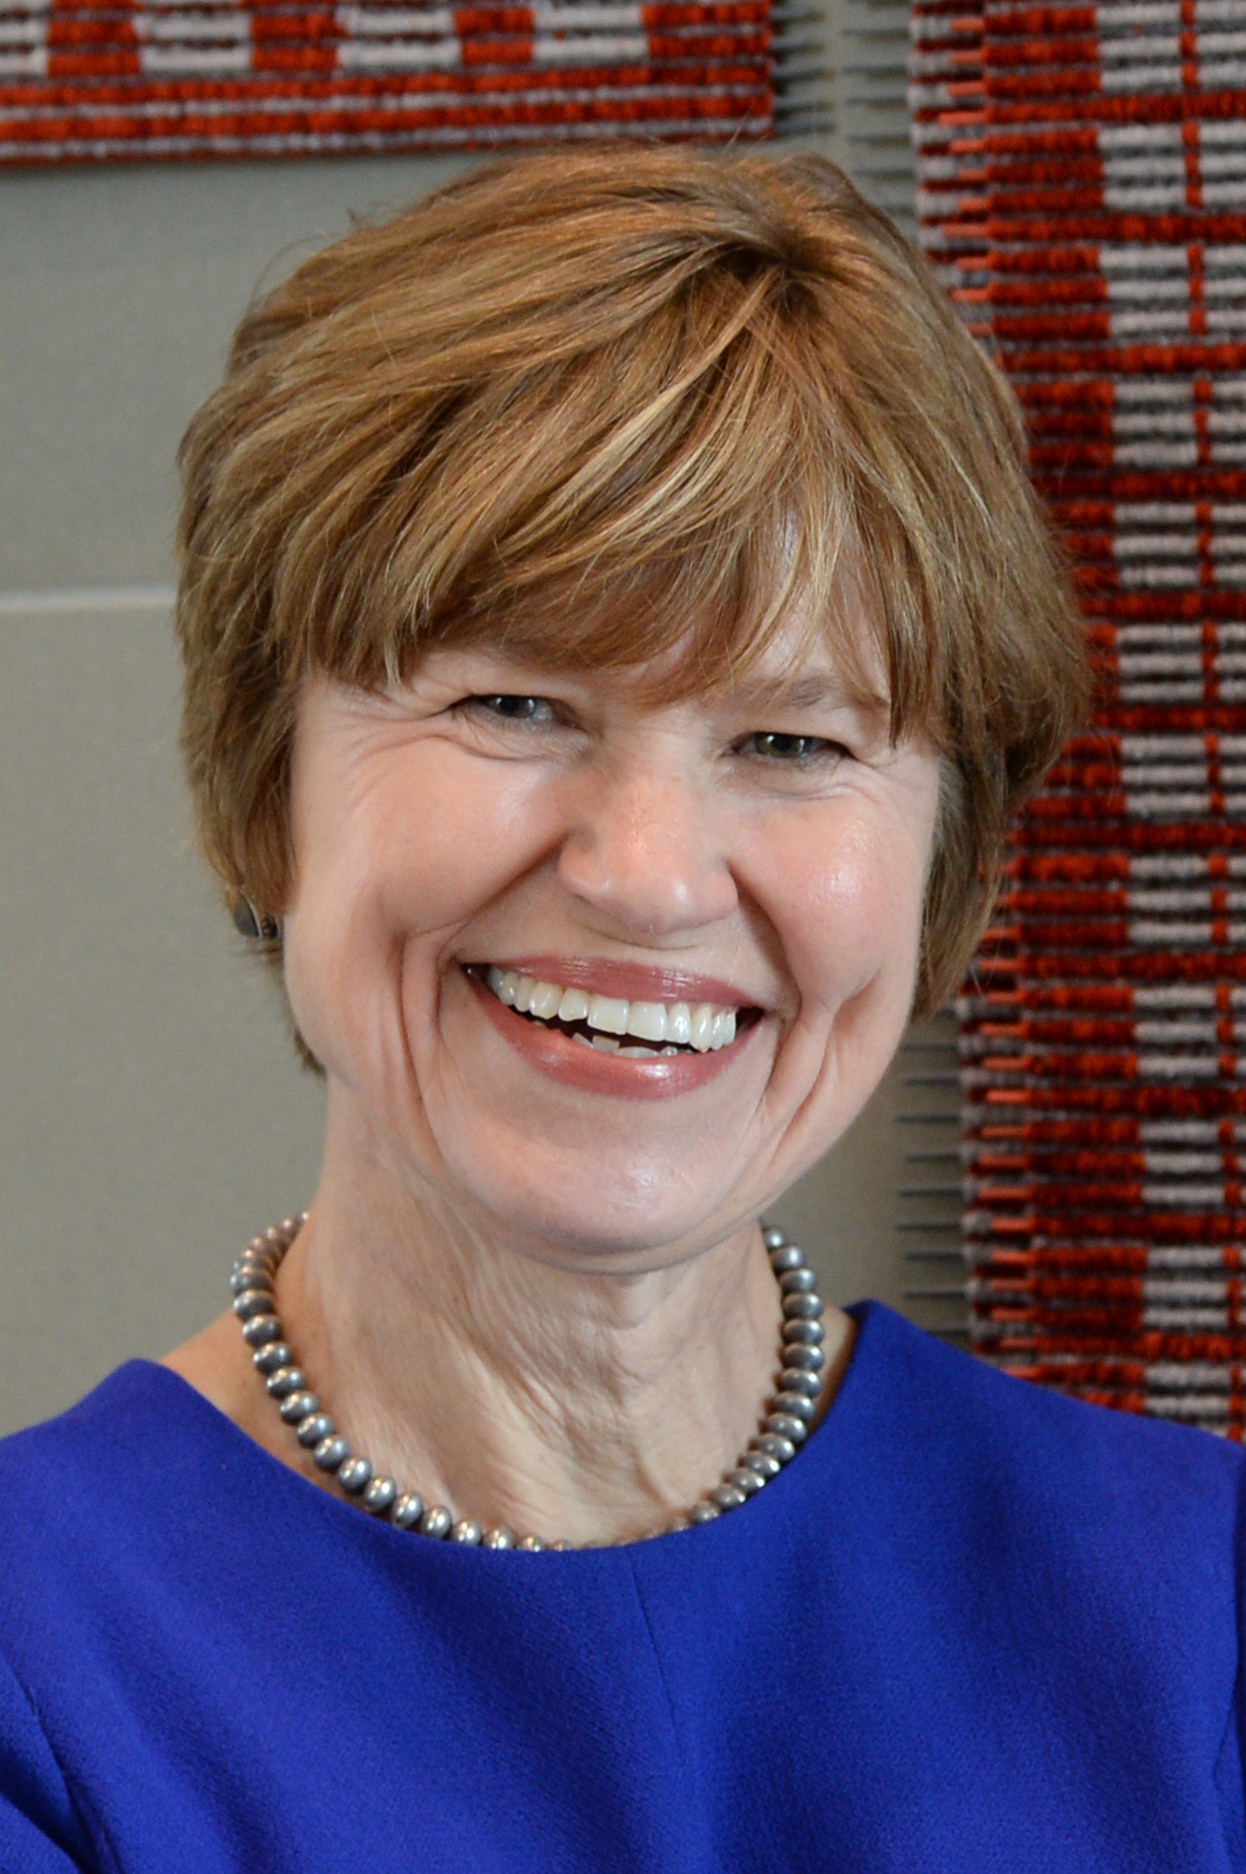

Last month, Representative Christine Chandler talked about the recent legislative sessions. Representative is n her forth year (two terms) in the state legislature. All the New
Mexico legislators are volunteers because the New Mexico legislature is the only unpaid legislature in the country.
They only get per diem during sessions. Therefore, they have to take time off from their jobs.

This fiscal year, the legislature met three times. In even years, the legislature meets for thirty days to consider tax and revenue items and items in the governor’s call. The legislature meets for sixty days in odd years and can consider all issues.

A special session was held in December for redistricting after the ten-year census. Population shifts require rebalancing the size of districts. Her district lost areas north of Valle Grande, but because Los Alamos County grew in size it was added to part of Santa Fe County. The district is now more compact and homogenous. The district still included the Jemez Springs area. Redistricting on the house side of the legislature went smoothly.

Revenue from the oil and gas taxes is higher. The budget was based on $60 per barrel oil which is now at $100 per barrel. This led to improved funding for education and higher education. The budget received a 14% increase including a 7% raise for state workers and a $15 per hour minimum for them. The state has a 30% reserve because oil and gas revenue is volatile. Experts expect oil and gas revenue to remain high for the next decade. There is also increases in revenue from personal income taxes, strong gross receipts tax, and increases in property taxes from Amazon, Intel and Facebook.

Representative Chandler is the chair of the House Taxation and Revenue Committee. The tax package reduced taxes by about $500 million. Social Security income was made tax exempt up to a limit. Military pensions will become exempt in three steps over five years, $10k, $20k, then $30k. The is also a tax rebate for children. Nurses working in COVID hospitals will receive a $1000 tax credit. Most of these changes were made permanent.

There were several improvements in funding for education. Teachers will receive a 7% raise as well as an increase of $10k for each of the three tiers. An Opportunity Scholarship was created for all first-time attenders in college or trade schools.

A public safety initiative was passed because the metro areas have problems. It included increases in mental health, more state police, and judges. The interest rate on installment loans was lowered from 175% to 36%.

There was a discussion on an amendment for the Antidonation Clause in the state constitution. Currently direct funding to individuals is prohibited. The proposal would exempt donations for essential household services such as electricity, water, sewer, and internet. Many can’t afford the installation. Many households need secure access to water and electricity.

A one-day special session was held in April. Due to escalating gas prices, A $500 per driver rebate was passed. Half would be paid in May and half in July, split over two fiscal years.

In response to a question, the Opportunity Scholarship would a break in education. It is not limited to 4-year colleges, but can also be used for trade schools and certificate programs. Every year, it would need to be funded.

A supplemental budget (junior budget) was passed in the April special session. It pays for legislators spending in earmarks for programs and projects in their districts.

LAHS NJROTC news

We Mexico have had many fun events happen from the last time you read this newsletter. The NJROTC unit hosted their annual awards ceremony, this ceremony is celebrating cadet’s new ranks, ribbons, and staff positions. It was an exciting night as all of the cadets were cheering each other on as many of them stepped up to receive their various awards and promotions. Another event that has been held is the annual military ball that was hosted within Fuller Lodge. It was a night full of ceremonial aspects along with great food and fun dancing. This ball was a fun way to introduce the new cadet staff as well as get other cadets to have fun and socialize with the other cadets within the unit. Lastly, in the near future there will be a spring car wash. This car wash is used to help raise money for the NJROTC competition trips as well to give back to the community.

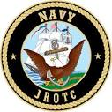
C/ENS Miranda Lopez

LAHS NJROTC Awards

The Los Alamos High School NJROTC held its Spring Awards Ceremony on April 8th. At the ceremony, the Chapter presented several awards. Patrick Henry Bronze Medallions were presented to NS1 Outstanding Cadet Petty Officer Second Class Patrick Baker, NS2 Outstanding Cadet Petty Office Second Class Samantha Nash, NS3 Outstanding Cadet Chief Petty Officer Tyson Lujan, and NS4 Outstanding Cadet Lieutenant Junior Grade Stephanie Peters. The NJROTC Award of Merit Medal was awarded to Cadet Lieutenant Junior Grade Ethan Chandler. Finally, the MG Franklin E. Miles Chapter $500 Scholarship was awarded to Cadet Lieutenant Commander Aleena Fullop.

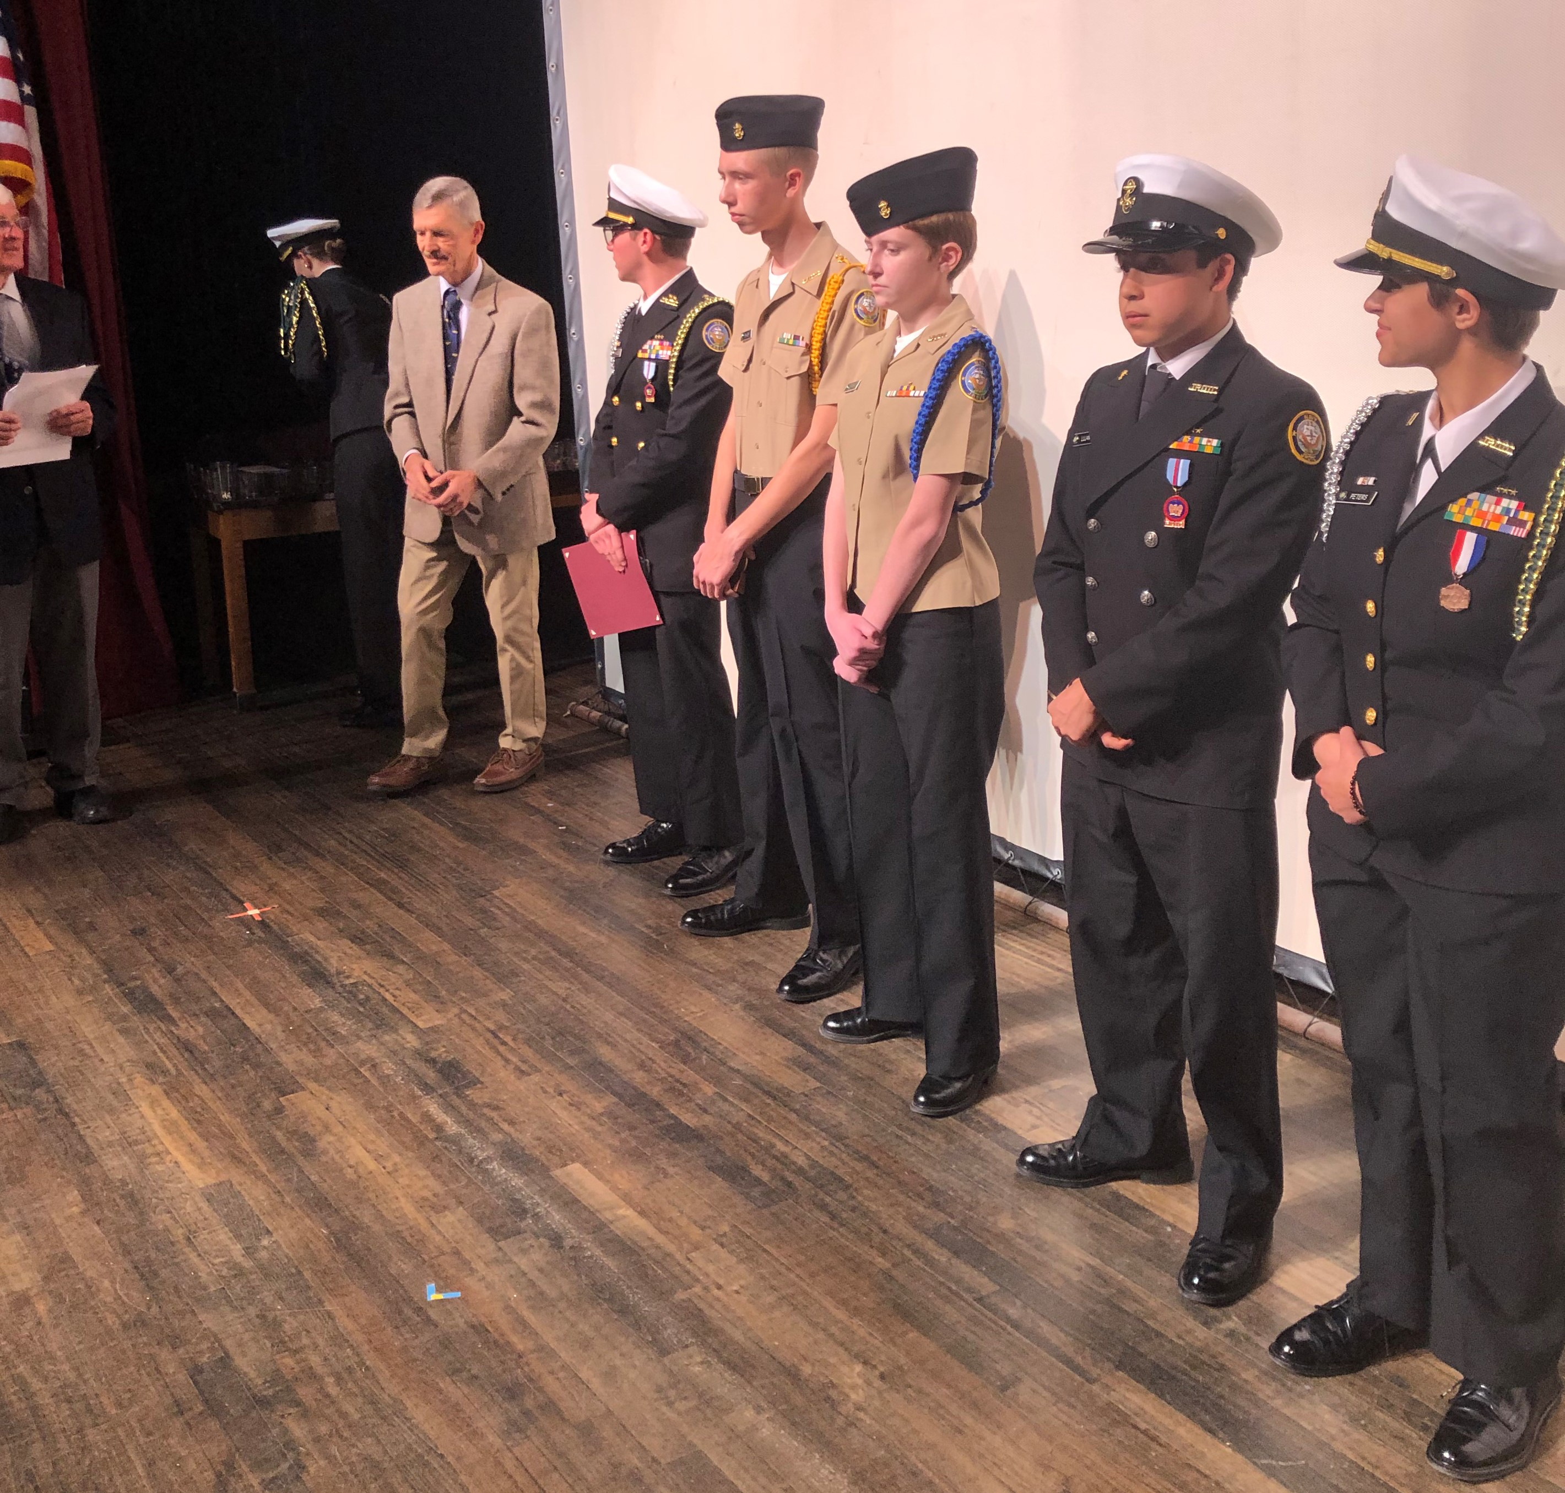

From left to right: C/LCDR Aleena Fullop, Wes Shumaker, C/LTJG Ethan Chandler, C/PO2 Patrick Baker, C/PO2 Samantha Nash, C/CPO Tyson Lujan, C/LTJG Stephanie Peters

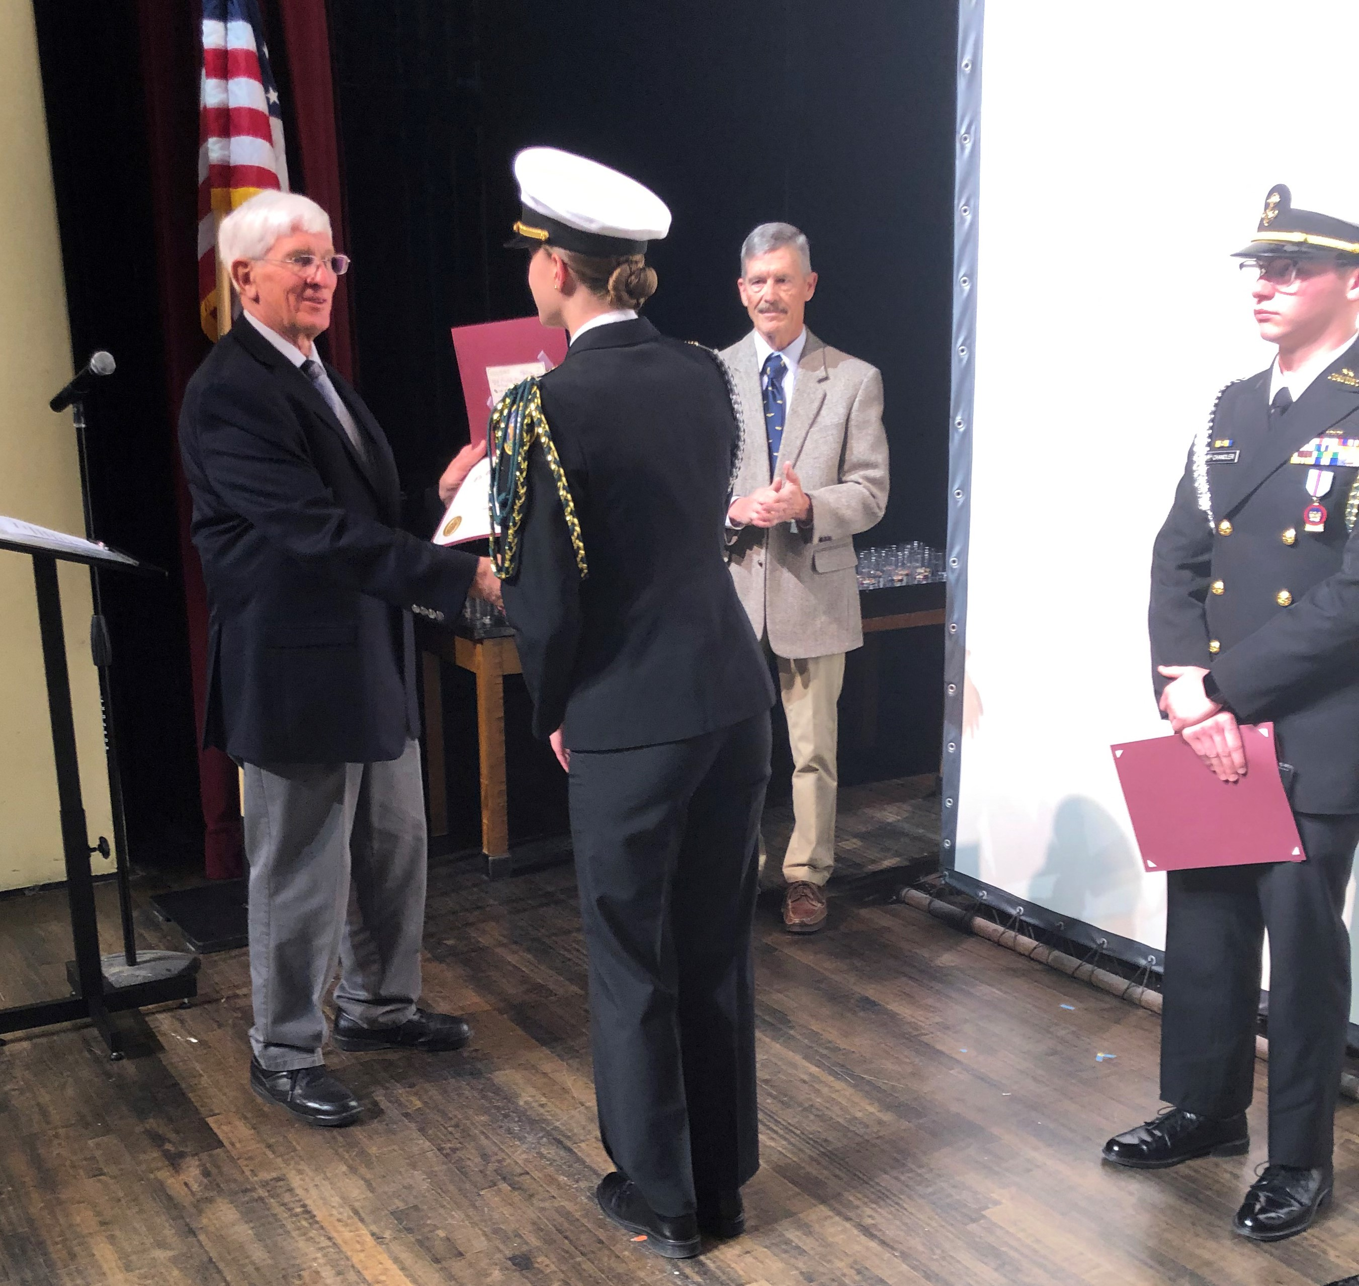

LCOL Gerald Bolme with C/LCDR Aleena Fullop

Below is the thank you note from C/LCDR Fullup, the recipient of the chapter’s scholarship.
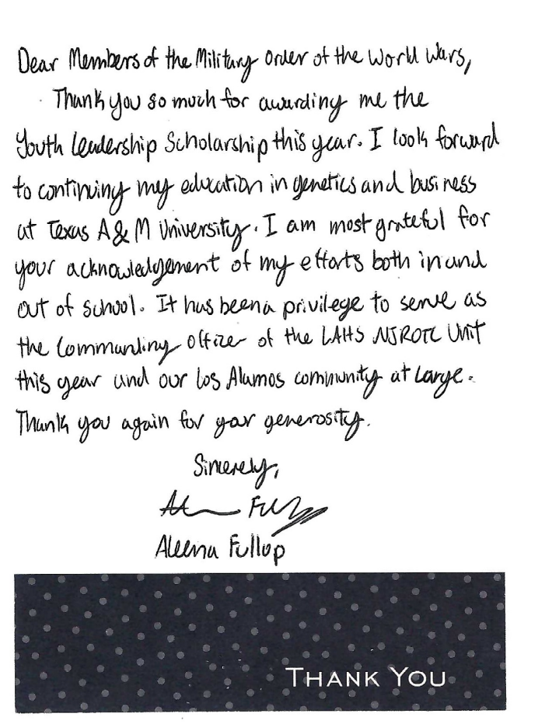

FOR THE GOOD OF THE CHAPTER

As you know, the 2022 Convention will be in Jacksonville, FL; the 2023 Convention will be in Annapolis MD. Another East Coast Region has expressed interest in hosting the 2024 Convention. The National leadership has expressed concern about three back-to-back-to back Conventions all on the East Coast. There has been some discussion lately within our own Region by Companions in the Southern AZ area who are interested in hosting a convention in 2024 perhaps wrapping it into a Region-wide event. 2022 Convention information will be attached with this newsletter.

NATIONAL OFFICERS

- COMMANDER IN CHIEF
LTC Michael A. Okin M.D. USA (Ret)
maokin1953@gmail.com

- VICE COMMANDEER IN CHIEF
Lt Col Marlon Ruiz, USAF (Ret)
ruizmarlon08@gmail.com

- REGION XIII COMMANDER
LTC Patrick C. Stolze, USA (Ret)
pstolze40@gmail.com

website www.MOWWSCV.com

NATIONAL STAFF

- CHIEF OF STAFF & COO
Col Michael Farrell, USMC (Ret) | chiefofstaff@moww.org

- DIRECT OF FINANCE
finance@moww.org

- MANAGER, MEMBERSHIP PROGRAMS (including dues payments)
HPM Justin Hiller | membership@moww.org

- MANAGER, MOWW STORE
Mrs. Sunny Alley | merchandise@moww.org

Website www.moww.org

MG MILES CHAPTER OFFICERS

Commander
LTC Gregg Giesler USA (Ret)
Home: 505-662-5574
g.giesler@computer.org

Senior Vice Commander
HPM Vernon V. Haywood, Jr.
Home: 505-661-4192
vvhaywoodjr@att.net

Adjutant
HPM Vernon V. Haywood, Jr.
Home: 505-661-4192
vvhaywoodjr@att.net

Treasurer
COL Gerald Bolme USAF (Ret)
Home: 505-672-1233
bolme@earthlink.net

Assistant Treasurer
MAJ Robert Hull USAF (Ret)
Home: 505-662-7950
rhull@lata.com

Chaplain
MAJ Donald B. Davidson, Jr., USA (Ret)
Home: 505-672-3794
dbd1alamos@msn.com

COMING EVENTS

May
9 Staff Meeting
17 Chapter Dinner – Alan Carr – Clouds Over Kokura (Part 1)
30 Memorial Day Ceremony – Guaje Pines Cemetery

June
13 Staff Meeting
? Region XIII Conference
21 Chapter Dinner & Elections/Installation of Officers – Alan Carr – Clouds Over Kokura (Part 2)
28 1994 Chapter chartered

