COMMANDER’S REMARKS (13 October 2025)
Greetings Companions!!
We had a terrific membership dinner on Thursday, 25th of September. The program featured the Rocky Mountain Youth Leadership Foundation (RMYLF) presentation by RF Smith and students who attended the 2025 Rocky Mountain Youth Leadership Conference (RMYLC). We had 4 students and 1 parent give testimonials about the Conference and how it impacted them. Also, I was able to present the Outstanding Service Award to Companion Lt Col (AF, ret) Paul Willey to honor his contributions to both our Chapter and as the Patriotic Education Program chair for the RMYLC. I also acknowledged Rich Peters and Randy Helms who attended the 9-11 Memorial Celebration at UCCS, representing our Chapter.
Our October meeting was the RMYLF Night at the Museum Fund Raiser on Saturday, October 4th at the World War II Aviation Museum. I would like to thank companions who attended the gala, invited other guests and donated to the Foundation. This partnership is critical to our Chapter because the Patriotic Education Program is the flagship for our Chapter. In addition, RMYLF provides funds to our Chapter from the Conference.
I recently became aware that MOWW has a membership oath for new members being sworn in to the order. Since we have not been doing this, I asked members to recite the oath at the September meeting:
“I, STATE YOUR FULL NAME, do solemnly swear (or affirm) that I will selflessly serve as (a Companion, or state the elected office) of the Order with a sincere spirit of volunteerism, that I will promote the principles, goals, and policies of the Order according to its Constitution and Bylaws; support the precepts of the Preamble to the Constitution of our Order; and abide by the MOWW Code of Ethics. I take this obligation freely, and I will faithfully discharge the duties of the office upon which I am about to enter; so help me God.”
Please consider volunteering to serve!
November activities are centered around Veteran’s Day. Here are some opportunities for you to help the Chapter celebrate Veteran’s Day:
- This Year’s Colorado Springs Veteran’s Parade will be on Saturday, November 8th at 1100 hours. Our Chapter is partnering with Nathan Watanabe and his historic military vehicles to participate in the parade. If you would like to join us riding in these vehicles, please let Kerm Neal or Rich Peters know. We have a limited number of seats available, but you can also march along the parade route.
- There will normally be a Veteran’s Day Observance on Tuesday, November 11th at 1100 hours at Memorial Park.
- Finally, there will be a Veteran’s Stand Down Day at Weidner Field, 21 October, 0900-1400, Volunteers welcome. Please let Rich Peters know if you are able and willing to help volunteer to help our veterans.
Our November meeting will be to celebrate Veterans, on Saturday, 22 November and will start our winter luncheon, meetings from 1100-1300. Our featured speaker is Mike McGrath, Naval Air Aviator, Viet Nam POW and local legend. Plan on attending this event and bringing others!
I am excited about the year ahead and request you consider how you can contribute your efforts for the good of the order, and to enact the motto “It is nobler to serve than to be served”!
Thank you again for the honor and privilege of being your commander and thank you all for your service!

Steve
It is nobler to serve than to be served.

****************************************COMING EVENTS

NOVEMBER MEMBERSHIP MEETING:
- Saturday, 22 November @1100hrs
- Location: Patty Jewett Golf Course
- RSVP: No later than noon on 19 November to
LTC Mike Berendt
VETERANS DAY PARADE:
- In Their Honor Veterans Day parade
- 11 a.m. Nov. 8 along Tejon Street
- We are teaming again with the Colorado Military History Group and will have three World War II and Vietnam War vintage vehicles
***************************************
COMPANIONS JOHN RUSSELL AND JOHN HANNAN GO ON HONOR FLIGHT TO DC.
Months ago our luncheon speaker spoke on The Honor Flight of Southern Colorado. After hearing the presentation, both companions applied and were selected. Fifty-seven veterans (15 wheelchair bound) went on Mission 21 to DC from 2-4 October. They were accompanied by an entourage of medical folks, a behavior specialist from VA, 2 individuals from KOAA Channel 5, and a large number of guardians as escorts and group leaders. John Russell says “it was a fun and fulfilling trip. While at the Tomb of the Unknown Soldier a young tomb guard from Parker gave 15 minutes of his time for questions. That was the highlight for many of us.”

STAFF MEETING (18 September)
TREASURER’S REPORT INFORMATION
The following tables depict the Chapter’s financial status as of 1 September.(1010 August
Account | Balances
CDs: | $13,448.74
Savings: | $104.18
Checking: | $2,048.13
Reserved: | $2,070.29
Total: | $17,671.34

CHAPTER ACTION PLAN (CAP)
Strategic Goal (SG) Current | Initiatives
SG1 Outreach – Consistent impactful outreach programs and activities. | Contact any Staff member if you have any suggestions on meeting SG-1.
SG2 Strategic Partnerships - | Engage with other veteran organizations to establish strategic partnerships. Contact Steve Shambach with any suggestions on meeting SG-2. In Progress.
SG3 Maximize Visibility | Chapter committed to participate in Colorado Springs Veterans Day Parade. Contact Staff if you have any suggestions for how Chapter can meet this objective.
SG4 Annually grow engaged and sustainable MOWW membership. | Chapter recruiting goal for OY25-26 is three Companions. Please contact Mark Ellis if you have any prospective candidates.
SG5 Obtain financial resources to fulfill Order’s mission. | Regular solicitation of donations from Chapter Companions. Contact Mike Berendt if you have any questions concerning donations or other opportunities for Chapter fundraiser.
SG6 Increase number of chapters and strengthen existing chapters. | Contact anyone on Staff if you would like to volunteer your skills or suggestions for meeting this SG (i.e., strengthen recruiting, Chapter social media presence, Chapter branding, etc.

NOVEMBER MEMBERSHIP MEETING
MOWW dinner meeting on Saturday, 22 November will be a celebration to Veterans. Mike McGrath, A Viet Nam POW will be our Speaker. Please note that it is our move to Saturday Lunch meetings.

COS MOWW Supports Honor Flight

On 4 October 2025, Honor Flight #21 of Southern Colorado returned to Colorado Springs. Almost 100 World War II, Korean War, and Vietnam War Veterans, along with their sponsor escorts, participated in a three day journey to Washington, D.C. from 2-4 October to visit the National Memorials to their service in our Nation’s wars. For some, like Sgt T.J. Ramos, a Vietnam War Veteran, this journey was both cathartic and cleansing, providing camaraderie with his peers as well as replacement of bad memories with good ones. He returned to the United States in the 1970s from service as a B-52D Tail Gunner in the Air Force and met both dissent and disdain from those opposed to the war. This time, he was welcomed with open arms by hundreds of cheering admirers from local Scouts, Students, Family, Colorado Springs Community Members, and Military Service Groups including COS MOWW Treasurer, LTC Mike Berendt, USA (Ret).
Honor Flight of Southern Colorado is part of the Honor Flight Network, a national organization with a mission of honoring our nations’ veterans by bringing them to Washington DC to visit the memorials dedicated to their service and sacrifice. Honor Flight of Southern Colorado takes veterans from the World War II, Korea and Vietnam eras on a three day, all-expense paid trip to our nation’s capital. These excursions, free to Veterans and funded solely by Non-profit Honor Flight Societies, have provided an everlasting “Thank-You” to Veterans whose service and sacrifice has been largely unrecognized or forgotten through the passage of time. The Honor Flights and their organizers, sponsors, and escorts truly represent the MOWW motto, that it is Nobler to Serve than to be Served!
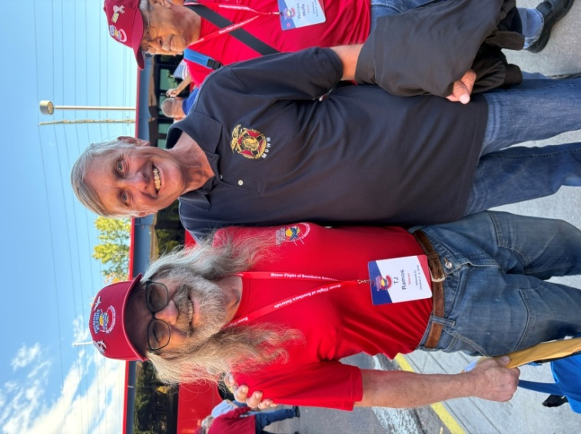
LTC Mike Berendt, USA (Ret), COS MOWW, meets T.J. Ramos, Vietnam War Veteran, at the conclusion of Southern Colorado Honor Flight #21.

ROTC/JROTC
School is back in session for most of our local high schools and our Department Commanders are reorganizing their ROTC/JROTC units with new cadet leadership and members. We are updating our contact information to reflect changes in Military leadership and phone numbers in preparation for spring award ceremonies. With the recent changes to MOWW Membership policies, we are also encouraging our retired Non-Commissioned officers to join our Colorado Springs MOWW chapter.

VOLUNTEER OPPORTUNITIES
Companions consider volunteering for the following Chapter vacancies for OY25-26:
- Newsletter Editor

- Historian
- Marshall
- Chaplain
- Surgeon General
- Public Relations Officer
- National Security Chair
- Veterans Affairs Chair

PATRIOTIC EDUCATION:
COL Shambach presented the MOWW National Third Place Certificate and Ribbon for Patriotic Education to our Rocky Mountain Youth Leadership Foundation (RMYLF) during the 25 September Companion Meeting. Colonel RF Smith, USAF (Ret), President of the Foundation and Lt Col Anja Wynne, USAF (Ret), Youth Leadership Conference Director, accepted the award and provided an update on the Foundation and recent youth Conference. We were impressed with observations and testimonials from four of this year’s youth conference students who joined us for dinner. Their eloquence, intelligence, self - appraisal, and praise for the Conference and senior staff from MOWW are a tribute to their development as future leaders and the success of the Conference in preparing the next generation for Service. With 33+ years and over 2,300 student graduates, the Rocky Mountain Youth Leadership Foundation and Conference continue to train, mentor, and inspire our emerging Colorado High School Seniors by Building Informed Citizen Leaders prepared to Serve rather than to be Served!
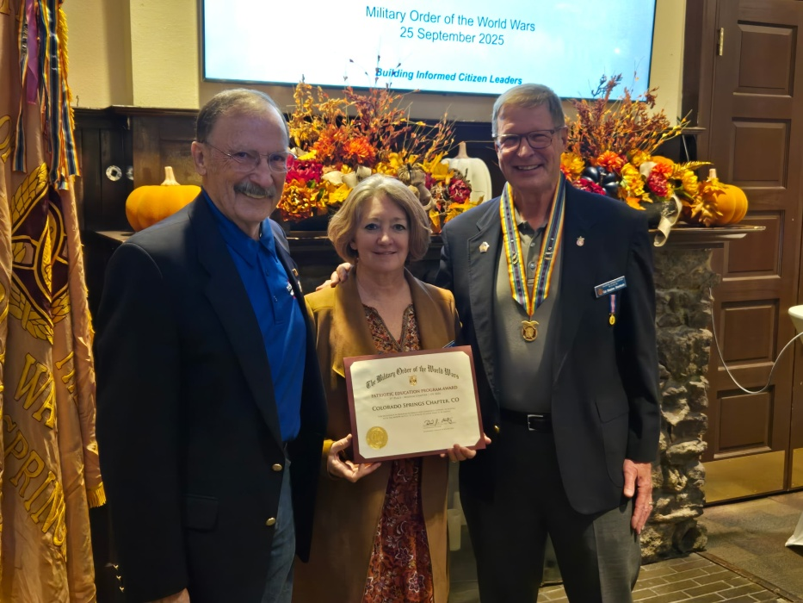
Colonel RF Smith and Lt Col Anja Wynne receive the MOWW award for Patriotic Education from Colonel Steve Shambach

OCTOBER COMPANION BIRTHDAYS
Col John Abbatiello; COL Lee Van Arsdale; LT Robert Bythewood; CPT John Hannan; LTC Victor Tise; Capt Ronald Maw
NOVEMBER COMPANION BIRTHDAYS
LTC John Russell; MAJ Roosevelt Hines, Jr;
Col Richard Rima; COL Stover James, Jr;
COL Michael Boatner

PREAMBLE
To cherish the memories and associations of the World Wars waged for humanity;
To inculcate and stimulate love of our Country and the Flag;
To promote and further patriotic education in our Nation;
Ever to maintain law and order, and to defend the honor, integrity, and supremacy of our National Government and the Constitution of the United States;
To foster fraternal relations among all branches of the Armed Forces;
To promote the cultivation of Military, Naval and Air Science and the adoption of a consistent and suitable policy of National Security for the United States of America;
To acquire and preserve records of individual services;
To encourage and assist in the holding of commemorations and the establishment of Memorials of the World Wars;
And to transmit all these ideals to posterity, under God and for our Country, we unite to establish The Military Order of the World Wars.

Link to MOWW Preamble
Chapter Website: www.cos_moww.org

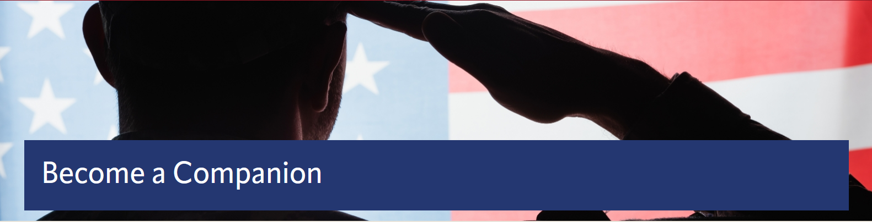
MOWW Membership Application
Please use this link to submit an electronic application: https://moww.org/become-a-companion/. Please see Staff for paper membership application or this link to print your own application: https://moww.org/wp-content/uploads/2022/10/MembershipApplication-MOWW-1.pdf

POINTS OF CONTACT

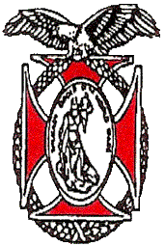
MOWW Chapter 151
Colorado Springs, CO
Commander
Stephen A. Shambach (COL, USA, Ret)
15270 Churchill Place
Colorado Springs, CO 80921
(719) 447-5505
shambachsm@msn.com
Senior Vice Commander
Mark A. Ellis(COL, USAR, RET)
5555 Chukar Trail
Colorado Springs, CO 80918
(402) 709-3373
Mae77@icloud.com
Junior Vice Commander
Ulysses Swift (Lt Col, USAF, Ret)
2585 Deliverance Drive
Colorado Springs, CO 80921
(719) 548-0865
swift888@comcast.net
Adjutant
(Vacant)
Treasurer
Mike Berendt (LTC, USA, Ret)
1230 Bowstring Rd.
Monument, CO 80132
(401) 908-6777
berendt478@aol.com
Patriotic Education Committee Chair
Stephen A. Shambach (COL, USA, Ret)
15270 Churchill Place
Colorado Springs, CO 80921
(719) 447-5505
shambachsm@msn.com
Homeland Security Committee Chair
(Vacant)
Public Safety and Law & Order Committee Chair
(Vacant)
ROTC and JROTC Committee Co-Chairs
Mike Berendt (LTC, USA, Ret)
Ulysses Swift (Lt Col, USAF, Ret)
Scouting Committee Chair
Kerm Neal (Col, USAF, Ret)
13303 Honey Run Way
Colorado Springs, CO 80921
(719) 205-1106
knealsfour@yahoo.com
National Security Committee Chair
(Vacant)
Veterans Affairs Committee Chair
(Vacant)
Surgeon General
Tisha K. Ellis (MAJ, USAR)
5555 Chukar Trail
Colorado Springs, CO 80918
402 541-2230
kim40@icloud.com

Judge Advocate General
Mark A. Ellis (COL, USAR, Ret)
5555 Chukar Trail
Colorado Springs, CO 80918
402 709-3373
mae77@icloud.com
Rocky Mountains Department Commander
Kerm Neal (Col, USAF, Ret)
13303 Honey Run Way
Colorado Springs, CO 80921
(719) 205-1106
knealsfour@yahoo.com
Region XIII Commander
Ken Robinson (LTC, USA, Ret)
32078 S Agarita Dr
Oracle, AZ 85623
(520) 825-5613
robinson4ken@gmail.com

