**COMMANDER’S CORNER (7 JUNE 2022)**

We will have a regular face-to-face General Membership Meeting on Saturday, 25 June 2022, starting at 11:30 A.M. The meeting will be held at Las Brisas Restaurant, 6787 S. Clinton Street, Greenwood Village, CO. Our speaker will be Vicki Siegel, Certified Exercise Physiologist and Personal Trainer. With Bachelor degrees in Physical Education and Commercial Recreation and a Master’s Degree in Exercise Physiology with a specialty in Cardiopulmonary Rehabilitation and extensive experience in that specialty, she is well qualified to give us some advice on a wellness program.

To get there (Las Brisas Restaurant), if you are coming from east of I25, drive west on Arapahoe Road to South Clinton Street (about a block before you get to I25) and take a left turn. Do not turn on Clinton Court as the next street is South Clinton Street. The restaurant is located on the east side of the Target Store parking lot. If you are coming from west of I25, drive east on Arapahoe Road until you pass under I25. The first street on the right is South Clinton Street. Turn right and you will see the restaurant on the east side of the Target Store parking lot. If you get lost, you can call me at 303-981-5519 (cell) and I will try to get you un-lost.

Coy D. Ritchie, D.M.

LCDR, USN (Ret)

Denver Chapter Commander

***It is nobler to serve than to be served***



**STAFF MEETING (7 June 2022)**

This meeting was conducted at Frances Long’s Home and virtually via Zoom. The meeting was called to order at 1005 hours by Denver Chapter Commander LCDR Coy Ritchie. Also attending were LT Evan Totten, HPM Pat Ritchie, and HPM Frances Long. Attending by Zoom were Col Ron Rakowsky, CPT Bob Mallin and HPM Stephanie Ritchie. Invocation was given by LCDR Ritchie followed by the Pledge of Allegiance led by LCDR Ritchie.

Minutes The minutes of the meeting on 12 May 2022 were approved on a motion by LT Totten and seconded by HPM Pat Ritchie.

Financials The Treasurer’s Report as of 31 May 2022 was submitted by LCDR Ritchie. The month ended with a U.S. Bank fund balance of $7,183.54 and ENT Credit Union fund balance of $8,855.17. The Treasurer’s Report was approved on a motion by LT Totten and seconded by HPM Long.

Scouts LT Totten reported that certificates for 30 Gold Awards were sent to Girl Scout Headquarters for presentation. Certificates for 116 Eagle Awards (23 of whom are girls) were delivered to Scout Headquarters for distribution as there will not be a banquet again this year. The required report was sent to the Chair of the MOWW National Scouting Committee

ROTC, JROTC LT Totten reported that all certificates and medals have been presented and the required report was sent to the Chair of the MOWW National ROTC Committee.

Patriotic Education LCDR Ritchie reported that this year’s Rocky Mountain Youth Leadership Conference will be held at the University of Colorado at Colorado Springs, 20-24 June 2022. About 100 students are expected.

Public Safety and Law and Order Nothing new to report.

Region XIII and Dept. of the Rocky Mountains LCDR Ritchie commented that the Region XIII Spring Conference will be conducted by Zoom on 18 June 2022.

Membership/Recruiting LCDR Ritchie reported that CAPT Shelley Owens had not renewed her membership. We now have 29 members and there is an ongoing need for younger members.

Hospitality The next General Membership Meeting will be held on Saturday, 25 June 2022 at Las Brisas Restaurant. Please bring your spouse and friends for a delicious Mexican lunch. We will order off of the menu.

Program/Speaker A presentation by Vicki Siegel, Certified Exercise Physiologist on Cardio Pulmonary Health.

Old Business None

New Business The slate of companions nominated to be chapter officers during the 2022 operating year includes: Commander-LCDR Ritchie, 1st Vice-CPT Mallin, 2nd Vice-HPM Stephanie Ritchie, Adjutant-HPM Long, and Treasurer-LCDR Ritchie. The new officers will be elected and installed during the General Membership Meeting on 25 June 2022.

The joint MHMOA and MOWW annual picnic will be held on 16 July 2022 at the home of HPM Frances Long. Cost is $10, Bring your lawn chair, shade cover and something to share with the meal. You will also enjoy music by the Rootin Tootin Jazz Band.

Next Staff Meeting The next staff meeting will be held on Thursday, 8 September 2022 starting at 1000 hours at the home of Frances Long. It is planned to have backup by Zoom for those unable to attend in person.

Benediction Offered by LT Totten.

Adjournment LCDR Ritchie adjourned the meeting at 1059 hours.



**COMING EVENTS (June & Later)**

* **STAFF MEETING (8 September 2022)**
  + (Thursday), 10:00 A.M.
  + Location: Frances Long Home + Zoom

* **MOWW NATIONAL CONVENTION**

**(2-7 August 2022)**

* + Location: Jacksonville, Florida

Southbank Marriott Hotel 904-396-5100



* **MEMBERSHIP LUNCHEON**

**(25 June 2022)**

* + (Saturday), time 11:30 A.M.
  + Location: Las Brisas Restaurant, 6787 S. Clinton Street, Greenwood Village, CO.
  + Menu: Order from the menu and each individual will pay their own bill.
  + Program: A presentation by Vicki Siegel, Certified Exercise Physiologist on Cardio Pulmonary Health



**FAT, GOOD OR BAD?**

CPT Robert E. Mallin, MD, USA (Fmr)

Surgeon General, MOWW

Three basic blocks make up nutrition: **Protein, Carbohydrates and Fats**. In the next few months, I plan to present a series of articles about them. This one is about fat. The common thoughts are that all fat is bad and fat free is good. Neither is true. There are good fats. These fats protect your heart and health. The good guys are the so-called “Omega-3 fatty acids.” These fats are essential to physical and emotional health! The bad fats increase cholesterol and disease risks. We are obsessed with low fat items. Guilt-free baked potato chips, low-calorie candy, fat-free ice cream, etc., have obviously **not** contributed to a trim society. In fact, obesity has doubled in recent decades. It is the “Trans” and “Saturated” fats that are the bad guys. Product labels usually distinguish them for us. Trans and Saturated fatty acids are the ones that are guilty of clogging arteries, contributing to weight gain, etc. Seek out monounsaturated, polyunsatu4rated and Omega-c fatty acids. These keep you on top of your game, feeling well, and they fight fatigue as well as keeping you in good health. So, check labels and choose correctly. Be advised it is the mix of fats, not the total amounts of fat, which counts. Where you carry your fat also counts. The fat seen around the abdomen indicates fat surrounding your vital organs. Your liver is in danger. You have an increased chance for resistant diabetes, which is not good. While the ability to store fat may have contributed to the energy and survival of primitive humans, it does little good for those of us who do not run down and fight for dinner. Fat on the hips and thighs is a better location. Good fat includes olive, canola, sunflower, peanut and sesame oils. Avocados, olives, nuts and peanut butter are all “monounsaturated” labeled foods. Soybeans, corn and safflower oils, as well as walnuts, sunflower, sesame, flax and pumpkin seeds, are “polyunsaturated” and pretty good.

Beef, lamb, pork, chicken with skin, milk, cream, butter cheese, ice cream, palm and coconut oil are very saturated—and no good. Likewise, commercially baked products, most snack foods, shortening, fried foods, and candy bars are no good (Pity, there is no broccoli on this list.) So read labels. Choose soft tub margarines with zero Trans fats and no partially hydrogenated oils. Instead of going no fat, go good fat. Choose beans and legumes instead of meats, and olive oil instead of butter…and do not forget to take the skin off the chicken before eating it. Low fat milk and fish are not too hard to take over red meat and regular milk. Fat has nine calories per gram. Make fat 20-35% of your diet. Label checks and a little math are needed. Cool things to do: cook with olive oil; eat more avocados, (filled with heart/brain healthy fats). A little guacamole goes a long way; a lot of guacamole makes a grand meal—especially here and in New Mexico. Olives and nuts are good snack food. Fish over meat is no sacrifice at all. OK, I know it can be difficult to change but I am trying and you can too. For those who are fit, they knew it all along.

*MOWW OFFICER REVIEW * October 2013 The Military Order of the World Wars*

*CPT (Dr.) Robert E. Mallin, USA (Former) is a graduate of Adelphi University and New York Medical College. He is certified with the American Board of Plastic and Reconstructive Surgery and is a Fellow of the American College of Surgeons. In private practice from 1975-94, he was the Alaskan State Physician of the Year. While in the U.S. Army (1966-1968) he earned a Bronze Star, Purple Heart and Air Medal, and a Combat Medical Badge, among other decorations.*

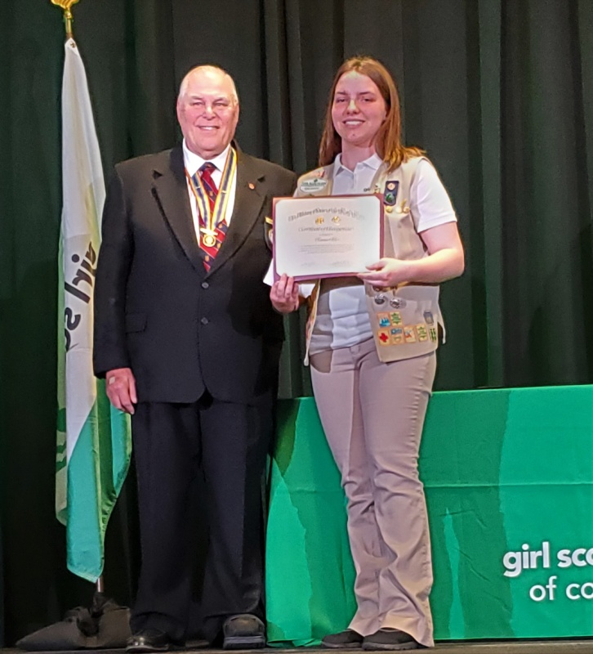

**LT Evan Totten, Chair of the Denver Chapter Scouting Committee, congratulates Girl Scout Janae Gadbois on earning her Gold Award and presents her with the MOWW Girl Scout Gold Award Certificate. Janae’s project was the Community of Hope Garden. She worked with the Intercession Episcopal Church to make their community garden more efficient and functional. The community garden now provides fresh, organic food to families in need.**

**POINTS OF CONTACT**

**Denver Chapter (093), CO**

**Commander & Treasurer**

LCDR Coy Ritchie, USN (Ret)

4198 South Kirk Court

Aurora, CO 80013-6022

303-690-5118 (Res), 303-981-5519 (Cell)

[**coyritchie@aol.com**](mailto:coyritchie@aol.com)

**Adjutant**

HPM Frances Long

6278 S. Kearney Street

Centennial, CO 80111-4237

303-694-1079 (Res)

[grannyfrancene@netzero.net](mailto:grannyfrancene@netzero.net)

**Commander, Rocky Mountains Department**

COL Steven A. Shambach, USA (Ret)

[shambachsm@msn.com](mailto:shambachsm@msn.com)

**Commander, Region XIII**

LTC Patrick C. Stolze, USA (Ret)

[pstolze40@gmail.com](mailto:pstolze40@gmail.com)