COMMANDER’S LOG

How time has passed. The year is almost over. It is time again to start collecting contributions for Wreaths Across America in Los Alamos. There are about 350 veterans buried in Guaje Pines Cemetery. Each year, the chapter joins other local organizations to purchase enough wreaths to put one on each of the graves of a veteran. The cost of each wreath is $15. The chapter has agreed to cover the cost of at least ten wreaths. In past years, our companions have contributed more than enough to reach this goal. Please be generous in your support to remember those who have gone before us. Please send your donations to me at 660 Navajo Road, Los Alamos, NM 87544 before November 15th so that they can be sent with the local order. Thank you for your continued support for this project.

THIS MONTH’S EVENTS

Our speaker this month is John Dukowicz.
John Dukowicz is a retired Lab Fellow who worked in Group T-3. John came to the US from Canada in 1966 after Grad School and has lived with his family in Los Alamos since 1977. His talk is entitled “The Dukowicz Family during WW2, 1939-1946”. John was born and lived in eastern Poland before WW2 broke out. As a 3-year old toddler, John and his mother were forcibly deported to Siberia by the Soviets, along with hundreds of thousands of other Polish citizens. John’s father, an army officer, managed to escape and joined the Polish forces in the West, where he participated in many battles, including the battle of France, the siege of Tobruk, and Monte Cassino in Italy. The family reunited in Italy after the war and eventually settled in Canada.

MEETING DETAILS

This month’s meeting will be on Tuesday October 19th. Because of the ongoing COVID situation, the meeting will again be a Zoom session. It will start at 7:00 pm. Zoom details will be in the reminder email.

LAST MONTH: SPEAKER

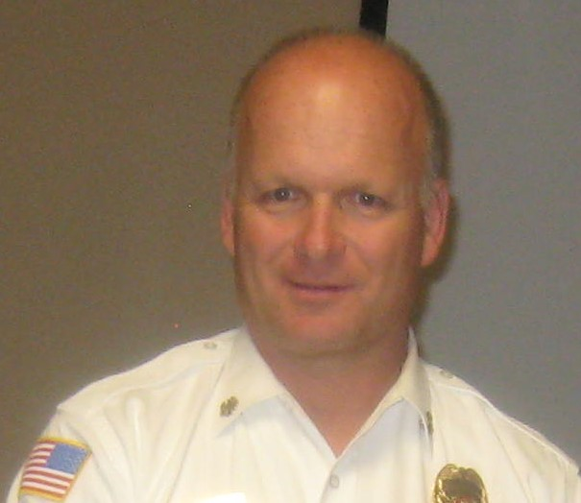

As part of National Emergency Preparedness Month last month, our speaker was LAFD Chief and Companion Troy Hughes. He started with a short biography of his 27 years of fire service. He started in Grand Isle, Nebraska were he rose to chief and served for 3 years. He came to Los Alamos and served as Assistant Chief for 10 years before becoming Chief for the last 10 years.

He then introduced Emergency Medical Services Division Chief Chris Bartlett. Bartlett started as an EMS 15 years ago and served as a support officer to the battalion chief. He has moved up in the department taking his present position a year and a half ago. Previously he was paramedic trained in Tulsa, Oklahoma and served in Las Vegas, Nevada for 6 years. He is a classic air helicopter medic with large city experience.

When Covid started to spread, it was expected to be a short term problem lasting a few weeks or months. When the orders to close the county and the laboratory were issued, it was life changing. Each unit was used to working independently under the direction of a captain or driver-engineer. They now could not go to fire administration or lab to get support. As in the military, they had to know the energy, strength, and weakness of their unit. With Covid, they now had to determine how to respond and to protect people. To do this, he worked with Joe Baca, the department’s Safety Chief.

The department held a chiefs meeting every Tuesday to plan strategy. Now they had to face te problem of getting supplies such as masks, sanitary fluids, water, etc. They were able to get through with the needed supplies and survived with no change. They were one of the few that could say that.
When the county was closed, testing for a new class of fire cadets was cancelled. The class was about ten cadets short of full. The department’s human relations department was sent home. Therefore, the department was not able to test or trin the new cadets. This left the department about twenty firefighter short. There is now a new class of about twelve tat is about half way through training. There is still a need for another class.

For setting up the clinics, the department looked to Seattle where the outbreak started to see what they did. Their EMS system developed a patient care response to Covid. This evolved into the CDC procedure. For several months, no one was infected on the job. It described how to deal with it on scene.

The medics needed a lot more supplies. The lab had lots of resources. They usually used JIT ordering for supplies, but other states ran out of supplies, first N95 masks, then gloves. The county contracted with Battelle to help. Dental suppliers were used to get sanitizers. Some supplies came from the state. Other support came from a manufacturer in Oregon who was contacted through a past chief. These were used to protect people to reduce the infection.

How to deliver the vaccine. First, the Department of Health was to provide vaccine to practices to support distribution, but that was not working. The county asked for help, and Nambe Drugs stepped up. They worked with the county emergency management director, and the fire department got the supplies. LANL vaccinations followed the same process. Nambe Drugs supported mass community clinics at the high school, for seniors at the Senior Center, and in White Rock for support people. Overall, 13,500 received the first dose (88% of eligible population) and fully vaccinated 12,500 (81% of eligible population).

Booster clinics will change. They will be for 65 years old and older and immunity compromised. If more boosters are needed, they will support the clinics. Ed note. The first clinic is scheduled for Oct. 10th.

The department support was first to vaccinate each other and then at clinics to watch the 15-minute waiting period. Later they worked with the medical reserve corps to vaccine the population. They were able to interact with the people in town. With Nambe Drug, they went to vaccinate the homebound including those with fear of large crowds and those that can’t get out. People needed to register online or call in to request service.

The state had problems scheduling clinics leading to shortages of patients for the schedule. After the first two clinics, the problems required changing the application. The initial coordination problems are better now.

The biggest problem is Covid fatigue. Many workers are working 48 to 96 hours per week. Also, the workers are concerned with protecting their families. Smiths has antibody tests available.
LAHS NJROTC NEWS

During September, there were many activities that took place, which offered service hours for the cadets that participated. There were 3 football games in September, all with an 8 or 9 man color guard. A primary reason why September was a busy month for the unit, is because of Homecoming week. The activities that happened during Homecoming week for our unit was the Pep Rally color guard, the Homecoming parade color guard and float, and the Homecoming football game color guard and sword arch. All of these events were successful because many cadets helped these events take place. After Homecoming week, the unit organized a fundraiser car wash from 0800-1300 on August 25th. This was a great success for the unit, and was estimated to be the highest we’ve earned from any NJROTC car wash at Los Alamos High School. Lastly, we have been preparing for our first drill and color guard competition in mid-October, which means practices are still taking place.

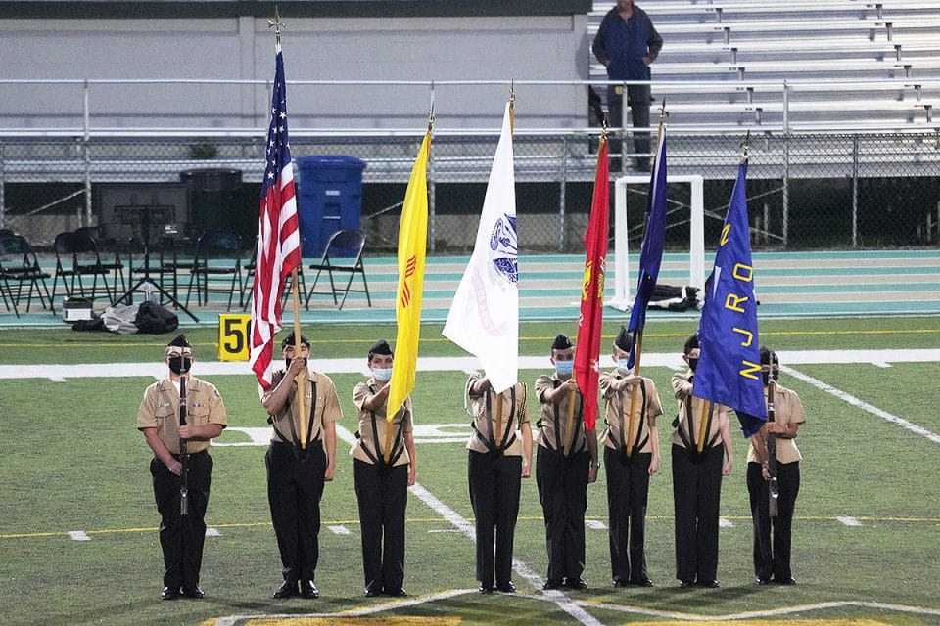 The Colors are presented by the NJROTC to open the Friday night football game against the Farmington Scorpions played on Sullivan Field. Photo by John McHale/ladailypost.com

C/ENS Megan Crawford

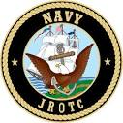

FOR THE GOOD OF THE CHAPTER

The 2020-2021 CINC’s Solicitation goal was $95,000. At the annual meeting, it was reported that the solicitation received $134,873 or 111% of the goal. Region XIII contributed 105% of its goal. Thank you to everyone that contributed. The 2021-2022 Solicitation year is now underway.

Operating Year 2021 ended with a strength of 5,703 companions, a loss of 353 for the year. The Order only recruited 25% of its goal of a 4% increase or 586 companions. Region XIII recruited 28% of its goal of 64 companions. This chapter recruited 0% of its goal of 2 companions. We all need to work on recruitment to preserve the chapter and Order.

The Order has a number of National Committees, and each committee has a representative from each region. As mentioned last month, Marlon Ruiz from Region XIII was elected as a VCINC. He was serving as the region representative on a number of the committee and now needs to be replaced. If you would to service on one of the committees to replace Marlon, please contact Pat Stolze, the region commander.

REGION XIII COMPANIONS ON NATIONAL COMMITTEES

EDUCATION AND TRAINING …………..MARLON RUIZ
HOMELAND SECURITY/ ……………….MARLON RUIZ
INFORMATION & PUBLICITY………… MARLON RUIZ
LAW AND ORDER…………………….RON ROKOWSKY
NATIONAL SECURITY ………………….DAVID McCOY
PATRIOTIC EDUCATION………………..MARLON RUIZ
ROTC/JROTC…………………….…………PAT STOLZE
SCOUTING……………………….……CHUCK MACKEY
STRATEGIC GROWTH …….…….STEVE SHAMBACH
VETERANS AFFAIRS……………………MARLON RUIZ

On another note, I (Region Commander Stolze) was just notified by the Chief of Staff's office that since Marlon Ruiz is now a VCINC, he cannot hold a position within Region XIII. Therefore, we need a new Region Vice Commander. Ideally, it will be the person(s) who want(s) to learn the ropes to become a future Region Commander. Please canvas your Chapters to see if we have a volunteer for the position.

NATIONAL OFFICERS

- COMMANDER IN CHIEF
LTC Michael A. Okin M.D. USA (Ret)
maokin1953@gmail.com

- VICE COMMANDEER IN CHIEF
Lt Col Marlon Ruiz, USAF (Ret)
ruizmarlon08@gmail.com

- REGION XIII COMMANDER
LTC Patrick C. Stolze, USA (Ret)
pstolze40@gmail.com

website www.MOWWSCV.com

NATIONAL STAFF

- CHIEF OF STAFF & COO
Col Michael Farrell, USMC (Ret) | chiefofstaff@moww.org

- DIRECT OF FINANCE
Mrs. Martha Ferrara, CPA | finance@moww.org

- MANAGER, MEMBERSHIP PROGRAMS (including dues payments)
HPM Justin Hiller | membership@moww.org

- MANAGER, MOWW STORE
Mrs. Sunny Alley | merchandise@moww.org

Website www.moww.org

MG MILES CHAPTER OFFICERS

Commander
LTC Gregg Giesler USA (Ret)
Home: 505-662-5574
g.giesler@computer.org

Senior Vice Commander
HPM Vernon V. Haywood, Jr.
Home: 505-661-4192
vvhaywoodjr@att.net

Junior Vice Commander
LT COL Norman Wilson USAF (Ret)
Home: 505-662-9544
NrmWil5@cs.com

Adjutant
HPM Vernon V. Haywood, Jr.
Home: 505-661-4192
vvhaywoodjr@att.net

Treasurer
COL Gerald Bolme USAF (Ret)
Home: 505-672-1233
bolme@earthlink.net

Chaplain
MAJ Donald B. Davidson, Jr., USA (Ret)
Home: 505-672-3794
dbd1alamos@msn.com

COMING EVENTS

October
7 Region XIII Zoom Meeting
11 Staff Meeting
19 Chapter Dinner – John Dukowicz – Life in Eastern Europe During WW II

November
8 Staff Meeting
11 Veterans Day
16 Chapter Dinner – tbd

December
6 Staff Meeting
5 Chapter Dinner – 2:00 pm
12 Wreaths Across America

January
10 Staff Meeting
18 Chapter Dinner - Robert Hull -
? Northern New Mexico Boy Scout Awards Banquet
22 Region XIII Zoom MBM meeting

PICTURES FROM July Chapter Picnic

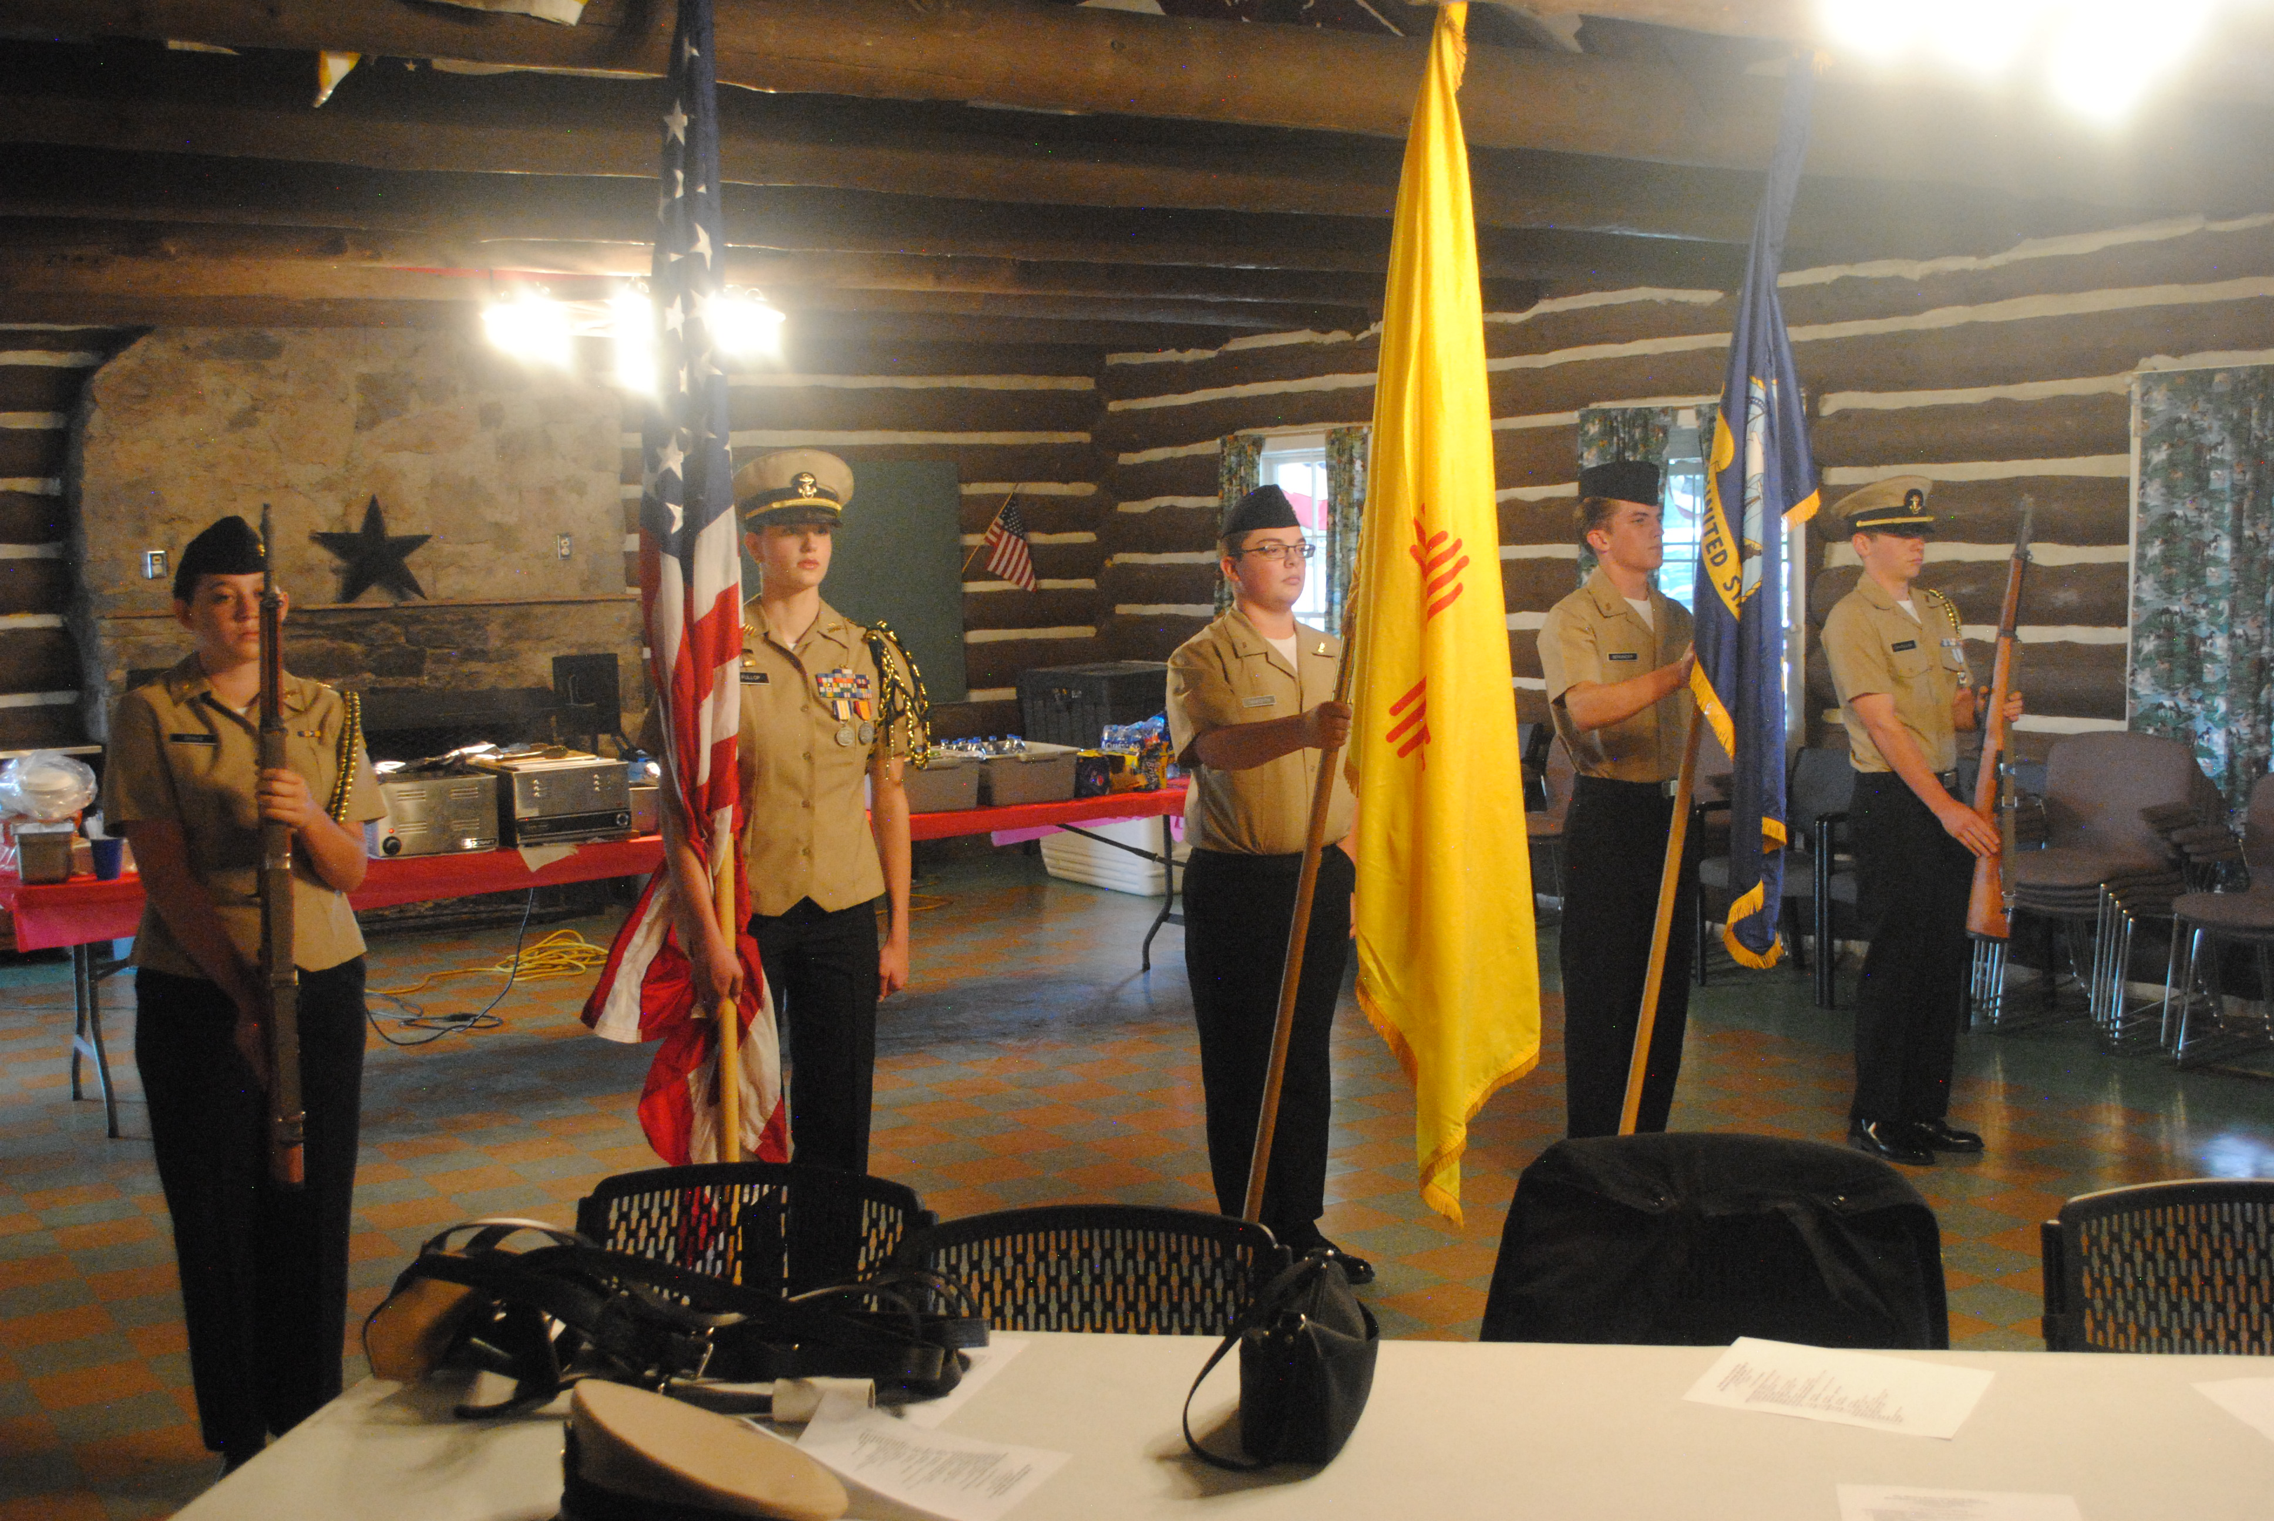

Color Guard at the July Picnic Meeting Ensign Ethan Chandler, CPO Emma Drake, Lieutenant Commander Aleena Fullop, Seaman Apprentice Joshua Danforth, and Seaman William Berninger

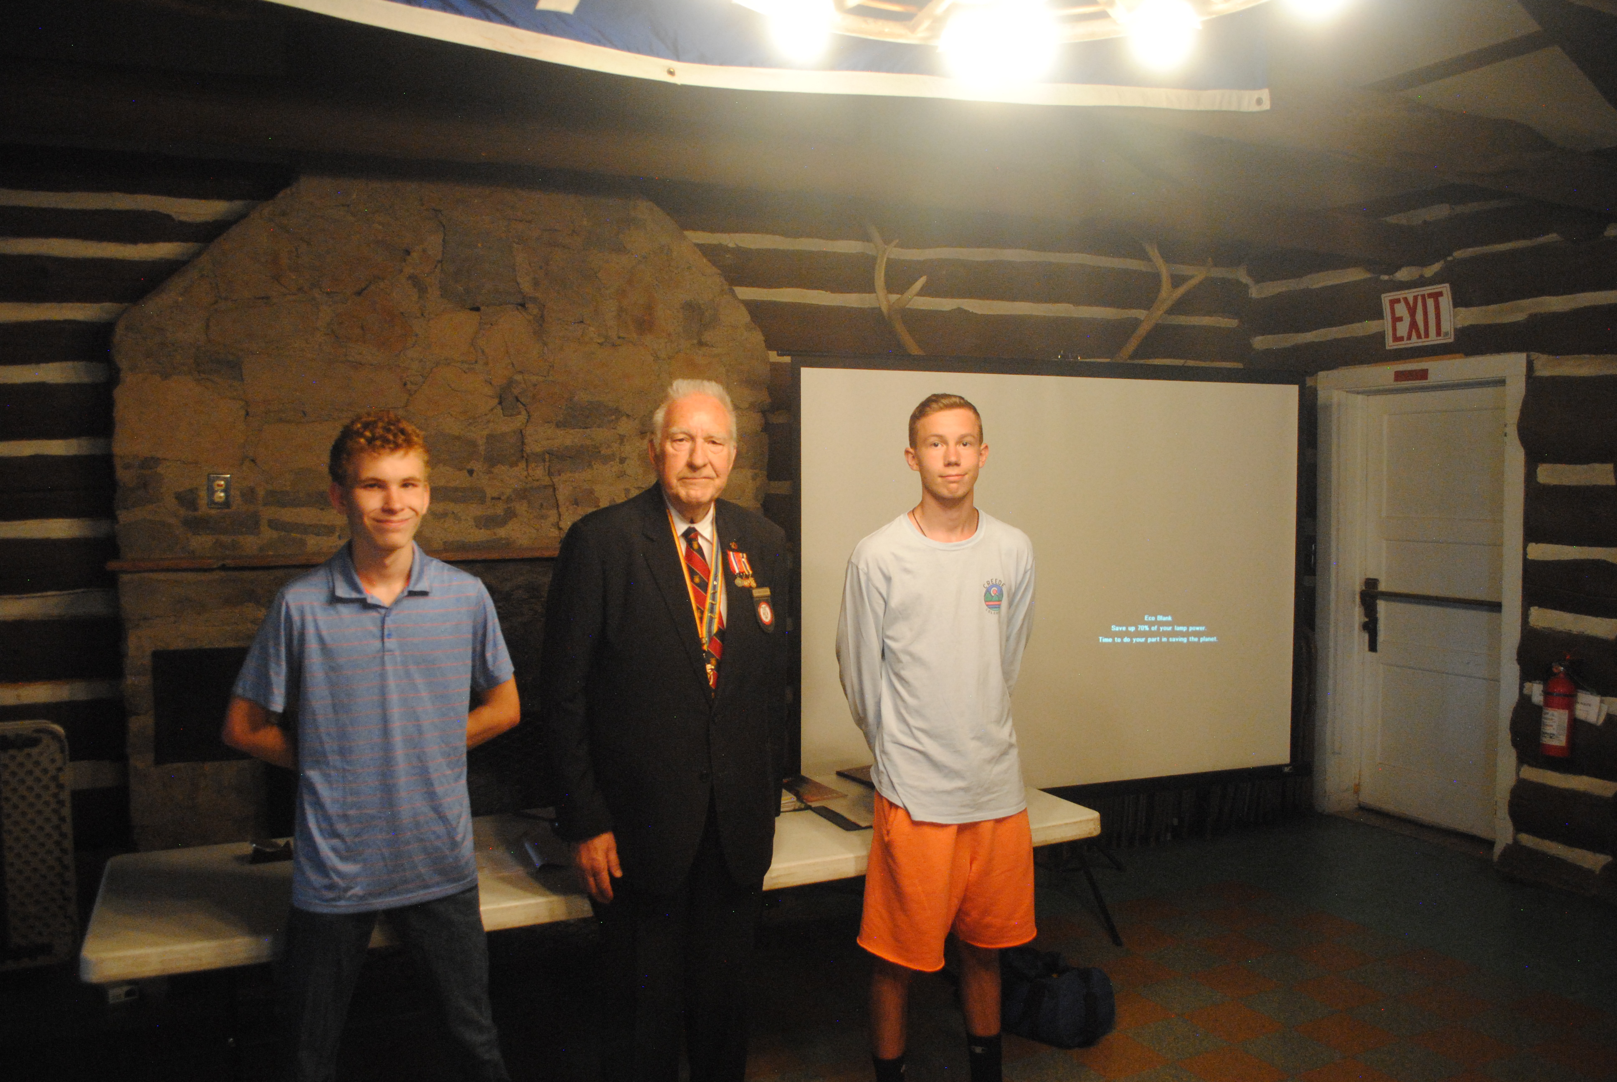

Commander Gregg Giesler with NJROTC Year Outstanding Award Winners NS2 CPO Jack Annerman and NS3 PO1 Hunter Gunn. Not present are NS1 SN Jaceena Hornberger and NS4 C/LT Garrett Slamas. C/LTSlamas was also the scholarship awardee.

