COMMANDER’S LOG

HAPPY BIRTHDAY

The MG Franklin E. Miles Chapter of MOWW was chartered on 28 June 1994 as the Los Alamos, NM Chapter. Therefore, this month the chapter celebrates thirty years since its chartering. This chapter started with about a dozen members focused on the local Los Alamos area and now covers all of Norther New Mexico. Although the chapter has grown in numbers and area of responsibility, it still needs more member to support and expand its responsibilities to its current members and area of support. In the recent issues of this newsletter, we have talked about the new strategic goals of the Order, now it is time to implement them on the local level. More next month.

The 2024 National Convention is scheduled for 7-10 August in Valley Forge, PA. Information about the schedule and the tours is in this and the last issue of the Officer Review and on the MOWW website. The registration form is an online form on the MOWW website. Hotel information is also on the website. This year’s award submissions include Newsletter, Information & Publicity, Scouting, ROTC, Homeland Security, National Security, Law & Order, and Patriotic Education. The winner in each area for small, medium, and large chapter receives a certificate and ribbon for their flag. The second and third place finishers receive a certificate. This chapter falls in the medium chapter category.

Don’t forget to contribute to the CINC’s solicitation. It is very helpful in supporting the many activities that are supported from the national headquarters.

Because of its length, the transcript for last month’s meeting has been moved to the end of this newsletter.

THIS MONTH’S SPEAKER

MG Franklin E. Miles Chapter Past, Present, and Future

Under the guidance, a few former military officers in Los Alamos, New Mexico petitioned the national headquarters of MOWW to form a local chapter. This group was approved and received a charter dated 28 June 1994. This chapter prospered and grew tripling its size in the next decades. Its further increased when the chapters in Santa Fe and Albuquerque were closed and their members were added to this chapter. Chapter Commander Gregg Giesler will relate some of this history honoring his predecessors as chapter commander and some of the activities the chapter has supported..

MEETING DETAILS

This month’s meeting will be on Tuesday June 18th. We will meet in the University of New Mexico Los Alamos Branch lunch room in Building 2. The building can be reached by entering University Drive from Diamond Drive across the street from high school Griffith Gym . It is the first building you reach and is to the left of the stairs. The room is on the upper floor. An elevator is available inside the doo to the right of the stairs.

The meeting will begin with a social period at 6:00 PM followed by a brief business meeting at 6;30 PM. There may be a presentation starting at about 7:15 PM. The meeting will be a hybrid session including Zoom online. Zoom session will start at about 6:00 PM. Zoom details will be in the reminder email several days before the meeting.

The Military Order of the World Wars meetings are open to all interested people for dinner and program with RSVP, or the program only at no cost. . The cost for dinner is $25. Please call Robert Hull 1-505-328-1502 for reservations. A reservation is a commitment to pay. The dinner menu is TBD with appropriate sides.

LAHS NJROTC news

For the summer, we have senior cadets attending Leadership Academy at McGregor Range on Ft. Bliss in El Paso this week. Next week, we will have junior cadets attending Basic Leadership Training, also at McGregor Range. These camps are for cadets already in leadership positions or are on track for future positions. They’re giving lessons on leadership and teamwork, while also learning marching drill and participating in physical training activities.

The cadets will not have anything going on during July.

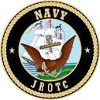
Chief Aron Ayers USN (Ret)
Naval Science Instructor

MEMORIAL DAY
The Los Alamos County Joint Organizations Memorial Day ceremony was held in Guaje Pines Cemetery on Monday May 27th. This year, the participating organization were represented with only their organizational flag and no national colors, and some organizations also placed memorial wreaths. This chapter was represented with its organizational flag and a wreath.
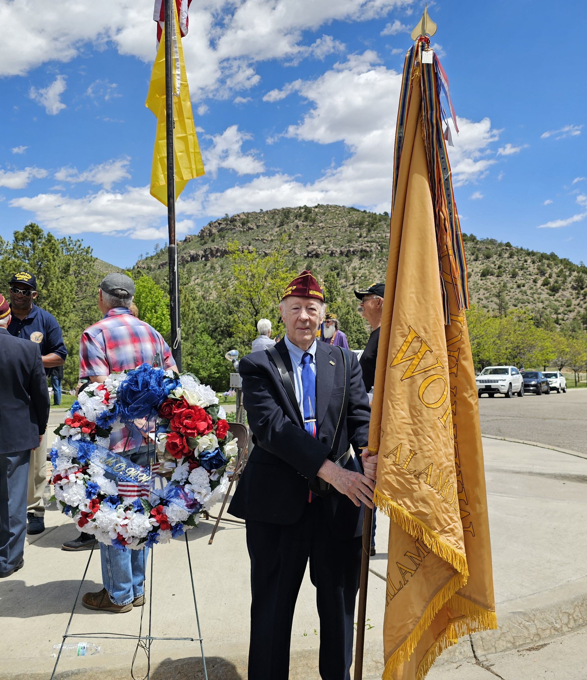
HPM Robert Malone with the chapter’s flag standing next to the chapter’s wreath.
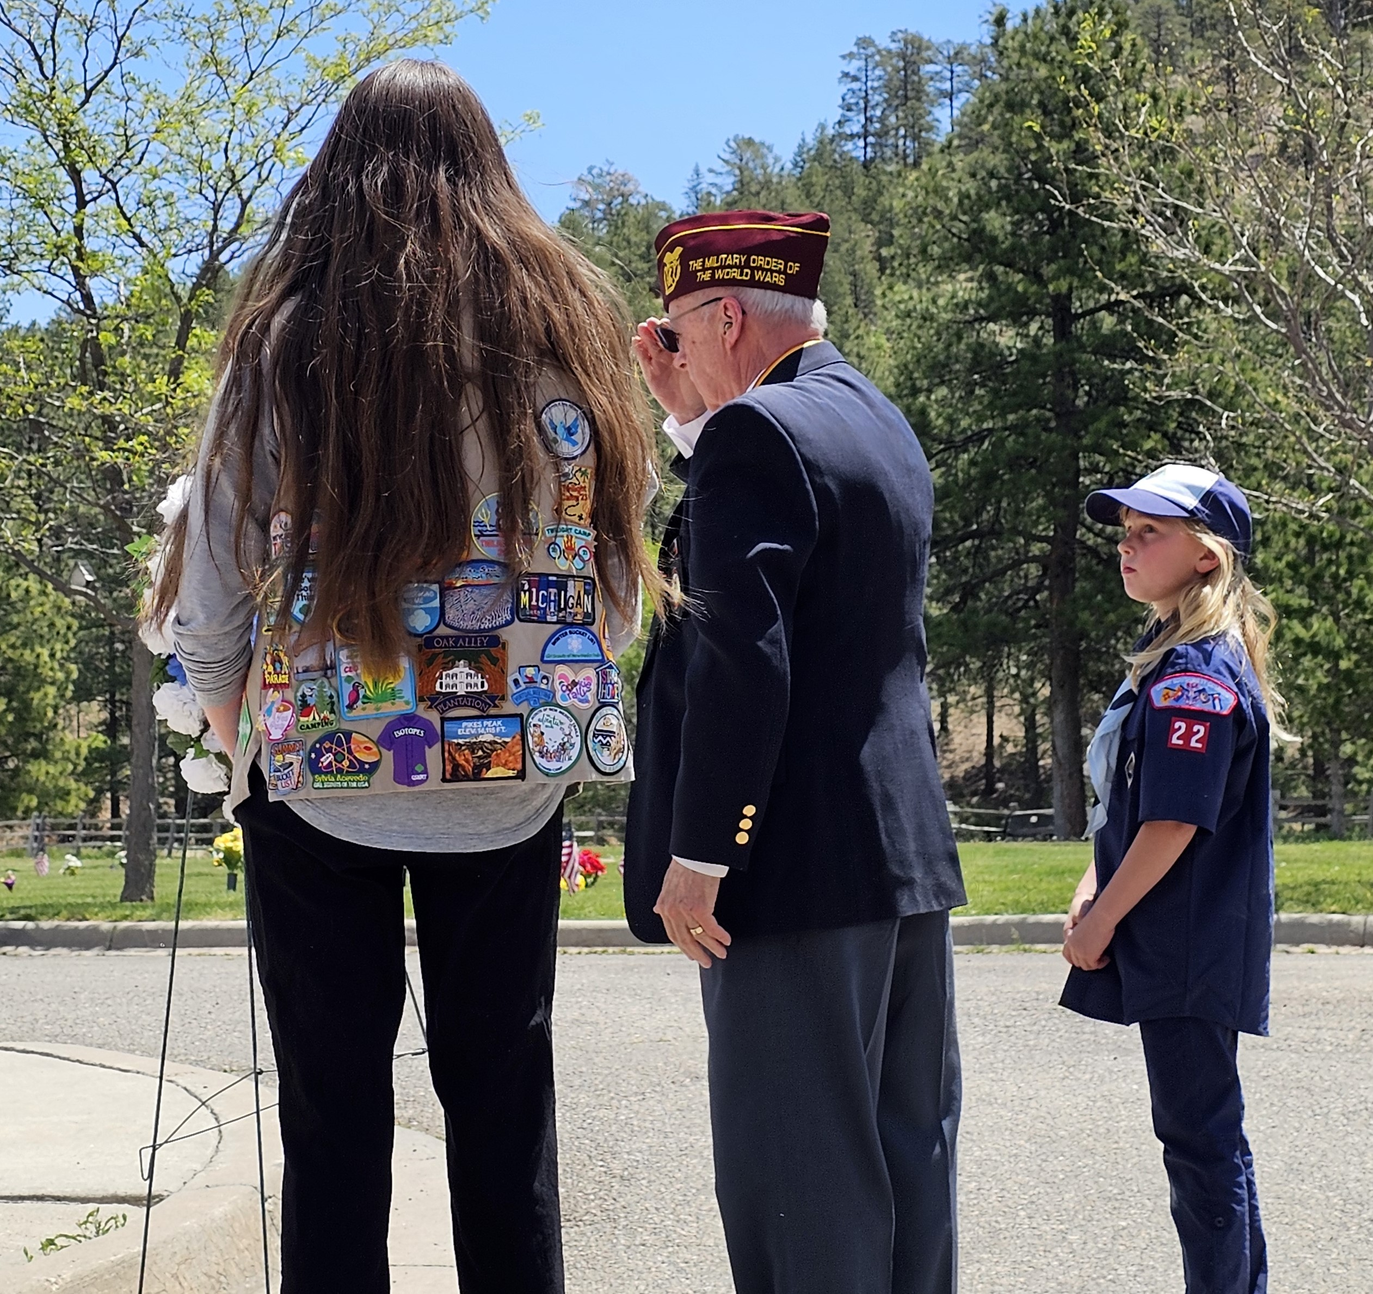
Lt Col Roger Goldie escorted with a local Cub Scout and Girl Scout after placing the chapter’s wreath
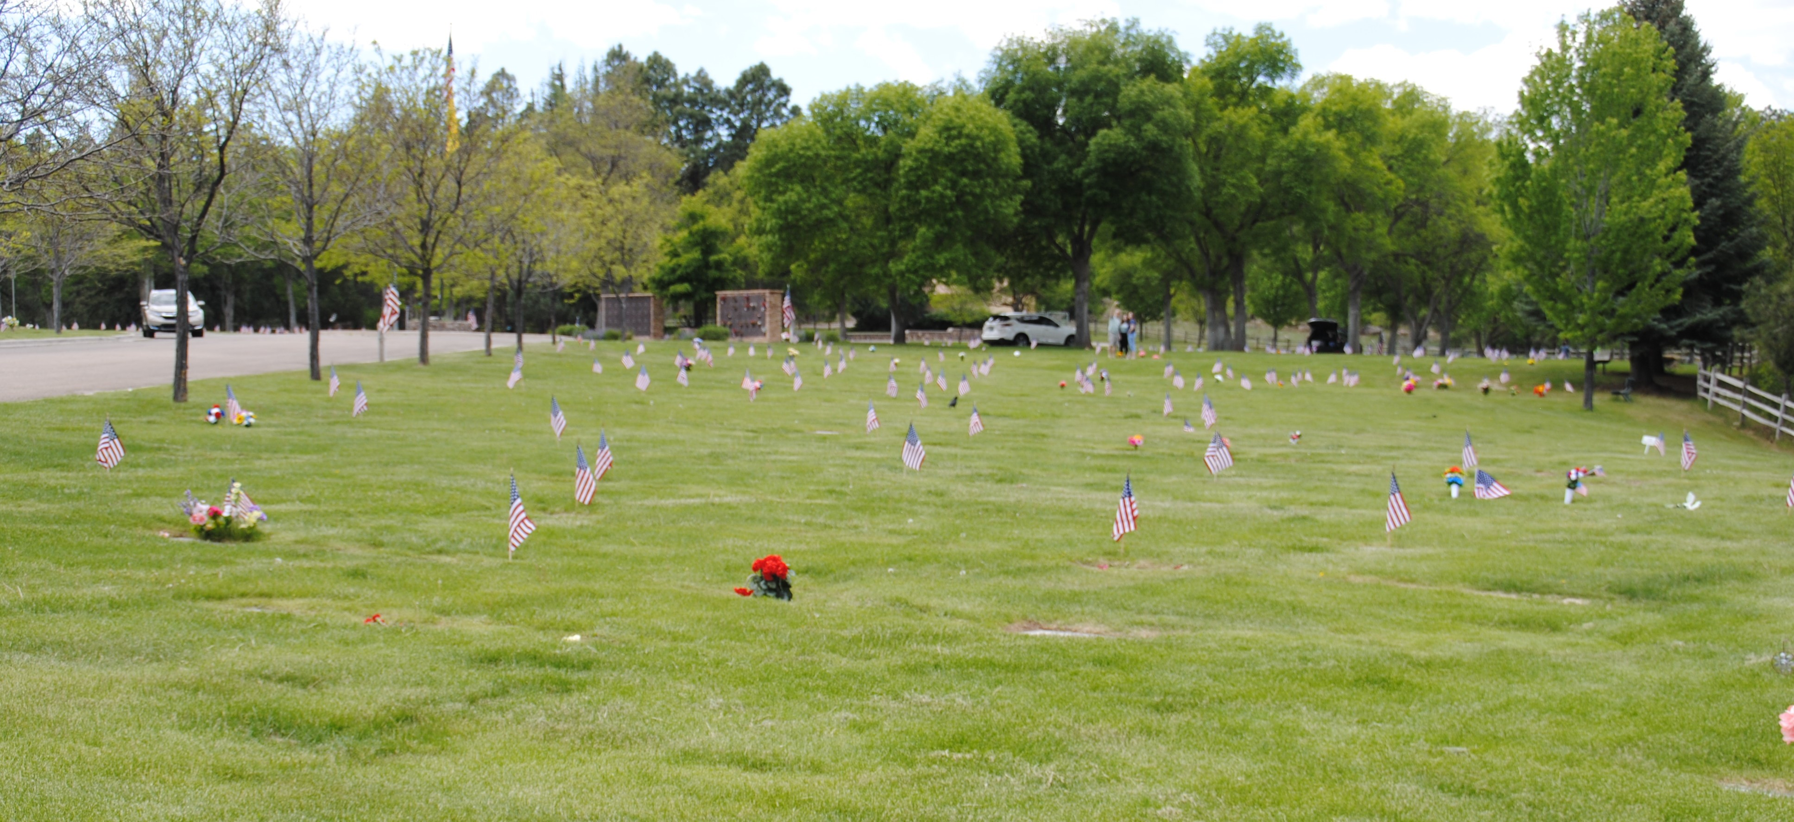
One section of Guaje Pines Cemetery showing the flags placed on the graves of veterans.

FOR THE GOOD OF THE ORDER

The May-June 2024 issue of the Officer Review has arrived. Pages 8-9 contain summaries of the proposed changes to the Constitution and Bylaws of the Order that are to be voted on in the upcoming National Meeting. Some are housekeeping items, but several important issues are to be considered. One is changing the membership available to senior NCOs in grades E-7 to E-9 or to all enlisted. Another relates to the name of the organization.
The articles about the possible name change for the Order on pages 16-18 in the January-February 2024 issue of the Officer Review. Details of the proposed changes are available on the MOWW web site. Please let me know your opinions on these issues so that I can represent you at the meeting.

LAST MONTH: SPEAKER

The speaker at our May 21st meeting was LANL Senior Historian Alan B. Carr who spoke by Zoom on

The Elegance of Fusion: The H-Bomb’s Origin Story, 1920-1945

Welcome to join us for tonight. Now as we jump into this, I don't know if I'm going to be able to get all the material into the 40 hours Gregg has provided. I'm going to do a fun dance try. Okay, I'll just do a set if I can. That always worked out really well, right? For those of you who don't know, my name is Alan Carr. I've been a historian at Los Angeles for 21 years on Monday. So my anniversary is coming up, and I've enjoyed most of the minutes of it, an awful lot. So I've had fun.

I worked, I'm part of the weapons program now, and our shop is called the National Security Research Center. Hence the first slide that we have on the screen, and for those of you who don't know about it, we are the lab, just to simplify things. We often call ourselves the lab's classified library. That's not a perfect title for what we do. There's actually a lot more to it than that, but we have a staff of about 60 now. We have digitizers, certified archivists, certified librarians. Of course, I believe many of you now know my colleague, Nick Lewis, who is the other full-time historian at the lab before you. And we have other people on our staff who enjoy doing history, too. Hence the Nobel Laureates book that we were talking about earlier. Things like that are now possible.

We have millions and millions and millions of records at the NSRC that we make available to the Los Alamos staff and to others as well. We work with the public, whether directly or in the Freedom of Information Act. We have a really cool role to play at the laboratory, and of course, because we have all these documents, I have been able to put together tonight's story. I will have the credits in just a moment, but before we go to the credits, here is the title of tonight's story.

Now, if you turned in to figure out how to make a hydrogen bomb, that's not what this talk is about. It's not a technical talk. We will talk about a few technical things along the way, at least at a very high level, but this is the story of the early H-fall. Some of you know that the first full-scale hydrogen bomb test that was performed in 1952. We're only going to go up to 1945. What was going on during the war and before World War II? I'm curious to see what you think of the talk. Not only what you think of that talk, but was it useful? Did it change your perception of what was going on in the early days of the hydrogen bomb? So anyway, that's what we have for us tonight.

I always like to show the credits before people leave or fall asleep, so here they are. Very much, I want to thank Earl Whitney. I don't know if anybody here knows Earl. Earl is a retired engineer at the laboratory. He is a phenomenal friend and teacher as well. A lot of the concepts in this talk, when you really get into the weeds, are pretty complex. Although we're not going to get into the weeds because I'm not really qualified personally to take you there, but Earl is one of these people who is an incredible technical translator. He can take equations and ideas and make them understandable to even people like me. So I'm grateful to Earl.

You can see the other past members there. I mentioned Nick, who is my partner in this business. Very grateful to Danny Alcazar there. The article's too big so many of these documents are available. I would hunt them down, but actually they give them to me, where I could do research with them. Danny was the conduit there and some of the other people.

Anyway, let's jump into this with a movie. I don't know if we have any movie fans, but some of you may have heard that there was a film about Robert Oppenheimer this past summer. Did you hear? It was kind of obscure, but anyway, what I'm going to show you now is a one-minute clip from that movie, and this is the movie's coverage of the wartime hydrogen bomb.

Alan then showed the clip starting with a speaker representing the small amount of uranium and plutonium available and commenting that a much larger quantity of these materials was needed to make a bomb. Robert Oppenheimer then queried Edward Teller about the look on his face. Edward replied that they should be looking at hydrogen, in particular, heavy hydrogen – deuterium. Fuse two deuterium atoms together and you are looking at not kilotons, but megatons. When asked how to do this, Edward replied to use a small fission bomb. Everyone laughed. The speaker then continued with saying we still have to figure out how to build a fission bomb.

No one is looking at the bomb. How about the movie that we've got to use? Because we've got a very lucky program. We've been arguing. All the people are arguing. So do you like the movie? You can have your idea of whether a movie or a shooting movie is a human image, and we've got a copy of the movie. Okay, does anybody remember that from the movie? I am watching chat. So if you're online, you can put comments in the chat and I will be watching, and if you're there, you can unmute and you can laugh or you can say this is boring. You know, right now, just talk to a screen. Hopefully you remember that. So that is the entire movie's coverage of this, and I would say to some degree, history's coverage of the early H-bomb kind of follows the same lines as the movie. So that was Edward Teller in there. and he will be one of our main cast members tonight. Edward suggests the idea of a hydrogen bomb, and everybody laughs at him, and that's it. There we go. Although it was a pretty good clip anyway. Good acting there. Good over acting.

Who wants to know the rest of the story? I can't hear anyone, so I'm going to assume that everybody would say, yes, tell us the rest of the story, and so that's what I'm going to do. Now, as I mentioned, this is the story of the early, the early history of the age bomb. It might surprise you that the early history goes all the way back, I would say to 1920, at least.eo we all know, I think everybody in this group knows what fission is. We've done lots of World War II talks. We've talked about fission. That's the sort of the process that produced all the energy for the World War II weapons. Fusion, the concept of fusing things together, is actually several years older than the concept for fission. So before we go deeper into this slide, we have talked about bombs up to this point, right? I showed you the clip from the Albert Hammer movie where they're talking about bombs. I want you to wipe the word bomb out of your brain. Drop the word bomb from your lexicon because for the next few slides, as we talk about fusion, none of these people are thinking about a bomb using fusion to derive its energy.

What are they interested in? Why did they be interested in fusion in 1920? The scientists are interested in understanding why the sun glows. You can see the quote from George Gamow down there at the bottom of the screen. He was a Ukrainian. Back then, Ukraine was part of the Russian Empire. He wrote a book, I believe it was published in 1940, and he starts that book by saying, how did our sun come into being? What keeps it hot and luminous, and what will be its ultimate fate? This was the age-old question, and at this part of our presentation, this is why the scientists are interested in fusion.

So, Arthur Eddington, you can see him in the photographs there on the left, he's the first to propose fusion as a mechanism for powering the sun. It's not complex, it's not detailed, Eddington's not able to explain how it works, but they're looking at the sun and wondering, why does it do that? Why does it exist? Why do we feel warm and seem light? And so he proposes the concept of fusion. We'll talk about what fusion actually is in a little bit, just a tad more.

So anyway, we've got basic concept there. Now, the next person to make a big contribution to this, and there were others as well, and I'll skip over there, is George Gamow, who I mentioned earlier, and Gamow is the one in the second photograph there, and you can see that he is holding a young lady and offering her a drink. Now, I could pick other pictures of Gamow, but I like this one because it really kind of captures his personality.

He liked to have fun, he was a good time, he was a joker, and also, some of you may know, who maybe may know who the woman in the picture is. Her name was Eugenia Kannegiesser, and she would later marry Rudolph Peierls, who became a group leader at Los Alamos during World War II, and she was a mother figure, almost, to a scientist, including Kraus Fuchs, but that is a story for a different day. But anyway, scientists up until the 1920s were still very much rooted in the world of classical mechanics, Newtonian laws and things like that.

This was before the era of quantum mechanics. It really was the transitional era, and you had scientists like Einstein, who were still rooted more in a Newtonian universe, but then you had scientists like Niels Bohr and Werner Heisenberg come along and challenge those old concepts that the natural world may not operate just as straightforward as we think. It may be more complex than that.

Now, our problem at this point is, when we think about the atom, atoms are made up of multiple parts, right? In the 1920s, physicists didn't think that you could break the nucleus of an atom, the nucleus of an atom. The center of an atom was as small as it got, and you just couldn't break through one way or the other. That was because when you look at classical mechanics, and you can see that graph on the wall, so you've got a solid barrier, you can't go through a solid barrier because it's solid.

Well, one of the things were not as solid as we thought. One of energy was not some solid thing, but it was more of a wave. What if energy traveled in waves? Could an object actually go through what we once thought was a solid barrier? So these are the origins, kind of the basic ideas of quantum mechanics, quantum physics.

Anyway, Gamow is thinking about this. Now, the problem back then was, you could look at the nucleus of an atom, and there would be pretty low energy output particles coming out of it, kind of oozing out a little at a time. Well, how can something ooze out if it's impenetrable? If the nucleus, the skin of the nucleus is impenetrable, how can things come out? If things can come out, surely things can go in as well.

It's what if things traveled, energy traveled in waves through these, once thought, these solid objects. So some really cool physics early on. Again, we'll get into stories, and we'll get away from this shortly, but Gamow is the one who is a young physicist thinking about this from a quantum perspective. Anyway, you can see Atkinson and Houtermans. They're on the right, the scientists on the right. Later in their life, and that's the best picture of both of them that I could find, they thought that sometimes you might be able to penetrate the nucleus of an atom. Now remember, for those of you who know about physics, this is before the neutron had been discovered. So they're actually thinking about specific objects that might be able to go through.

So all of a sudden, the once impenetrable nucleus of an atom is under assault by George Gamow, for instance Houermans, Robert Atkinson. So the field of fusion is picking up. The reason that this matters is if you can penetrate the nucleus of an atom, if you can get through it, you might be able to fuse atoms together, and if you're able to fuse certain types of atoms together, you might be able to release a lot of energy. Again, there will not be a test on this. If you're sitting there thinking, well, I don't follow that, I'm going to simplify it for you in another two slides.

Before we get there, let's continue our path through time. Now it's 1932. Enrico Fermi, you can see him with his wife Laura there on the left. Fermi is just starting to emerge as the leading experimental physicist in the world, at least in my opinion, at this point in time, and so remember, we think that you might be able to split the nuclei of atoms, and you might be able to fuse them together. But if you're going to fuse something together, you need a mechanism for doing that. You need some energy for doing that. What's that energy going to be? Well, in this case, heat.

You want to melt fields together, you're going to need heat to do it. Where does the heat come from? Well, Fermi proposed the idea of photons, okay? He explained how photons are created. So you've got three electrons moving around and occasionally they find an ion, a nucleus that doesn't have a electron. As those electrons fly by, they interact with that ion, and you get a photon, and if you want me to explain the physics of why, I can't. Some of you may be able to, but you get a photon. Now, what is a photon? Again, if you're sitting there thinking, I don't understand this, you didn't know what a photon is. Maybe you've stood in front of a fireplace before and you've felt the warmth there, or you've gone outside in the sun. Somebody turned up the heat here in West Texas this past week. You're feeling photons. We perceive photons as light and heat, and Fermi has now explained how you've made a photon. Okay, so now we have our heat.

The next thing, same year, 1932 James, Chadwick discovers the neutrons. So neutrons are little parts of almost all atoms except hydrogen. You see a hydrogen atom there on the left. Actually, all three of those are hydrogen atoms on the screen right now. Just basic hydrogen, common hydrogen, has no neutron, but every other atom is made except for that one. So Chadwick discovers this basic piece of an atom. The thing is, now we know the nucleus of an atom is made up of multiple parts. It's made up of protons and neutrons, and the number of protons dictates what element it is. Well, if it's made up of different parts, protons, neutrons, can you split them up? This is the idea for fission, right?
Now, at this point in time, Europe is starting to lose a lot of physicists as these important discoveries are being made, and they're losing them because of the rise of fascism. So, of course, in Italy, Fermi leaves, barely gets out of the country, in 1938. That's an interesting story, but not for tonight. Many of these scientists that we've mentioned left authoritarian European governments, and they went to the United Kingdom or the United States, many of them ended up here in the United States, including Edward Teller, who mentioned Fermi, with a mention of the United States as well. So did George Gamow. He left the Soviet Union and decided he didn't want to go back. Go bigger, and he ends up here as well.

He recruits Edward Teller, who's a little bit younger than he is, to come work with him at George Washington University as a member of the faculty. So that's how Teller kind of enters into the picture. And again, he's going to be a dominant figure in the story well beyond the years that we're talking about as well. Now, there are other scientists. You can see over there, kind of the third one from the left is Hans Bethe. Bethe is very interested in this business about how stars work as well.

But remember, somebody said, well, it might be fusion, but what is fusion? What does fusion look like? Bethe gets very interested in this question, and he works with Charles Critchfield, who I believe was one of Teller's students, and they propose a mechanism, which you can see on the next slide, for doing just that. They propose a mechanism for creating deuterons, and so you can see a deuteron. Deuterium is hydrogen. It's just hydrogen. It's one proton with one neutron. It's hydrogen. It's a different isotope of hydrogen, and of course, you can see a proton with two neutrons, but its on right-hand side of the screen, we'll talk about what that is in just a few more slides. But anyway, deuterium is going to be very important to our story. Again, one proton with one neutron. Remember deuterium. Deuterium, just a proton and a neutron. In its water form, it's pretty common. Its oxide form is heavy water. It's pretty cheap. Not that hard to produce. Keep that in mind. Is deuterium cheap? Yes. Is it easy to get a hold of? Yes. So that's going to be important as well. And again, we're almost through storytelling. It has all this physics stuff. If you're not interested, hold on a little bit longer. So anyway, these great discoveries continue really throughout the 1930s. For instance, fission is produced in 1938, and it was interpreted as such late that year.

Of course, we've told that story other nights. Well, you split the nucleus of that, it releases some energy, and some of those neutrons that when that nucleus go off and split other nuclei, release a lot of energy, you might have a thought, and that's the usual story that you tell, but not tonight, because we're talking about fusion. Anyway, fission is produced, it's discovered, and it's produced in Nazi Germany, which might be a little bit scary. We would not want the Nazis to have a nuclear weapons monopoly.

Now, the next year, a few months later actually, Bethe publishes an article explaining specifically the processes that power not only kind of small and medium sized stars, but big ones as well. You can see that is the physical process that illuminates for the most part, our sun, the closest star, the one that we revolve around here in our solar system, and many, many other trillions of stars as well. And you can see, you put a couple of protons together, it releases some energy, and well, you can see the cycle for yourself. Ultimately, you are going to generate a lot of energy, which you can see if you look up at the sun, in the form of the creation of helium-4. You can see, you start putting all these hydrogens together, it pops out helium with immense force when you start gluing those hydrogens together. It releases a lot of energy. And again, we're not thinking about bombs, all right? I know I shouldn't have said it yet, but we're not thinking about bombs. We are interested in stars, and that's what Bethe and Critchfield both have demonstrated. They have now shown how stars work. They quantify how stars work. Years later, Hans Bethe is going to win a Nobel Prize for that work.

Now, of course, going back to our typical Manhattan Project story, Albert Einstein and Leo Szilard sent the letter to President Roosevelt warning him about fission and what it could mean. He's still three years away from the Manhattan Project. He talked about that in other lectures before. At this point, though, it's going to take a while for the Manhattan Project to come into existence. Some of these are still doing work, and one of those scientists who you see in the middle there, yes, that is J. Robert Oppenheimer with a full head of hair. He probably caught her eye there. Oppenheimer publishes a paper that postulates the existence of black holes, September 1st, 1939. He didn't use that term. That term, black hole, did not exist back then, but think about that for a minute. But the day the German army, invades Poland starting World War II in Europe. Oppenheimer does that work, and it was not demonstrated experimentally in his lifetime. I think maybe if it had been, maybe Oppenheimer and his graduate student would have won the Nobel Prize for that. But anyway, it just didn't work out as such.

So we'll take a deep breath here. We've covered a lot of ground in terms of time. We've covered a lot of ground in terms of physics. What does it all mean? So for myself, and maybe for some of you as well, this is as I promised, where we're going to greatly simplify things. This slide has everything that you need to know in terms of physics for the rest of the presentation. So to make a bomb, and we're going to get into bomb-making on the next slide. So right now, let's focus instead still on stars. Stars for this last slide then we get bombs. So if you're going to have fusion in smaller stars, you need fuel. What's our fuel? It's going to be hydrogen for the reasons you see on the screen. Hydrogen is the most simple and most abundant element in the universe. There's a lot of energy in it, and it's good at breaking through nuclear barriers. It's the perfect fuel, and it's everywhere. Well, if we're going to fuse hydrogen atoms together, we're going to need heat. Where does the heat come from? Well, maybe from photons.

Remember, we all, maybe we don't use the term, but we all feel photons, see photons, all the time. Photons might provide the heat. I know it's kind of weird for most people, but we can understand heat. Understand heat and velocity as being nearly interchangeable terms, okay? Photons will give us the heat that we need to glue the hydrogen together, we hope. If we take that heat and we take some hydrogen and we fuse it together, this may produce nuclear fusion. That's why, again, the stars illuminate for us.

So who was the first to come up with the idea of taking this stellar process, bringing it on Earth and making it into an explosive? Well, that's going to be Enrico Fermi. Now, we don't have a lot of time tonight. I want to keep moving things along. You all, for the most part, hopefully know the World War II story and the Manhattan Project story and all of that pretty well. So let's jump ahead to the first idea. So you see Edward Teller and Enrico Fermi speaking. That picture was taken after the war was over, probably around 1950, but they got along very well. They worked together very closely. Fermi, we think, now this is a challenge, but we think Fermi is the first to propose the idea of a fusion explosive bomb.

Well, we can take that process going on in the star and make a bomb out of it. He mentions that to Teller. Just plants the seed. Teller takes the idea, and he wants to figure out if it can be done. A fusion bomb is actually really scary when you start to think about it, and I'm going to show you why in a few more slides. Now, Teller takes this idea, he thinks about it, and he decides, you know, you are going to need a lot of heat to sustain a fusion reaction long enough to make an explosive, to hold something together long enough to make an explosive out of it, and he concluded pretty quickly that it can't be done. You cannot maintain that level of heat to make the fusion reaction, and that was it. Or was it? Teller could not let this idea go.

As the idea, even though he dropped it, he had demonstrated it couldn't work. This idea continued to percolate. Now, as it is, the Japanese attack Pearl Harbor and World War II comes to the United States. Now the U.S. is an active combatant at the end of 1941, just a couple of months after Fermi and Teller have their conversation. Now, in the spring of 1942, Teller still has this idea, he thinks that he's shown that it's not going to work, but he's not proven that it can't work. So he brings in one of his colleagues, another physicist is from Indiana, from the University of Indiana, named A.L. Konopinski. We'll have a picture of Konopinski in just a little while. T.L. and Konopinski come in, they're going to work together.
The objective is to prove you can't make a fusion bomb, and they can't. Every potential problem that they consider, they find a potential solution to. Interesting. Okay, so anyway, it looks like it might be possible, after all, to make one. Now, this is about a year before Los Alamos has its first technical conference. He was bringing back from 1943.

Now, shortly after Konopinski and Teller had kind of concluded their work and concluded that he might, in fact, be able to make a fusion ball, there is a top-secret weapons design conference at a public university, at Berkeley. Where better a place to have a weapons design conference? So this becomes known as the Berkeley Summer Conference of 1942, about three quarters of the year before Los Alamos has its first major technical conference. We primarily have theoretical physicists there, and the leader of the group is Oppenheimer.
You can see Oppenheimer, that picture over on the right was probably taken around 1943, maybe 1944, possibly 1945. That's Konopinski over there on the far left. Oppenheimer presides over this, and here's the thing, I don't know if we have any engineers in the room.
You can say that you already can put that in chat. They've not done a lot of activity in chat yet. I want to encourage everybody to drop in your favorite joke, whatever it takes, make sure that we're all still awake.

Theoretical physicists are awesome. They're good to have around, but they don't make physical things. Who makes physical things? Engineers figure out how to make practical physical objects that work. Well, we don't have any engineers there for the most part, so our theoretical physicists at this conference, they discuss how they're going to make a fission bomb, and they figure it out like in two days. I mean, how far can it be? So they all, when Teller brings it up, they all willingly and gladly engage in this discussion about making a hydrogen bomb. If you've heard of the Berkeley Summer Conference before, most of it, 90% of it, according to Teller, 75% of this conference, according to Bethe, they're talking about how to build a hydrogen bomb.

So were they laughing at Edwards? No. Well, they were having a blast talking about, well, choice of words, but they were really thoroughly enjoying the scientific, the technical challenge of thinking about this incredibly complex possible object, a hydrogen bomb. So anyway, they don't have a lot of data to go on. So what do you do if you don't have data? You rely on ideas, chalkboards, you make calculations, and, of course, the calculational tools at that point in time were not very advanced or anything like that. Now, here's the thing. Remember, deuterium is the form, the isotope of hydrogen, that we want to try and fuse together. We want to glue deuterium to deuterium. Why do we like deuterium? It's cheap. It's easy to get a hold of. There's no shortage of deuterium. It's in regular water. It's the less common hydrogen that you'll buy in water, but it's deuterium. That's why we like it. It’s a cheap, easily accessible fuel.

They know that if you are going to fuse deuterium atoms together, you are going to need an incredibly high temperature. Maybe, a temperature you can’t produce. During the conference, Konopinski remembers the work he did back in Indiana. So he says there is tritium. Remember the slide back here? There is tritium on the right, a proton with two neutrons. That is tritium. Does anyone know what tritium is? I bet some of you do. Where does it come up? A watch band that glows in the dark. Some pistols have tritium sights on them. It is something we know a little about, but it is a little more common. Back then, it did not exist. It was unobtainable. There was precious little in existence. It was very expensive to manufacture. Very expensive. It is a reactor byproduct. There was almost no tritium in the world. Konopinski had some familiarity with it. What if we take tritium and try to fuse it with deuterium, we might not need as high a temperature? So he proposes this. He proposed it in his earlier work. We might get the temperature down. So this is where the idea came from that if we try to fuse deuterium with tritium instead of fusing deuterium with deuterium, we might get the temperature down.

Another thing comes up at this conference. If you set off a fusion bomb, might it ignite the atmosphere and destroy all human life? You may have heard this before. It was dramatized in the Oppenheimer movie. The answer is no because we are all here after the first test. It is said that Teller first proposed it at this conference, but he doesn’t remember it.

Fission weapons don’t seem all that complicated, but they are expensive to manufacture. On the other hand, fusion weapons look pretty cheap to make if deuterium is our fuel. Deuterium-tritium looks great, but we are focused on a deuterium bomb. Deuterium-tritium is more complicated. As I said before, if we can make a hydrogen bomb, it is pretty scary. Why? As this quote from Oppenheimer in a classified document “Three tons of deuterium when burned to completion gives an energy evolution equivalent to 10^8 tons of TNT. That is about 10^4 times the original estimate of energy released from fission bombs. It will devastate an area of about 1000 sq. miles. Ten to the eighth tons is a lot. Ten times ten times ten times ten times ten and so on and so on. That's many tons of TNT. In fact, I believe somebody checked my math a hundred megatons. So, that is the equivalent of nearly 7,000 Little Boy type bombs, the bombs that destroy Hiroshima. It's mind-blowing. This is about 10 to the fourth times the original estimate of energy released from fission bombs. It will devastate an area about a thousand square miles. Unbelievable stuff. So, anyway, that is what they are talking about there in Berkeley.

What about the German fission bomb? Sometimes the question of the German fission bomb, there was a German fission bomb program. We know in hindsight that it was not very successful at all, but is it possible somebody in Germany was maybe thinking about building one of these relatively cheap, thermonuclear bombs? Going back to our Manhattan Project story, the Manhattan Project was formally established finally in August of 1942, and it was recognized the main reason for bringing the Manhattan Project into existence was to beat Hitler in the race to build a fission bomb. Well, what about a German fusion bomb? Much, much more powerful. Could they be thinking about it? As it turns out, there were scientists in Germany who were thinking about fusion reactions. One was Hartmut Israel Kalman.
Now, who thinks that Hartmut Israel Kalman was a member of the Nazi Party? And if you guessed no, I think you are correct. He is not a Nazi. He is Jewish. One of his patents is a patent that pertains to the production of fusion for scientific and industrial purposes, not a fusion explosive bomb. There are people thinking about fusion in Nazi Germany, and I think that it's interesting when you compare our two countries. On the one hand, you have Nazi Germany. You have Hartmut Israel Kalman being hunted by the SS throughout the war. They want to track him down, put him in a concentration camp, maybe murder him. He actually survives World War II. On the other hand, here in the United States, we are welcoming in scientists who are fleeing that regime, and they are doing remarkable things for us. Such an incredibly different experience going on in the two countries. And remarkably, unfortunately, the German program, the fission bomb program, never posed any real threat to us. We didn't know that in World War II, but fortunately, the nuclear weapons program in Germany really got a lack of success, and there was no fusion bomb program, although there were people thinking about producing fusion for other purposes in Germany at that point in time.

It's early fall of 1942. The Manhattan Project has been brought into existence now, and the de facto weapons laboratory, for the Manhattan Project, was in the University of Chicago Metallurgical Laboratory. According to Teller, and, again, take it or leave it, if you believe in Teller or not, I've not been able to find any other evidence to support this, but according to Teller, Oppenheimer, who wanted to be a lab director, who wanted to bring a new weapons design laboratory to New Mexico, he lobbies for the job that he lobbies for a nuclear weapon, or a weapons laboratory to put in fusion. According to Teller, he uses the idea of a super weapon, a hydrogen bomb, we'll use that term interchangeably, hydrogen bomb, thermonuclear bomb, super, these all mean the same thing. According to Teller, Oppenheimer uses that new development from Berkeley as a reason for creating the lab. So, again, think about the movie clip that we saw earlier. Far from Oppenheimer laughing at it, apparently, there's some evidence to suggest Oppenheimer uses the prospect of a hydrogen bomb to help create Los Alamos. Remember, early on, we are still trying to make a deuterium-deuterium bomb because it is cheap, but we want to know more about this idea of how it tends to be yet. What if you use deuterium and tritium? Does that really get the temperature lower?

So, we need some help from the experimentalists, the experimental physicists, because so far the theoretical physicists have been talking about this, we need somebody to do the experiments. So, who are you going to call? In this case, they called Purdue University and some of the young physicists there. And they tell them, hey, we need you to do some experiments for us. We can't tell you what they pertain to, it's secret. Get your laboratory, get a security guard, get some blocks, but we can help us out. Their job is going to measure the cross-section of using deuterium and tritium in a laboratory. Basically, what are the odds high probability of using when you put deuterium and tritium together or low probability? That's going to be the job. We'll come back to that.

I think many of you know this next part of the story. As the land in Los Alamos is being acquired for Oppenheimer's lab, Fermi builds the first complete nuclear reactor and it goes critical on December 2, 1942. This is the first big breakthrough of the Manhattan Project. If you can produce a controlled chain reaction in a reactor. If you can produce a controlled chain reaction, you can also produce an uncontrolled chain reaction. What is an uncontrolled nuclear chain reaction? Well, some type of weapon. So, we knew from that point forward that it was possible to build some type of nuclear weapon. I love the quote from Arthur Compton. They are doing this work in a squash court beneath the stands for the football field at the University of Chicago. Compton says President Hutchinson, the President of the University of Chicago, was in no position to make an independent judgment of the hazards involved in the experiment. Based on considerations of the university's welfare, the only answer you could have given would have been no, and this answer would have been wrong. I love that. Again, this is wartime experience. The world's at war. Hundreds of Americans are being killed every day. We need to get the job done, and Compton found out a way to do that. So, we have work going on at Chicago. Los Alamos is now nearly under construction, and it was perceived at that point in time that the Germans probably had a 6 to 12 month lead. We know now that they did not, but that's what we thought we were up against at that point in time.

Let's talk about what's going on at Los Alamos. According to Bethe, he writes that he said we didn't really understand how hard making a fission bomb was going to be until the spring of 1943. Think about that for a minute. They leave Berkeley thinking fission bombs would be easy. We should think about building a hydrogen bomb instead. That wasn't some fleeting thing. That was the perception of the scientists for months and months and months after the conference. Basically, two-thirds of a year after Berkeley, they are still primarily focused on building a hydrogen bomb because fission doesn't look that hard. Well, by the spring of 1943, actually manufacturing a real fission bomb could be a lot harder than anyone thought. As Los Alamos is coming into existence and we set up for our first big pick-up conference in April 1943, there is a big shift from fusion over to building a fission bomb.

You can see those are Oppenheimer's notes from March 1943. In his handwritten notes, he says, what are the chances of initiating thermonuclear reactions? What would this do? What are the notes of scientific and development problems, estimate of time? Well, within weeks, it's just not that important right now. We'd have to build a fission bomb instead. So building a hydrogen bomb, as you can see from the quotes, naturally becomes secondary to building a fission gadget. Anyway, Teller is given a group. Now, his boss is Hans Bethe, but Teller is given a group, and he is allowed to explore the feasibility of the super. So again, this was not Oppenheimer or Teller showing up at the conference saying, hey, why don't we think about hydrogen bombs? They've been thinking about hydrogen bombs for months, and the only reason that they're not going to continue focusing on hydrogen bombs is it's too hard, or fission is too hard. We need to focus on that. At this point in time, Oppenheimer is still giving resources to make a hydrogen bomb. Teller did this as a group. They also built a cryogenics laboratory. You can see a picture of it, and you can see the man who built it, an engineer Earl Long. That's his badge photo.

Now, why do you do a cryogenics laboratory? Well, for this reason, it's not hard to have gaseous material. Gaseous material is not a problem. Gaseous hydrogen, no problem at all. The issue with your gaseous hydrogen is that it takes up a lot of space. Pick a bedroom or something bigger, maybe a room like you're in right now. Maybe not quite that large, but take a pretty big room. Fill it with gaseous hydrogen. Can you deliver an object that big in the form of a bomb of that big room that you're in right now? No. What if you liquefy the gas? If you liquefy the gas, it goes from this gas filling the room to something pretty small. That's why you want to liquefy your deuterium? The issue is, does anybody know what is the point at which gaseous deuterium becomes a solid, at negative 423 degrees? So we're going to have to build a facility in wartime Los Alamos that can produce temperatures at negative 423 to turn gaseous deuterium into liquid deuterium. That's a significant investment, and they did that. It took a lot of people to do that. That's one of the early, early things that happened at Los Alamos. Now you know the reason why you need cryogenics is to basically get the size of the fuel down to something that you can deliver.

Now, Bethe is made the division leader of the Theoretical Division, and working for him is Edward Teller, a group leader. Edward was not happy about that at all, okay? During the rumors, Edward Teller will confirm them himself, he was very disappointed. He was hurt that he was not made the division leader. Now, they start out their relationship working together, they're working a relationship like that, and it does not get a lot better from that point forward. Teller has been assigned calculations that are relevant to the implosion program. Implosion is very important at this point in time, and it's going to get a lot more important several months later. He doesn't want to do calculations. He thinks that he's just not suited to that type of work, that he should be doing more creative things, and maybe he's got a point there. If the division leader tells you to do something, you should probably do it. Well, he didn't want to do it, and they had him falling out over this. The way he predicted this is that Bethe don't believe that Teller had an overly fertile mind. Always producing ideas, but so many of them not very good. On the other hand, Teller just thought that Bethe wasn't imaginative enough. He wasn't a big enough thinker, and he didn't appreciate the creativity that Teller brought to the table. So these two were just not a good fit. Far from being a rival and laughing at Teller, Oppenheimer was the referee and tried to make this relationship work. The other thing is that political divisions are starting to form among the staff as well. We don't have time to go into that tonight, but many of you who are still on the call probably understand some of that story. We can come back to it later if you would like. You have divisions due to personnel differences, also political divisions that are starting to form as well.

As we go along, let's go back to Purdue very quickly. These measurements are secretly taking place to measure the cross-section of deuterium and tritium. You can see the folks who were doing that. Charles Baker, Michael Holloway, “Perc” King (Percival King), and Raemer Shriver. Some of you on the call may have known some of them personally or at least known of them, before they came to Los Alamos, they were all at Purdue. They were doing this work together. They were doing pretty crude measurements. It was not their fault. They had to do these under wartime conditions. No one had ever done anything like this before. They had to detune their high-energy cyclotron to bring it down to making low-energy measurements because we want to know how low you can get that ignition temperature. They had almost no tritium to work with, but what they have available, they were able to make the first cross-section of the deuterium-tritium reaction ever. And as you can see, the deuterium-tritium reaction was about 100 times greater than the deuterium reaction. What does that mean? It means that the temperature for deuterium-tritium is a lot lower. So we won't need as much if we had a bunch of tritium. But guess what? They don't have a lot of tritium. Nobody does. So they're still focused on a deuterium-tritium bomb. Now they know, deuterium-tritium has a pretty low fusing point. That is going to be an important data point later. They finished their initial measurements at Purdue and then all four of them transfer to Los Alamos, hence the badge photos. We're not going to talk about it tonight, but of course Mark Holloway is basically the lead engineer. He's a physicist by training, but the lead engineer for the Ivy Mike test.

We're racing through this. In September of that year, Bethe is willfully and gladly relieved of supervising super work. He's not interested in it. Yes, he was at Berkeley. He's curious, but he's a division leader and he's got to focus on making a fission bomb, and for him, he's just not that interested. Now the management of the laboratory, the highest level of management, has a management meeting and they decide that only one full-time employee can be engaged in super research. What's going to happen is that, no one person is going to do that. Instead, you're going to have a few people that are doing just a little bit of it, okay? Teller's going to be one of the main people at this point, but there's virtually no staff available for this moment in time to look at the super. So if you're Teller and you want to know more about this, and again, Oppenheimer was willing to help, but he doesn't have the resources. What do you do?

Teller starts hunting around, trying to find help elsewhere, and Oppenheimer approves this. So he knows Maria Goeppert-Mayer. She's at Columbia University. She is hired to do opacity studies with her graduate students. One is Harris Mayer. By the way, no familiar relation. Harris just died this past September at the age of 100. So he was personally involved in the story. The reason that opacity studies are important is you need to know how energy travels through some materials. For instance, if you want to contain a bunch of material in a bomb, well, it would be good to have a material that doesn't let that energy travel through it, something that is opaque. You can see on the graph number one. That's opaque. You can't see a star in column number one. Translucent is the second column. You can kind of see a star and then you're quite transparent over there on the third. We need to know how different materials will work when it comes to energy traveling through them or containing energy. She is asked to do these opacity studies. She doesn't have any idea what they're for, but she is incredibly bright. She is going to win that Nobel Prize in the years following World War II, and this is how Teller is going to be able to get more of his work done by outsourcing it to people in public universities. There's more to this story, but not for tonight. This is the point at which Teller becomes first acquainted with Klaus Fuchs, but I'm sorry that we just don't have enough time to go into that. So we have an issue, as I mentioned before, how can you contain the energy that you need for fusion? How do you keep it from escaping? How do you keep your weapon from cooling too fast? This is a major problem, cooling problem.

Now, we have a new cast member that comes in at this point, and that is John von Neumann, the famous Hungarian mathematician. Now, remember, Teller's producing like 20 new ideas every day, and most days they're all bad. Von Neumann plays multiple parts in this story, but one of the first parts is he goes to Edward, his fellow Hungarian, and says, look, instead of just spouting this stuff out, why don't you do some calculations? Why don't you actually explain how this might work? Enough with the abstract ideas. Let's get more concrete. So von Neumann is bringing some discipline to the way that Teller is thinking. They are a good pair in that regard. Regarding the weapon itself, the proposed weapon, problem number one, the device might blow itself apart before a substantial number of fusion reactions occur. Well, how do we keep it together long enough for enough fusions to occur? That goes back to probably the opacity studies at Columbia. We'll look at different materials, hoping that some of them may contain energy long enough to get the fusion that we need. That's a problem at this point. We don't know if we can do that. Another problem is that what's called inverse Compton scattering might carry away energy from the reaction in many different ways, and that's the issue. We don't want escaping energy. We need to contain it. We need to hold the device together, and now we've got leaks, basically, energy leaks in these different architectures that we're coming up with for this potential weapon.

We've got more bad news. Patsy Jane Roberg who does work in the Theoretical Division that demonstrates that the deuterium-deuterium fusion that we're all hoping for, because deuterium's cheap, it's not going to work. I've done the calculations, Jane says, and they're not going to work. The division conference report from January 1944 quoted there. It is therefore hopeless to start a nuclear reaction with pure deuterium in the gadget, although a mixture of deuterium and tritium might still be detonated. Okay, the cheap way during this is totally off the board. The really expensive way of doing it with a material that basically doesn't exist might work. So things are not looking good in early 1944 for our program. Anyway, there's no tritium. It's going to take longer to do this than anyone anticipated, and it's kind of a secondary or tertiary concern at Los Alamos at this point in the war, but at this point, things are going to gradually start getting better.

Now, one thing is that a future, very important task member arrives on the scene for the first time, and that is Polish mathematician Stan Ulam. An incredibly interesting story behind Stan. I recommend his memoir, Adventures of a Mathematician. He arrives at the staff, and he is assigned to do calculations pertaining to the development of the hydrogen bomb. That's his first job at the laboratory. At this point in time, Teller has already made a couple of friends. He and Gamow really aren't getting along that well. By the way, Gamow is not at Los Alamos or anywhere else. He's got family members back in the Soviet Union, and he was not really totally trusted. They're not really getting along. Remember, Gamow is the one who got Teller first job in the United States. Teller and Bethe are not getting along either, and Ulam and Teller instantly don't like each other. In Teller's memoir, he said, I instantly developed an allergy to them, so they're not off to a good start either. Teller was just one of these very polarizing people who could be incredibly charming. He could also really make you pretty unhappy, pretty quickly as well. He was just a passionate person, and that passion hit different people in different ways, and it changed over time.

We get some good news for the program, though, a young physicist named Henry Hurwitz. Hurwitz was known as the team's irreverent character. He was known for keeping a very messy office and making drawings and doodles on all of his technical work. He does better calculations than Ulam or Teller, and Ulam and Teller would both tell you that. He does extremely good, highly thorough calculations, and he looks at the inverse Compton-Couley problem and through his calculations shows the deuterium-tritium fusion, it's still on the table. It might work, just like Jane thought. It is looking likely that that could be made to work. Although we had some tritium to actually do experiments on, which is still very, very lacking. So that is where we are. There's so much more, but I do want to point out before we go on, that couple things happen. First of all, Teller is now, his group, is assigned directly to Oppenheimer. Not going to last very long, but for a brief few weeks and time, maybe a couple months, Oppenheimer is Teller's direct supervisor.

But look at Richard Tolman. Richard Tolman is a very senior scientist in the Manhattan Project. He is more or less the liaison between Los Alamos and the senior people in Washington. What do people, what do Tolman and the people in Washington think about the high range of bomb in 1944? He says, in this case, or in the case, so the tremendous of weapons, the super, there was a long range of responsibility that could not be completely ignored. It is clear that the super cannot be completely forgotten if we take seriously our responsibility for the permanent effects of the United States of America. It is a big deal. It's not the top priority, but it is an important one. As you can see, more and more people, more very good scientists, are becoming involved in it to one degree or another.

What we need now is actual experimental data. What do we need to do? Experiments we need for tritium. Oppenheimer personally goes on the hunt nationwide for tritium, trying to find out, for instance, can we get more tritium out of the reactors at Hanford. At the same time, he also pauses work at Earl Long's cryogenic facility. He does this to free up the staff there to do more impressive work. So Oppenheimer is making difficult decisions. He's interested in the hydrogen of bomb. He knows that it's an important priority that the people in Washington care about. So does he, but he's got a fission bomb. So he's going to do everything, and this is where we'll end the lecture in a few more minutes, but this is kind of a conclusion. Oppenheimer is going to do everything that he can within his power to help the hydrogen of bomb work very well in Washington without compromising the main lines of research. Teller is now, his group is added to Enrico Fermi's brand new division. He's going to have a group that is totally focused on the super working for Fermi. The other thing is in that same group, or in the same division, in Fermi's division, an experimental group is set up as well. Now think about this for a minute. Fermi has a division. I believe that it had four groups. Two of the groups were totally dedicated to the super. The theoretical super group under Teller and the experimental super group under Egon Bretscher. You can see Bretscher standing in the middle photograph there on the left. All three of those photos are from the Bretscher family collection, and I'm grateful to them for letting me use these photos. I don't think that you will find them hardly anywhere else, maybe nowhere else besides this presentation. Then of course that's Teller over on the left with Egon Bretscher's wife. But to think about that, two groups reporting to Fermi looking at super. That is a lot different than the movie clip that we opened up with just a little bit earlier. Bretscher's task is to try and get good, high-quality cross-sections of the deuterium tritium reaction, but he doesn't have tritium, so they're going to start by practicing with deuterium because it's readily available. So that's how things start as they wait for the tritium to come in.

As you can see, we're now getting toward the end of 1944, Oppenheimer's charge to Bretscher in this super experimental group. They do the thinking of the super, a thermonuclear weapon. It's not going to be fast. It was not going to be easy, but it looks like it may be possible, and therefore this type of work needs to continue to be pursued. Now, as 1944 comes to an end, the collapse of Nazi Germany starts to come into view. They're not going to be a super in World War II and maybe for a while after that. The fission bomb is getting closer and closer to reality because it was clear that Nazi Germany was going to collapse before there was enough material for a fission bomb, the focus was always on using the weapon against Japan, because Japan will proceed to be able to last many, many more months than Nazi Germany.

Let me go back to von Neumann. Von Neumann is a consultant to Los Alamos and other laboratories as well. He knows about a new computer that was being built at the University of Pennsylvania called the ENIAC. It's under construction, and it needs some calculations to do as a test. So he said, what if we ran some calculations pertinent to the super on the ENIAC? This is something, of course, that the Los Alamos staff was very excited about, and so the maiden voyage, if you will, of the ENIAC computer was doing super calculations during World War II. This was one of the foundational events of the field of computational physics.

At the same time, Brescher's now got his experimental apparatus set up. They are doing cross-sections on deuterium-deuterium fusion. Things are starting to pick up, and so is just barely tritium production in the Hanford reactors. It’s only 4 Ml per month, but things are starting to look better. Richard Tolman was telling the Secretary of War Henry Simpson that a super in a day could permit an enemy in a single day to issue a declaration of hostilities and carry out an action that can be decisive to the outcome of a war. You don’t think that in Wahington they weren’t thinking seriously of the super, you bet they were.

Nazi Germany collapses and surrenders on May 7,1945. Fighting largely stops in Europe on May 8th, and the war is over there. But just know, there was interest the highest levels in Washington about building hydrogen bombs in the future. Trinity is conducted on July 16, 1945. It’s the world’s first nuclear test. Just a few days later, Bretscher’s group got enough tritium to do his tests. He was able to built the equipment he had at Purdue and was able to confirm the work at Purdue. When he got the results, they were alarming. According to Anthony French, a British scientist on Bretscher’s team, they could almost not believe the data they were getting from the machine. He said it was real, and the implications of that were monstrous. We realized something very momentous had happened. Now they absolutely know for sure that deuterium-tritium has an achievable temperature for fusing things together. If you can fuse deuterium and tritium together, it is more likely you can build one of these monstrous thermonuclear weapons. At this point, Fermi enters in, very, very much a skeptic, but as a skeptic he is very fascinated in this subject and gives the first of six lectures on the hydrogen bomb.

We know the story of the end of World War II. If you don’t, I give a lecture on it. You can call me up on it. I have already given it including to MOWW in the past. As the war in the Pacific is coming to an end, as the weapons are being used, Fermi continues to give the lecture series. He gives the second lecture the day after the bombing of Hiroshima. Bretscher’s group continues to do experiments that are very useful to the thermonuclear program.

The war comes to an end. According to Teller, again Teller is the only data point that I have for this, Teller claims that Oppenheimer said, there's no need to continue work on this issue. Is that how Oppenheimer felt? I don't know. It's how Teller thinks he felt. I can make a case either way. I can make a pretty convincing case that Teller's right, and Oppenheimer probably said that. I think I can make a pretty convincing case to the contrary as well. Teller says Oppenheimer said it, we don't need to do this anymore. I am skeptical of that.

Anyway, work did proceed at Los Alamos. It proceeded at Los Alamos, and it proceeded at Columbia where Maria Goeppert-Mayer and Harris Mayer and their team was, with Oppenheimer's approval. He did nothing to stop that. Now, Fermi gets to the ending lectures of his series, and you can see this. I don't know if this is captured in much of the literature that's out there, but you can see the concluding remarks of Fermi's final lecture, which was offered on October 9th. He's skeptical of this, and he says, this is what we're going to do next. The procedure that has been adopted to try and resolve the question of practical capability of a super is that Teller proposes a design which he considers somewhat over-designed, and Fermi, who was also nicknamed “The Pope”, and Fermi, the lecturer, will try to show that it is under-designed. This makes the pope, the devil's, advocate.

That's where things stand. Think about the people who were involved in this at that point in time, and again, think about our movie clip that we saw earlier. People ask me was the Christopher Nolan movie accurate? A lot of it wasn't accurate at all. It was a great film, but it's not a historical learning product. I'm trying to make one for you tonight. Maybe not as entertaining, but more lucrative, but I think it's more accurate if that's for something.

Oppenheimer leaves the laboratory as the director, and on October 16th, the day that he gives his speech at Fuller Lodge, kind of summing up the war, the next day North Bradbury takes over as our second director. This was something, this work on the super was something that Bradbury was very mindful of. He thought that it was important. His basic philosophy on this was we cannot avoid the responsibility of knowing the facts, no matter how terrifying. Imagine what it must have been like to utter those remarks at that point in time, having just seen the most violent, calamitous war in history, having seen what fission bombs had done to Hiroshima and Nagasaki, and then having to contemplate that there might actually be a weapon, hundreds and maybe thousands of times more powerful.

So Teller, remember, for most of the war, well, really throughout the war, Oppenheimer and Teller got along very well, but those political divisions, the outlook for the future, Teller and Oppenheimer didn't have the same goal of a more peaceful and sustainable world. They had very different views on how to get there. Teller, for instance, thought that the best way to get there was to pursue all of this technology in a deterrent role. It was necessary. Oppenheimer was hoping that a nuclear arms race could be avoided. I think that both thoughts on this are noble, but they're also very very different.

So this is our last slide with text on it. Thanks for letting me give you another long talk tonight, but it is almost over. I want to look back at Oppenheimer and Teller and the super during World War II, the fiction that we saw earlier versus the reality. So a quick recap.
Remember, Oppenheimer made many contributions to the wartime super. He chaired the 1942 Berkeley Summer Conference and wrote the only known technical summary of his work. Other people have written kind of historical things later, but he wrote the only technical summary of it which remains classified to this day. As the Los Alamos director, he hunted for sources of tritium himself. He asked about it for tritium for experimental purposes. He also raised the issue of the super with senior officials, people above him, regularly throughout the war. It is clear from the original source of documentation that Oppenheimer did everything within his power to support and even nurture the super program, everything he could without compromising those other main lines of research, chiefly the gun and implosion methods of building an implosion bomb.

On the other hand, we have Edward Teller. Teller was always gave timetables that were overly optimistic. Teller always thought the super was a year away. It's always a year away. In 1945, the super is just a year away. This was unrealistic. Later he would claim that Los Alamos dragged its heels, and Oppenheimer was part of that. That's just not true. That's not the reality. It's a question of prioritization and physical reality. So Teller's timetable simply under any circumstances was not realistic at all. As we heard earlier, as a staff member, he refused work. You know, Fermi didn't like that. Remember, in the words of his enemy, Stan Ulam, Ulam said it, but it was really Teller who kept the thing together and moving forward during the war. He saw his big contributions, not only his creative contributions, but logistically going out and finding people like Maria Goeppert-Mayer and others, taking advantage of very talented people like Henry Erwin. Stan Ulam, who he didn't belong with, and so on and so on, to build a team. Ultimately getting his own group to look at the super. I had two different points at the beginning of the work at Los Alamos and, again, looking for family towards the end.

Look at all the names on the screen. These are just notable people. We don't have there people like construction workers that built the cryogenic laboratory. Nameless people where we wouldn't have been able to do what we did if it weren't for them. I've listed the ones that some of you may know. Some of you may have known these people personally. Many of these people, if they had not already established themselves as scientists, went on a bit after the war. I think that there are three Nobel Prize winners on that list who contributed to the wartime super. So in a little way, the wartime super was a significant endeavor. They made important discoveries during World War II that would be crucial to building a better nuclear weapon in the late 40s and early 1950s. They really did change history. I'm sorry that it got boiled down to one minute in Christopher Nolan's movie again for a film, but just simply, it is not an accurate portrayal of the incredible reality of the wartime super and, of course, the remarkable science that went on in the years leading up to World War II. That is the end of the presentation.

This transcription was assisted by TurboScribe.ai.

NATIONAL OFFICERS

- COMMANDER IN CHIEF
BG Victor S. Perez, USA (Ret)
perezv56@gmail.com

- VICE COMMANDER IN CHIEF
Lt Col Marlon Ruiz, USAF (Ret)
ruizmarlon08@gmail.com

- REGION XIII COMMANDER
Capt Michael J. Halpin, USMC
usmcf4gib@yahoo.com

Region XIII website www.MOWWSCV.com

NATIONAL STAFF

- CHIEF OF STAFF & COO
Col Michael Farrell, USMC (Ret) | chiefofstaff@moww.org

- DIRECTOR OF FINANCE
finance@moww.org

- MANAGER, MEMBERSHIP PROGRAMS (including dues payments)
HPM Justin Hiller | membership@moww.org

- MANAGER, MOWW STORE
Mrs. Sunny Alley | merchandise@moww.org

Website www.moww.org

MG MILES CHAPTER OFFICERS

Commander
LTC Gregg Giesler USA (Ret)
Home: 505-662-5574
g.giesler@computer.org

Senior Vice Commander
MAJ Robert Hull USAF (Ret)
Home: 505-662-7950
rhull@lata.com

Adjutant
HPM Robert Malone
Home: 505-672-0248
Robert_malone2@aol.com

Treasurer
MAJ Robert Hull USAF (Ret)
Home: 505-662-7950
rhull@lata.com
COMING EVENTS

June
10 Staff Meeting
21 Region XIII Conference Hybrid 9:00 am
18 Chapter Dinner & Elections/Installation of Officers
28 1994 Chapter chartered

July
4 Independence Day
8 Staff Meeting –
13 Chapter Lunch – Pecos Trail Cafe – 11:30 am

August
7-10 National Meeting in Annapolis, MD
5 Staff Meeting –
20 Chapter Dinner –

