**COMMANDER’S REMARKS (11 JANUARY 2024)**

We had a staff meeting today and we will have a regular face-to-face General Membership Meeting on Saturday, 17 February 2024, starting at 11:30 A.M. The meeting will be held at Las Brisas Restaurant, 6787 S. Clinton Street, Greenwood Village, CO. Our featured speaker will be LTC Nathan Watanabe, USA (Ret) who will provide us with some information about NORAD and USNORTHCOM.

To get there (Las Brisas Restaurant), if you are coming from east of I25, drive west on Arapahoe Road to South Clinton Street (about a block before you get to I25) and take a left turn. Do not turn on Clinton Court as the next street is South Clinton Street. The restaurant is located on the east side of the Target Store parking lot. If you are coming from west of I25, drive east on Arapahoe Road until you pass under I25. The first street on the right is South Clinton Street. Turn right and you will see the restaurant on the east side of the Target Store parking lot. If you get lost, you can call me at 303-981-5519 (cell) and I will try to get you un-lost.

Looking ahead, we have a very special speaker scheduled for our General Membership Luncheon on Saturday, 17 February 2024. This speaker is GS-15 Nathan Watanabe (LTC, USA, Ret) who is an Adjunct Professor of Homeland Security at Colorado State University-Pueblo and is currently a Strategic Campaign Planner and Deputy Branch Chief (J5) at the North American Aerospace Defense Command and US Northern Command (NORAD and USNORTHCOM). His remarks, to be presented on a non-attribution basis, should provide us with a candid view of the strategic priorities and current focus areas of the two Commands responsible for homeland defense of the United States and Canada.

Coy D. Ritchie, D.M.

LCDR, USN (Ret)

Denver Chapter Commander

It is nobler to serve than to be served



**STAFF MEETING (11 JANUARY 2024)**

This meeting was conducted at Frances Long’s home and was called to order by Chapter Commander Coy Ritchie at 1105 hours. Also attending were HPM Pat Ritchie, and HPM Francis Long. The invocation was offered by HPM Frances Long followed by the Pledge of Allegiance.

Minutes The minutes of the staff meeting on 7 December 2023 were approved on a motion by HPM Frances Long and seconded by LCDR Ritchie.

Treasurer’s Report The Treasurer’s Report as of 31 December 2023 was submitted by LCDR Ritchie. The month ended with a U.S. Bank fund balance of $4,240.43 and ENT Credit Union fund balance of $8,996.76. The Treasurer’s Report was approved on a motion by HPM Pat Ritchie and seconded by HPM Frances Long.

Scouts Nothing new

ROTC/JROTC LCDR Ritchie met on 2 January 2024 with 35 JROTC Instructors from the Denver High Schools to present information on RMYLC and MOWW membership as well as the MOWW medals that we present at the JROTC awards ceremonies.

Patriotic Education LCDR Ritchie met with BG Steve Best, President of the Denver Chapter of The West Point Society and COL Steve Shambach, Commander of the MOWW Rocky Mountain Department on 11 December 2023 to discuss possible cooperation between The West Point Society and MOWW in that we have some similar goals.

Public Safety and Law and Order Nothing new.

Region XIII and Department of the Rocky Mountains

The Fall Conference for MOWW Region XIII will be conducted on Friday 19 January 2024 via Zoom.

Membership Adjutant Frances Long received the materials for installation of our newest member, MAJ Robert Price, USA (Ret)

Program/Speaker At our meeting on 17 February 2024, we have a speaker from NORAD and USNORTHCOM slated to speak.

Hospitality The next luncheon is on February 17, 2024 at Las Brisas Restaurant. We order from the menu. Fellowship begins at 1130 hours.

Old Business Nothing to report.

New Business Nothing to report.

Next Staff Meeting Thursday, 8 February 2024, starting at 1100 hours at the home of HPM Frances Long.

Benediction Offered by HPM Frances Long.

Adjournment LCDR Ritchie adjourned the meeting at 1145 hours.



**COMING EVENTS (February & Later)**

* **STAFF MEETING (8 February 2024)**
  + (Thursday), 11:00 A.M.
  + Location: Frances Long’s Home
* **MOWW NATIONAL CONVENTION**

**(August 4-11, 2024)**

* + Location: Valley Forge, PA
* **MEMBERSHIP LUNCHEON**

**(17 February 2024)**

* + (Saturday), time 11:30 A.M.
  + Location: Las Brisas Restaurant, 6787 S. Clinton Street, Greenwood Village, CO.
  + Menu: Order from the menu.
  + Program: LTC Nathan Watanabe speaking



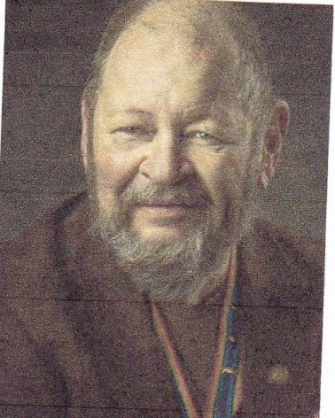

**Bob**

KEEP VETERANS IN THE GAME

CPT Robert E. Mallin, MD, USA (Fmr)

Surgeon General, MOWW

Being the Surgeon General of the Military Order has allowed me to follow, for an extended time, the various stages of soldiers and soldering. First, to credit the stories we tell, we each may have been the champion of “truth, justice and the American way,” while making the world safe for democracy. Logically, the next stage comes after a lengthy military or civilian career, i.e., the more cerebral and activist stage of soldiering. This is the stage most of our MOWW Companions are enjoying today.

While acknowledging the past adventures of patriots continues, veterans still want to continue being a part of as many meaningful activities as possible today to encourage patriotism and service to the nation. In doing that, veterans are committed to “leave no one behind.” i.e., leave no veteran uninvolved.

For those of us no longer engaged in an active military or civilian career, or who are battling health or other enemies, we can still take on other less demanding tasks supporting the good work of the Military Order. The challenges of PTSD, the VA system, disability qualifications and the burden of caring for fellow veterans, along with addictions or homelessness, need action from each of us.

Even though some veterans’ organizations to which I belong have members who show signs of “maturity” in the form of a cane, etc., it is still important to keep veterans in the game. In short, the motive that made us warriors and patriots in the first place still exist today and will continue to do so into the future. Volunteering allows that. MOWW’s mission to support ROTC, scouting, memorials, patriotic education and veterans is worthy of each of us. While there are some purely social organizations, most Veteran Service Organizations (VSO), such as the Military Order of the World Wars, the Vietnam Veterans of America, and the Iraq and Afghanistan Veterans of America, are devoted to helping and supporting veterans. Veteran involvement with these or other VSOs all help to keep the flame alive.

Additionally, it is our duty to speak out on veteran and patriotic issues whenever possible—to large and small groups. Our continuing veteran involvement lets others know that even in confusing times, a solid foundation of inclusive patriots still exists and is still serving—regardless the veteran’s stage of life. As involved Companions, you can accurately pass on history from an actual participant’s perspective to those who are far removed from such events—and be involved in outreach programs today. Such activities may be tailored to fit the capabilities and stage of life of the Companion to let them continue playing a vital part in today’s world. So, make keeping in the game an active part of your life. Be well. Bob

*The Military Order of the World Wars THE OFFICER REVIEW May--June 2018*

*CPT (Dr.) Robert E. Mallin, USA (Former) is a graduate of Adelphi University and New York Medical College. He is certified with the American Board of Plastic and Reconstructive Surgery and is a Fellow of the American College of Surgeons. In private practice from 1975-94, he was the Alaskan State Physician of the Year. While in the U.S. Army (1966-1968) he earned a Bronze Star, Purple Heart and Air Medal, and a Combat Medical Badge, among other decorations.*



**PREVIOUS MEMBERSHIP MEETING SPEAKER**

**(15 DEC 2023)**

Rabbi Rick Brody provided us with some information about the Jewish celebration of Hanukkah aa well as his personal opinion about the present situation in Israel. This very interesting presentation was enjoyed by all Companions who attended.





**THE PREAMBLE**

To cherish the memories and associations of the World Wars waged for humanity;

To inculcate and stimulate love of our country and flag;

To promote and further patriotic education in our nation;

Ever to maintain law and order, and defend the honor, integrity, and supremacy of our national government and the Constitution of the United States;

To foster fraternal relations among all branches of the armed forces;

To promote the cultivation of military, naval, and air science and the adoption of a consistent and suitable policy of national security for the United States of America;

To acquire and preserve records of individual services;

To encourage and assist in the holding of commemorations and the establishment of memorials of the World Wars; and

To transmit all these ideals to posterity; under God and for our country, we unite to establish**…**

**The Military Order of the World Wars**



**TODAY IN NAVAL HISTORY**

11 January 1863

**TROUBLE AT LOCKWOOD FOLLY INLET**

Lockwood Folly Inlet is a two-mile-wide break in the North Carolina coast south of Cape Fear. It provides access to the Intercoastal Waterway and the Lockwood Folly River. Its sand bars shift, making it a difficult passage even today.

On 26 September 1863 the side-wheel blockade runner *Elizabeth* ran aground at the inlet while trying to skirt the breakers past Union blockaders. She was set ablaze to prevent her capture. Two moonless flood tides later, a second runner, the 162-foot, iron-hulled; paddlewheel, *Bendigo* attempted the same run northward from Nassau. She sighted a Union blockader at the inlet and hugged even closer to the shore. The blockader turned out to be the still visible wreck of *Elizabeth* and the mistake proved fatal. *Bendigo* ran aground as well.

She was indeed fast, and the next morning local Confederates lightened her where she rested. When the Union supply ship, *USS FAHKEE*, was spotted passing south with coal and freight for the North Atlantic Blockading Squadron, the rebels set fire to *Bendigo*. *FAHKEE* was a new ship, a 163-foot screw steamer built for the China trade in 1862 and acquired by our Navy the following year. She usually served the inglorious role of running supplies to other warships, but this morning her 73 sailors saw an opportunity to join the fighting! They spotted the smoke and closed the wreck to investigate. Small arms fire erupted from Confederates ashore that *FAHKEE* answered with her single 10-pounder rifle and twin 24-pounder Dahlgren howitzers. Finding the runner’s hull yet intact, *FAHKEE* passed a line and attempted to tow the runner free. But the supply ship’s modest engine and single screw were not equal to the task. She held station for the next few days while help cruised north from the squadron’s headquarters. On January 9th the Union warships: *FORT JACKSON, IRON AGE, DAYLIGHT*, and *MONTHOMERY* arrived to survey the situation. *IRON AGE*’s skipper, LCDR Edward Stone, agreed it was worth salvaging the runner and renewed efforts to free her. They worked until the afternoon of January 10th, when *IRON AGE* and *MONTHOMERY* likewise grounded! The latter was soon freed, but the 144-foot screw steamer *IRON AGE* could not be lifted. Stone lightened his warship as much as possible and awaited the next high tide, yet still she was fast. Finally at 0400 this morning *IRON AGE* was fired. She exploded not two hours later when the flames reached her magazine. *FAHKEE* and the other warships pummeled *Bendigo* to a worthless wreck, and then departed.

Today the wrecks of *Elizabeth, Bendigo*, and *IRON AGE* continue to hazard boaters and fishermen off southern North Carolina. As a Federal archeological site, the wrecks cannot be disturbed.

Watch for more “Today in Naval History.”

CAPT James Bloom, Ret

Department of the Navy, Naval History Division, Dictionary of American Naval Fighting Ships, vol 2 “C-F” Washington, DC GPO 1977 p. 383

Department of the Navy, Naval History Division Dictionary of American Naval Fighting Ships, vol 3 “G-K” Washington, DC

GPO 1977 p. 459

“Lockwood Folly Inlet and the Civil War Wrecks” Saltwater Central website AT:https://saltwatercentral.com/modules.php?name=content&pa=showpage&pid=3, retrieved 3 December 2023.

Silverstone, Paul H. Warships of the Civil War Navies. Annapolis, MD: USNI Press, 1989m pp. 92, 110.

**THE CINC SOLICITATION**

The Commander in Chief is appealing to you to donate generously to the CINC Solicitation by making a *donation* in support of our Order’s patriotic and educational activities. He also asks that you encourage other Companions in your chapter to do so too. Our CINC Solicitation goal helps pay for activities such as:

* Supporting chapters via essential services (e.g., YLC insurance) and merchandise (i.e., products of all types)
* Existing awards, e.g., ROTC/JROTC Awards of merit, GSUSA Gold Award, and BSA Eagle Scout Certificates
* New awards, e.g., Outreach Service Medal and BSA Sea Scout, Quartermaster and Venture Scout Certificates
* Service Academy awards and military college awards
* Medals & certificates to ROTC/JROTC cadets & BSA & GSA scouts not supported by chapters
* Promotional material and program brochures for existing and start-up chapters
* The *Officer Review* magazine, which is MOWW’s only way to communicate with all Companions
* YLC Support via additional YLC issues of the O*fficer Review* that YLC Directors use for advertising & recruiting
* The MOWW website at [www.moww.org](http://www.moww.org), which the Order’s Companions use in support of every activity area
* MOWW Convention Support, including the Distinguished Service and National Commander Award programs

It is very easy to contribute, just open up the Order’s web page and at the very top next to the logo is the DONATE tab. You can also mail in your contribution when you receive the solicitation in the mail from MOWW HQ.

Your donation supports patriotic activities only MOWW provides. *Please donate today!*



**MEMBERSHIP APPLICATIONS**

Applications may be obtained by contacting the Chair of the Membership Committee at 303-981-5519 or [coyritchie@aol.com](mailto:coyritchie@aol.com).

It is nobler to serve than to be served



**POINTS OF CONTACT**

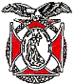

**MOWW Denver Chapter (093), CO**

c/o Coy D. Ritchie

4198 S. Kirk Court

Aurora, CO 80013-6022

[www.mowwscv.com/publications](http://www.mowwscv.com/publications)

**Commander and Treasurer**

LCDR Coy Ritchie, USN (Ret)

4198 South Kirk Court

Aurora, CO 80013-6022

303-690-5118 (Res), 303-981-5519 (Cell)

[coyritchie@aol.com](mailto:coyritchie@aol.com)

**Adjutant**

HPM Frances Long

6278 S. Kearney Street

Centennial, CO 80111-4237

303-694-1079 (Res)

[grannyfrancene@netzero.net](mailto:grannyfrancene@netzero.net)

**Commander, Rocky Mountains Department**

COL Steven A. Shambach, USA (Ret)

[shambachsm@msn.com](mailto:shambachsm@msn.com)

**Commander, Region XIII**

Capt Michael J. Halpin, USMC (Fmr)

[mjhalpin4@gmail.com](mailto:mjhalpin4@gmail.com)

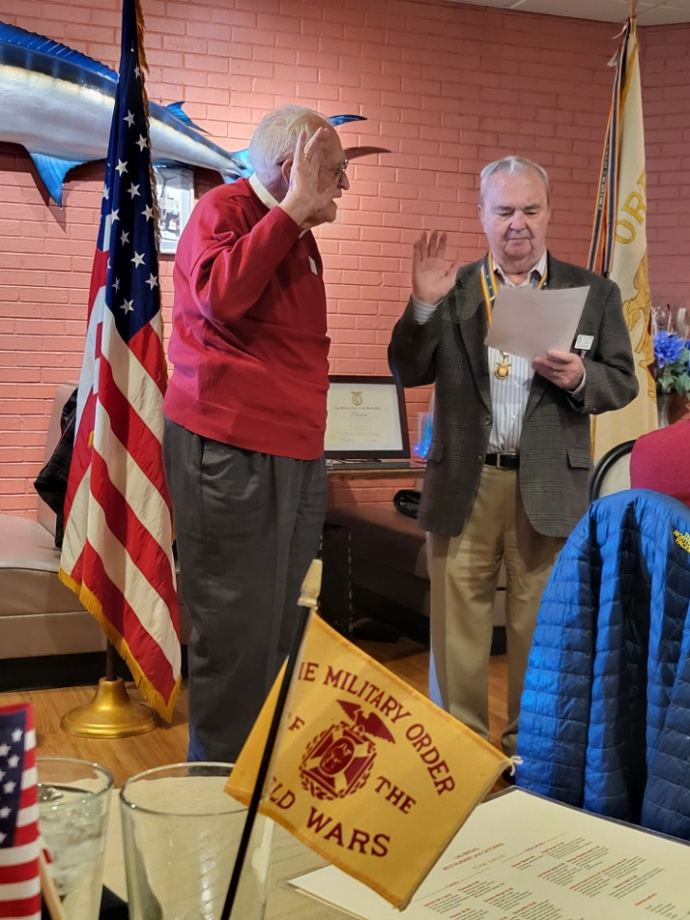

**Capt Bob Matteson, USAF (left) was installed as a perpetual member by LCDR Coy Ritchie during the Membership Luncheon on 15 December 2023.**

**DENVER CHAPTER STAFF**

Denver Chapter Executive Board-Elected Officers

Commander: LCDR Coy Ritchie, USN (Ret) 303-981-5519

1st Vice Cdr: CPT Robert Mallin, USA (Fmr) 303-794-4790

2nd Vice Cdr: HPM Stephanie Ritchie 720-910-3647

Adjutant: HPM Frances Long 303-694-1079

Chaplain: HPM Frances Long 303-694-1079

Treasurer: LCDR Coy Ritchie, USN (Ret) 303-981-5519

Denver Chapter Staff: Committee Chairs

Membership: LCDR Coy Ritchie, USN (Ret) 303-981-5519

Newsletter Editor “ “

Public Relations: “ “

Finance & Budget: “ “

Rocky Mountain YLC: “ “

Patriotism: “ “

ROTC & JROTC: HPM Stephanie Ritchie 720-910-3647

Scouting: “ “

Programs: CPT Robert Mallin, USA (Fmr) 303-794-4790

Law & Order: Col Ron Rakowsky, USAF (Ret) 303-770-7121

Hospitality: HPM J. Pat Ritchie 303-690-5118

Marshall: HPM Stephanie Ritchie 720-910-3647