COMMANDER’S REMARKS (11 December 2025)

We will have our next General Membership Meeting on Saturday, 20 December 2025, starting at 11:30 A.M. at the Black-eyed Pea Restaurant, 5180 S. Broadway, Englewood, CO 80113. It is located near the corner of Broadway and Belleview next to Starbucks. The featured speaker will be LtCol Shelley Kalkowski, USAF (Ret) who is President of the United Veteran Coalition of Colorado (UVC). She will be speaking about the UVC and how they support the veterans in Colorado. Considering that the Denver Chapter of MOWW recently became a member of the UVC, I think you will find her presentation very interesting.

I am looking forward to seeing all of you at our luncheon on Saturday, 20 December 2025.

Coy D. Ritchie, D.M.
LCDR, USN (Ret)

It is nobler to serve than to be served

______________________________________________________________________________________________________________________

STAFF MEETING (11 December 2025)

This meeting was conducted at Frances Long’s home and was called to order by Chapter Commander Coy Ritchie at 1100 hours. Also attending were HPM Pat Ritchie, HPM Francis Long, HPM Stephanie Ritchie, and Capt Dennis Orr by phone. The invocation was given by HPM Frances Long followed by the Pledge of Allegiance.

Minutes: The minutes of the staff meeting on 6 November 2025 were approved on a motion by HPM Frances Long and seconded by HPM Pat Ritchie.

Treasurer’s Report: The Treasurer’s Report as of 30 November 2025 was submitted by LCDR Ritchie. The U.S. Bank checking account had a beginning balance of $2,924.77. LCDR Ritchie reported that he sent the required annual report to the Secretary of State of Colorado at a cost of $25 leaving an ending balance of $2,899.77. There was no activity in the account at the ENT Credit Union and the total remained at $8,340.67. The ENT Credit Union is merging with the Wings Credit Union and its name will change to the Wings Credit Union. The Treasurer’s Report was approved on a motion by Capt Orr and seconded by HPM S. Ritchie.

Scouts: LCDR Ritchie received an invitation to attend a scouting Court of Honor in Northglenn, Co on January 25, 2026. He will attend an present MOWW Eagle Scout Certificates of Recognition.

ROTC/JROTC: HPM S. Ritchie sent holiday greetings to the units supported by this Chapter.

Patriotic Education: Nothing new.

Public Safety and Law and Order: HPM S. Ritchie will contact Arapahoe County Sheriff to request him to be a possible speaker in 2026.

Region XIII and Dept. of the Rocky Mountains:
Nothing new.

Membership: Our newest member will be attending his first General Membership Luncheon on 20 December 2025.

Program/Speaker: The speaker at our General Membership Meeting on 20 December will be Lt Col Shelly Kalkowski, USAF (Ret), who is President of the United Veterans Coalition of Colorado (UVC).

Hospitality: The next General Membership Luncheon will be on Saturday, 20 December 2025 at the Black-eyed Pea Restaurant starting at 1130 hours. We will order from the menu.

Old Business: None.

New Business: None.

Next Staff Meeting: Thursday, 8 January 2026, starting at 1100 hours at the home of HPM Frances Long.

Benediction: Given by HPM F Long.

Adjournment LCDR Ritchie adjourned the meeting at 1118 hours.

Submitted by Adjutant, HPM Frances Long.

COMING EVENTS (December & Later)

- STAFF MEETING (8 January 2026)
  - (Thursday), 11:00 A.M.
  - Location: Frances Long’s Home

- MOWW NATIONAL CONVENTION
( August, 2026)
  - Location: Westin Hotel, San Antonio, TX.

- MEMBERSHIP LUNCHEON
(20 December 2025)
  - (Saturday), time 11:30 A.M.
  - Location: The Black-eyed Pea Restaurant, 5180 S. Broadway, Englewood, CO 80113.
  - Menu: Order from the menu.
  - Program: Lt Col Shelly Kalkowski, USAF (Ret), President of the United Veterans Coalition of Colorado (UVC) who will be speaking about the UVC.

PREVIOUS MEMBERSHIP MEETING SPEAKER
(18 October 2025)
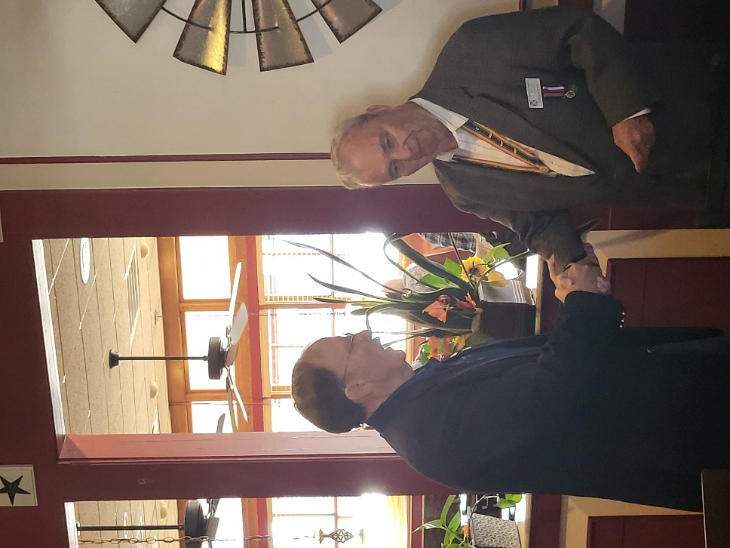

The featured speaker was Col Robert Smith, USAF (Ret) who is President of the Rocky Mountain Youth Leadership Foundation. He explained that the objective of the annual Rocky Mountain Youth Leadership Conference is to train High School Juniors and Seniors to be leaders in their schools and throughout their future lives and covered many of the details of the curriculum presented in the Conference.. He also answered a number of questions posed by the Chapter members. In the photo above, Col Smith (L) is being congratulated for his very interesting presentation by Chapter Commander Coy Ritchie..



THE PREAMBLE

To cherish the memories and associations of the World Wars waged for humanity;

To inculcate and stimulate love of our country and flag;

To promote and further patriotic education in our nation;

Ever to maintain law and order, and defend the honor, integrity, and supremacy of our national government and the Constitution of the United States;

To foster fraternal relations among all branches of the armed forces;

To promote the cultivation of military, naval, and air science and the adoption of a consistent and suitable policy of national security for the United States of America;

To acquire and preserve records of individual services;

To encourage and assist in the holding of commemorations and the establishment of memorials of the World Wars; and

To transmit all these ideals to posterity; under God and for our country, we unite to establish…

The Military Order of the World Wars
_________________________________________________________

TODAY IN NAVAL HISTORY

7-8 DECEMBER 1941

WHERE WERE THE CARRIERS?

Most everyone will recall that one significant shortcoming of the Pearl Harbor raid from the Japanese perspective was its failure to destroy the American Navy’s aircraft carriers. Yamamoto had targeted them in particular, appreciating as he did, the importance of naval air power. It was with some disappointment that the airstrike launched knowing the carriers were not in port. But just where were our carriers at 0755, 7 December 1941?

For the past year, U.S. attentions had focused on the Atlantic where four of our seven carriers were based. German U-boats had already attacked U.S. warships escorting freighters on Roosevelt’s “Neutrality Patrol.” In fact, REUBEN JAMES (DD-245) had been sunk in September 1941 on just such a mission. Dawn on December 7th found YORKTOWN (CV-5) in Norfolk and RANGER (CV-4) a day out, both having just finished Neutrality Patrols. Brand new HORNET (CV-8), just 2 months in commission, was also readying herself in Norfolk. WASP (CV-7) was serving as our training carrier and lay at anchor in Grassy Bay, Bermuda, observing the usual Sunday morning routine between Caribbean cruises.

In the Pacific, SARATOGA (CV-3) was fresh out of dry-dock in Bremerton. The morning of December 7th found her pulling into San Diego to embark Marine Corps aircraft intended for Wake. After hearing the news from Hawaii, SARATOGA got underway immediately, hoping to reinforce the besieged garrison at Wake. She reached Pearl Harbor on the 15th, stopping only for fuel. But the tiny island outpost at Wake fell before SARATOGA could arrive.

Two carriers were in the waters around Hawaii, ENTERPRISE (CV-6) was returning from an aircraft ferrying assignment, having delivered VMF-211 to Wake Island. She had planned to make Pearl that day, in fact, her scout planes arrived over the harbor in the midst of the Japanese attack and joined the defense. She pulled in on this day, pausing briefly to refuel, then departed to hunt down the Japanese. Though she did not locate the enemy strike force, her aircraft did sink the sub I-170 on the 10th. Our oldest flattop in service, LEXINGTON (CV-2), was returning from Midway, having likewise delivered a squadron of Marine fighters. Upon learning of the Pearl Harbor attack she promptly launched search planes in an unsuccessful attempt to locate the Japanese fleet, then diverted south to rendezvous with ENTERPRISE and INDIANBAPOLIS (CA-35).

After today’s disaster, YORKTOWN cast off for Hawaii on December 16th. HORNET was readied for Doolittle’s Tokyo raid, departing Norfolk on 4 March 1942. WASP was pulled from training duties and eventually transferred to the Pacific after the loss of YORKTOWN at Midway in June 1942. RANGER remained in the Atlantic.

Watch for more “Today in Naval History”

CAPT James Bloom, Ret.

Department of the Navy, Naval History Division. Dictionary of American Naval Fighting Ships, Vols 2, 3, 4, 6, 8. Washington , D.C.: GPO. 1977-1981.

ADDITIONAL NOTES: RANGER is perhaps the least well-remembered of our seven pre WWII carriers. She remained in the Atlantic and Mediterranean until August 1944, when she also transferred to the Pacific. Here she was relegated to pilot training duties off the California coast. Our fist carrier, the former LANGLEY (CV-1), was still in service, but had been converted to a seaplane tender (AV-3) in the 1930s. She was operating with the Asiatic Fleet at the war’s outbreak and was sunk by Japanese planes in late February 1942.

MEMBERSHIP APPLICATIONS

Applications may be obtained by contacting the Chair of the Membership Committee at 303-981-5519 or coyritchie@aol.com.

It is nobler to serve than to be served

THE CINC SOLICITATION

The Commander in Chief is appealing to you to donate generously to the CINC Solicitation by donating in support of our Order’s patriotic and educational activities. He also asks that you encourage other Companions in your chapter to do so too. Our CINC Solicitation goal helps pay for activities such as:
- Supporting chapters via essential services (e.g., YLC insurance) and merchandise
(i.e., products of all types)
- Existing awards, e.g., ROTC/JROTC Awards of merit, GSUSA Gold Award, and BSA Eagle Scout Certificates
- New awards, e.g., Outreach Service Medal and BSA Sea Scout, Quartermaster and Venture Scout Certificates
- Service Academy awards and military college awards
- Medals & certificates to ROTC/JROTC cadets & BSA & GSA scouts not supported by chapters
- Promotional material and program brochures for existing and start-up chapters
- The Officer Review magazine, which is MOWW’s only way to communicate with all Companions
- YLC Support via additional YLC issues of the Officer Review that YLC Directors use for advertising & recruiting
- The MOWW website at www.moww.org, which the Order’s Companions use in support of every activity area
- MOWW Convention Support, including the Distinguished Service and National Commander Award programs
It is very easy to contribute, just open up the Order’s web page and at the very top next to the logo is the DONATE tab. You can also mail in your contribution when you receive the solicitation in the mail from MOWW HQ.

Your donation supports patriotic activities only MOWW provides. Please donate today!

CHAPTER ACTION PLAN

Each year our chapter is asked to prepare and submit a Chapter Action Plan to the Commander Region XIII. The Action Plan shows the actions to be taken by the chapter to support the MOWW Strategic Goals. Our Action Plan is shown below.
Reviewing the Action Plan may explain why we do certain things.

2025-2026 DENVER CHAPTER ACTION PLAN

Strategic Goal 1 (SG 1) Consistently develop and deliver attractive and high-impact community outreach programs and activities.

#Improve planning for speakers at our meetings.
#Continue to Support the Colorado Springs Chapter Rocky Mountain Youth Leadership Conference.
#We will participate in the Buckley SFB Retiree Appreciation Day activities.
#Conduct a presentation with the assembled leadership of the 12 JROTC Units in the Denver Public Schools.

SG 2 Expand our impact through alliances and strategic partnerships with organizations that align with our mission.

#We are now members of the United Veterans Coalition of Colorado (UVC) organization. Their membership includes practically all of the Veterans Service Organizations in Colorado. This will improve our visibility and communications with like-minded organizations.

SG3 Increase visibility of the Order at the national and community levels through focused communications, marketing strategies, and local community engagement.

#We have a social media presence through the Region XIII Hub and Spoke project.

SG4 Annually grow engaged and sustainable MOWW membership.

#We will hold a general membership meeting every other month, five each operating year.
#Meet or exceed the small chapter recruiting goal of two new members.
#Recruit only military veterans as Chapter members to support the IRS 75% requirement.
#Encourage our members to regularly attend the General Membership Meetings.

SG5 Increase adequate financial resources to fulfill Order’s mission.

#Obtain at least one donation from a community civic organization or Chapter supporting organization.
#Solicit donations from Chapter members to support selected expensive programs such as ROTC/JROTC, Scouting and recognition awards for deserving Companions.

SG6 Increase the number of chapters and strengthen existing chapters.

#Continue to support our succession plan & prepare Companions to assume leadership roles.
#Continue to identify, recognize, and nominate for awards our highly productive chapter Companions.

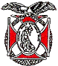

POINTS OF CONTACT

Denver Chapter (093), CO
c/o Coy D. Ritchie
4198 S. Kirk Court
Aurora, CO 80013-6022
www.mowwscv.com/publications

Commander and Treasurer
LCDR Coy Ritchie, USN (Ret)
4198 South Kirk Court
Aurora, CO 80013-6022
303-690-5118 (Res), 303-981-5519 (Cell)
coyritchie@aol.com

Adjutant
HPM Frances Long
278 S. Kearney Street
Centennial, CO 80111-4237
303-694-1079 (Res)
grannyfrancene@netzero.net

Commander, Rocky Mountains Department
Col Kermit Neal, USAF (Ret)
knealsfour@yahoo.com

Commander, Region XIII

DENVER CHAPTER STAFF

Denver Chapter Executive Board-Elected Officers
Commander: LCDR Coy Ritchie, USN (Ret) 303-981-5519
1st Vice Cdr: Capt Dennis Orr, USAF (Former) 303-526-2156
2nd Vice Cdr: HPM Stephanie Ritchie 720-910-3647
Adjutant: HPM Frances Long 303-694-1079
Chaplain: HPM Frances Long 303-694-1079
Treasurer: LCDR Coy Ritchie, USN (Ret) 303-981-5519

Denver Chapter Staff: Committee Chairs
Membership: LCDR Coy Ritchie, USN (Ret) 303-981-5519
Newsletter Editor “ “
Public Relations: “ “
Finance & Budget: “ “
Patriotic Education “ “
ROTC & JROTC: HPM Stephanie Ritchie 720-910-3647
Scouting: HPM Stephanie Ritchie 720-910-3647
Programs: Capt Dennis Orr, USAF (Fmr) 303-526-2156
Law & Order: Capt Dennis Orr, USAF (Fmr) 303-526-2156
Hospitality: HPM J. Pat Ritchie 303-690-5118
Marshall HPM Stephanie Ritchie 720-910-3647

