**COMMANDER’S REMARKS (6 APRIL 2023)**

We will have a regular face-to-face General Membership Meeting on Saturday, 22 April 2023, starting at 11:30 A.M. The meeting will be held at Las Brisas Restaurant, 6787 S. Clinton Street, Greenwood Village, CO. We will be meeting in a different room this time so that the speaker can use a computer and projector. We will be using the large separate room outside the main dining area.

To get there (Las Brisas Restaurant), if you are coming from east of I25, drive west on Arapahoe Road to South Clinton Street (about a block before you get to I25) and take a left turn. Do not turn on Clinton Court as the next street is South Clinton Street. The restaurant is located on the east side of the Target Store parking lot. If you are coming from west of I25, drive east on Arapahoe Road until you pass under I25. The first street on the right is South Clinton Street. Turn right and you will see the restaurant on the east side of the Target Store parking lot. If you get lost, you can call me at 303-981-5519 (cell) and I will try to get you un-lost.

Our 2022 Operating Year ends officially on 30 June 2023. At that time, we may install new Chapter officers. We will have an election at our meeting on 22 April for any new officers. The positions available are Commander, First Vice Commander, Second Vice Commander, Adjutant and Treasurer. Companions interested in serving in one of these positions should contact LCDR Ritchie at 303-981-5519 or coyritchie@aol.com.

Coy D. Ritchie, D.M.

LCDR, USN (Ret)

Denver Chapter Commander

It is nobler to serve than to be served



**STAFF MEETING (6 APRIL 2023)**

This meeting was conducted at Frances Long’s home and was called to order by Commander Coy Ritchie at 1105 hours. Also attending were HPM Pat Ritchie, HPM Francis Long, and CPT Bob Mallin, MD by telephone. The invocation was offered by HPM Long followed by the Pledge of Allegiance led by LCDR Ritchie.

Minutes The minutes of the meeting on 9 March 2023 were approved on a motion by LCDR Ritchie and seconded by HPM Long.

Treasurer’s Report The Treasurer’s Report as of 31 March was submitted by LCDR Ritchie. The month ended with a U.S. Bank fund balance of $4,119.77 and ENT Credit Union fund balance of $8,880.41. The Treasurer’s Report was approved on a motion by HPM Pat Ritchie and seconded by HPM Frances Long.

Scouts LCDR Ritchie reported that supplies have been received and certificates recognition have been prepared.

ROTC/JROTC LT Totten reported that ROTC and JROTC updates are coming in and medals, presentation folders, and certificates are being prepared.

Patriotic Education LCDR Ritchie sent a check for $750.00 to the RMYLF to sponsor students at the YLC to be conducted during 12-16 June 2023.

Public Safety and Law and Order Nothing new to report.

Region XIII and Department of the Rocky Mountains On 13 April there will be a Region XIII Conference in Tucson conducted by Zoom. A second Conference is scheduled for 15-17 June in Phoenix and will also be conducted utilizing Zoom.

Membership LCDR Ritchie reported that a possible new member has indicated he will attend our next general membership luncheon.

Hospitality Our next general membership luncheon will be held on 22 April 2023 at Las Brisas Restaurant with the social period at 11:30 and lunch at 12:00.

Program/Speaker LT Totten will be our speaker on 22 April. He will be speaking about his military experiences during the Viet Nam War.

Old Business Nothing to report.

New Business Nothing to report.

Next Staff Meeting Thursday, 11 May 2023, starting at 1100 hours at the home of HPM Frances Long.

Benediction Offered by HPM Frances Long.

Adjournment LCDR Ritchie adjourned the meeting at 1134 hours.



**COMING EVENTS (April & Later)**

* **STAFF MEETING (11 May 2023)**
  + (Thursday), 11:00 A.M.
  + Location: Frances Long’s Home
* **MOWW NATIONAL CONVENTION**

**(1-6 August 2023)**

* + Location: Annapolis, MD
* **MEMBERSHIP LUNCHEON**

**(22 April 2023)**

* + (Saturday), time 11:30 A.M.
  + Location: Las Brisas Restaurant, 6787 S. Clinton Street, Greenwood Village, CO.
  + Menu: Order from the menu.
  + Program: LT Evan Totten with a presentation on his experiences during the Viet Nam War.



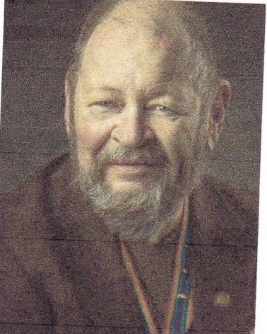

**Bob**

REMEMBERING.

CPT Robert E. Mallin, MD, USA (Fmr)

Surgeon General, MOWW

Recently I was looking for an award plaque I knew I had, but could not find. After ordering another, it turned up. This, of course, is all too common, and so it deserves some research and understanding. People have long tried to understand memory and its operation. We often think of memory as a big file cabinet with many folders, or as a super computer. It is probably more complex than that. Memory is a brain-wide phenomena drawing on many areas. To illustrate, driving a car involves the driving, the directions, the analysis of road and weather, the fear of collision, the sound of things, etc. The information needed to address these things and more come from different areas of the brain. Our brain codes each bit of information to a particular place in the brain, and then the brain rapidly decodes that information as needed. It is a web of interaction. If some parts of the web, such as a first name, are damaged, other parts, such as the last name or occupation, may not be. Additionally, there are short-term and long-term memory components, each of which is coded differently and stored with different methods of recall. Memory is distinct from learning, although once something is learned; it becomes a part of memory.

“Remerging” is pulling many things together from many parts of the brain. It is not like pulling a book off the shelf or a file from a drawer. This complexity is handled by using memory to pull thoughts together, to plan or to change direction given a new concept. Associations and inferences also play a part. Forgetting is not the same as not noting or caring. A person may remember the football scores of a decade ago and not remember the ingredients in a Margarita. In similar fashion, the smart phone is not ruining our memory. We are simply assigning certain information to be stored in it, i.e., information we choose not to deal with or learn. Contrary to popular opinion, the computer improves our memory because we know where to find the information.

The phenomenon of fact distortion in memory is real. For example, we may “remember” things even though they never happened. This is a widespread occurrence. Of course, conscious lies and distortions of the truth are different matters—although true belief in these thoughts can and does happen. In theory, a lie detector can be lied to with impunity. I recall what Major Metz told me long ago. “Try to make most of your war stories mostly true.” Just to make it more complicated, there is community memory that allows individuals to build on the experiences of a group and thus advance knowledge. Writing and audiovisual products are external forms of memory. That capability allows civilization to advance. The parting thought to remember is that memory can atrophy if not used. Just as physical exercise strengthens our physical functioning, we must keep up thinking to strengthen our mental functioning. That is why remaining intellectually challenged is vital to our health. Be well/Bob.

*MOWW OFFICER REVIEW APRIL 2013 p21*

*The Military Order of the World Wars*

*CPT (Dr.) Robert E. Mallin, USA (Former) is a graduate of Adelphi University and New York Medical College. He is certified with the American Board of Plastic and Reconstructive Surgery and is a Fellow of the American College of Surgeons. In private practice from 1975-94, he was the Alaskan State Physician of the Year. While in the U.S. Army (1966-1968) he earned a Bronze Star, Purple Heart and Air Medal, and a Combat Medical Badge, among other decorations.*



**PREVIOUS MEMBERSHIP MEETING**

**(18 FEB 2023)**

LCDR Ritchie shared with the Chapter Companions his experiences in 1957 supporting the Formosan military forces in retaking the islands of Quemoy and Matsu from mainland China and later in patrolling in the China Sea berween Formosa and mainland China to prevent further hostilities. He also related his experience when entering the harbor in Guam at night and explained the facts behind the nautical rule “*Red right returning*.”

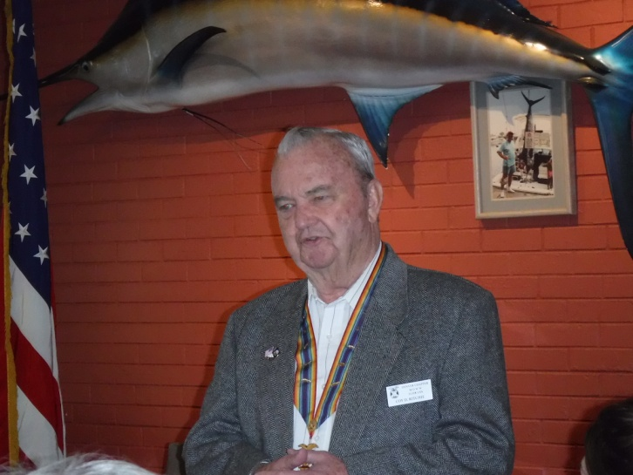

**LCDR Ritchie shares his experiences in the South China Sea in 1957.**





**THE PREAMBLE**

To cherish the memories and associations of the World Wars waged for humanity;

To inculcate and stimulate love of our country and flag;

To promote and further patriotic education in our nation;

Ever to maintain law and order, and defend the honor, integrity, and supremacy of our national government and the Constitution of the United States;

To foster fraternal relations among all branches of the armed forces;

To promote the cultivation of military, naval, and air science and the adoption of a consistent and suitable policy of national security for the United States of America;

To acquire and preserve records of individual services;

To encourage and assist in the holding of commemorations and the establishment of memorials of the World Wars; and

To transmit all these ideals to posterity; under God and for our country, we unite to establish**…**

**The Military Order of the World Wars**



**THE CINC SOLICITATION**

The Commander in Chief is appealing to you to donate generously to the CINC Solicitation by making a *donation* in support of our Order’s patriotic and educational activities. He also asks that you encourage other Companions in your chapter to do so too. Our CINC Solicitation goal helps pay for activities such as:

* Supporting chapters via essential services (e.g., YLC insurance) and merchandise (i.e., products of all types)
* Existing awards, e.g., ROTC/JROTC Awards of merit, GSUSA Gold Award, and BSA Eagle Scout Certificates
* New awards, e.g., Outreach Service Medal and BSA Sea Scout, Quartermaster and Venture Scout Certificates
* Service Academy awards and military college awards
* Medals & certificates to ROTC/JROTC cadets & BSA & GSA scouts not supported by chapters
* Promotional material and program brochures for existing and start-up chapters
* The *Officer Review* magazine, which is MOWW’s only way to communicate with all Companions
* YLC Support via additional YLC issues of the *Officer Review* that YLC Directors use for advertising & recruiting
* The MOWW website at [www.moww.org](http://www.moww.org), which the Order’s Companions use in support of every activity area
* MOWW Convention Support, including the Distinguished Service and National Commander Award programs

It is very easy to contribute, just open up the Order’s web page and at the very top next to the logo is the DONATE tab. You can also mail in your contribution when you receive the solicitation in the mail from MOWW HQ.

Your donation supports patriotic activities only MOWW provides. *Please donate today!*



**MEMBERSHIP APPLICATIONS**

Applications may be obtained by contacting the Chair of the Membership Committee at 303-981-5519 or [coyritchie@aol.com](mailto:coyritchie@aol.com).

It is nobler to serve than to be served

**POINTS OF CONTACT**



**MOWW Denver Chapter (093), CO**

C/o Coy D. Ritchie

4198 S. Kirk Court

Aurora, CO 80013-6022

[www.mowwscv.com/publications](http://www.mowwscv.com/publications)

**Commander and Treasurer**

LCDR Coy Ritchie, USN (Ret)

4198 South Kirk Court

Aurora, CO 80013-6022

303-690-5118 (Res), 303-981-5519 (Cell)

[coyritchie@aol.com](mailto:coyritchie@aol.com)

**Adjutant**

HPM Frances Long

6278 S. Kearney Street

Centennial, CO 80111-4237

303-694-1079 (Res)

[grannyfrancene@netzero.net](mailto:grannyfrancene@netzero.net)

**Commander, Rocky Mountains Department**

COL Steven A. Shambach, USA (Ret)

[shambachsm@msn.com](mailto:shambachsm@msn.com)

**Commander, Region XIII**

LTC Patrick C. Stolze, USA (Ret)

[pstolze40@gmail.com](mailto:pstolze40@gmail.com)

**DENVER CHAPTER STAFF**

Denver Chapter Executive Board-Elected Officers

Commander: LCDR Coy Ritchie, USN (Ret) 303-981-5519

1st Vice Cdr: CPT Robert Mallin, USA (Fmr) 303-794-4790

2nd Vice Cdr: HPM Stephanie Ritchie 720-657-3783

Adjutant: HPM Frances Long 303-694-1079

Chaplain: LT Evan Totten, USNR (Fmr) 303-819-5729

Treasurer: LCDR Coy Ritchie, USN (Ret) 303-981-5519

Denver Chapter Staff: Committee Chairs

Membership: LCDR Coy Ritchie, USN (Ret) 303-981-5519

Newsletter Editor “ “

Public Relations: “ “

Finance & Budget: “ “

Rocky Mountain YLC: “ “

Patriotism: “ “

ROTC & JROTC: LT Evan Totten, USNR (Fmr) 303-819-5729

Scouting: “ “

Programs: CPT Robert Mallin, USA (Fmr) 303-794-4790

Law & Order: Col Ron Rakowsky, USAF (Ret) 303-770-7121

Hospitality: HPM J. Pat Ritchie 303-690-5118

Marshall: HPM Stephanie Ritchie 720-657-3783